UNITED STATES
SECURITIES AND EXCHANGE COMMISSION
Washington, D.C. 20549

FORM 8-K

Current Report

Pursuant to Section 13 or 15(d) of the Securities Exchange Act of 1934

Date of Report (date of earliest event reported): April 3, 2024

IOVANCE BIOTHERAPEUTICS, INC.
(Exact Name of Registrant as Specified in Charter)

Delaware
(State of Incorporation)
001-36860 |  | 75-3254381
Commission File Number |  | (I.R.S. Employer Identification No.)
825 Industrial Road, 4th Floor
San Carlos, California |  | 94070
(Address of Principal Executive Offices) |  | (Zip Code)
(650) 260-7120
(Registrant’s Telephone Number, Including Area Code)
Check the appropriate box below if the Form 8-K filing is intended to simultaneously satisfy the filing obligation of the registrant under any of the following provisions:

 | ☐ | Written communications pursuant to Rule 425 under the Securities Act (17 CFR 230.425).

 | ☐ | Soliciting material pursuant to Rule 14a-12 under the Exchange Act (17 CFR 240.14a-12).

 | ☐ | Pre-commencement communications pursuant to Rule 14d-2(b) under the Exchange Act (17 CFR 240.14d-2(b)).

 | ☐ | Pre-commencement communications pursuant to Rule 13e-4(c) under the Exchange Act (17 CFR 240.13e-4(c)).

Indicate by check mark whether the registrant is an emerging growth company as defined in as defined in Rule 405 of the Securities Act of 1933 (§230.405 of this chapter) or Rule 12b-2 of the Securities Exchange Act of 1934 (§240.12b-2 of this chapter). Emerging growth company ☐

If an emerging growth company, indicate by check mark if the registrant has elected not to use the extended transition period for complying with any new or revised financial accounting standards provided pursuant to Section 13(a) of the Exchange Act. ☐

Securities registered pursuant to Section 12(b) of the Act:

Title of each class | Trading Symbol(s) | Name of each exchange on which  registered
Common stock, par value $0.000041666 per share | IOVA | The Nasdaq Stock Market, LLC

Item 8.01. | Other Events.

As previously disclosed, on December 11, 2020, a purported stockholder derivative complaint (the “Derivative Action”) was filed by plaintiff Leo Shumacher against Iovance Biotherapeutics, Inc. (the “Company”), as nominal defendant, and certain of the Company’s current officers and directors, as defendants, in the Court of Chancery in the State of Delaware (the “Court”). On March 12, 2024, the parties agreed to a proposed settlement, set forth in a Stipulation of Compromise and Settlement (the “Stipulation”), which was submitted to the Court for approval. The Stipulation calls for the Company to adopt certain governance changes, the cancellation of certain option awards made to non-employee directors, and for the Company to pay to plaintiff’s counsel $600,000 for certain legal fees and expenses.

On March 20, 2024, the Court entered a Scheduling Order setting a hearing to determine whether final approval will be given to the settlement. The hearing has been set for July 11, 2024 at 3:15 p.m. in the Leonard L. Williams Justice Center, 500 North King Street, Wilmington, Delaware 19801. As required by the Scheduling Order, the Company is filing the Notice of Pendency of Settlement of Action with this Current Report on Form 8-K, a copy of which is attached hereto as Exhibit 99.1.

Item 9.01. | Financial Statements and Exhibits.

(d) Exhibits.

Exhibit  No. |  | Description
99.1 |  | Notice of Pendency of Settlement of Action, dated March 25, 2024.
104 |  | Cover Page Interactive Data File (embedded as Inline XBRL document)

SIGNATURES

Pursuant to the requirements of the Securities Exchange Act of 1934, the Registrant has duly caused this Report to be signed on its behalf by the undersigned hereunto duly authorized.

Date: April 3, 2024 | IOVANCE BIOTHERAPEUTICS, INC.
 | By: | /s/ Frederick G. Vogt
 |  | Frederick G. Vogt, Interim CEO & General Counsel

Exhibit 99.1
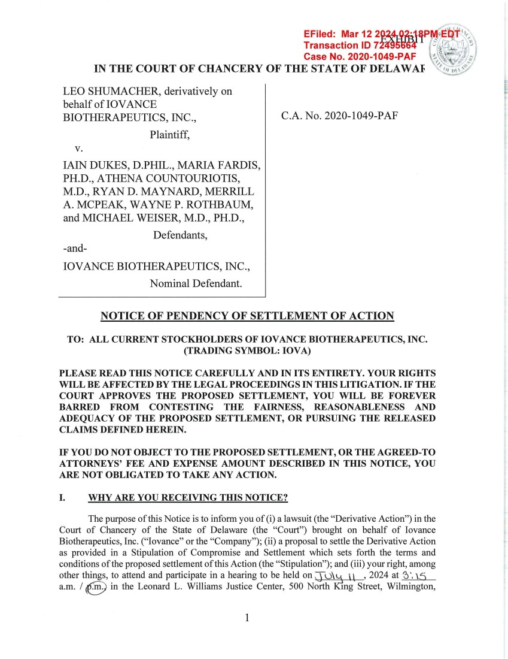 | LEO SHUMACHER, derivatively on behalf of IOVANCE BIOTHERAPEUTICS, INC., Plaintiff, V. IAIN DUKES, D.PHIL., MARIA FARDIS, PH.D., ATHENA COUNTOURIOTIS, M.D., RYAN D. MAYNARD, MERRILL A. MCPEAK, WAYNE P. ROTHBAUM, and MICHAEL WEISER, M.D., PH.D., Defendants, -and-IOV ANCE BIOTHERAPEUTICS, INC., Nominal Defendant. C.A. No. 2020-1049-PAF NOTICE OF PENDENCY OF SETTLEMENT OF ACTION TO: ALL CURRENT STOCKHOLDERS OF IOV ANCE BIOTHERAPEUTICS, INC. (TRADING SYMBOL: IOV A) PLEASE READ THIS NOTICE CAREFULLY AND IN ITS ENTIRETY. YOUR RIGHTS WILL BE AFFECTED BY THE LEGAL PROCEEDINGS IN THIS LITIGATION. IF THE COURT APPROVES THE PROPOSED SETTLEMENT, YOU WILL BE FOREVER BARRED FROM CONTESTING THE FAIRNESS, REASONABLENESS AND ADEQUACY OF THE PROPOSED SETTLEMENT, OR PURSUING THE RELEASED CLAIMS DEFINED HEREIN. IF YOU DO NOT OBJECT TO THE PROPOSED SETTLEMENT, OR THE AGREED-TO ATTORNEYS' FEE AND EXPENSE AMOUNT DESCRIBED IN THIS NOTICE, YOU ARE NOT OBLIGATED TO TAKE ANY ACTION. I. WHY ARE YOU RECEIVING THIS NOTICE? The purpose of this Notice is to inform you of (i) a lawsuit (the "Derivative Action") in the Court of Chancery of the State of Delaware (the "Court") brought on behalf of Iovance Biotherapeutics, Inc. ("Iovance" or the "Company"); (ii) a proposal to settle the Derivative Action as provided in a Stipulation of Compromise and Settlement which sets forth the terms and conditions of the proposed settlement of this Action (the "Stipulation"); and (iii) your right, among other things, to attend and participate in a hearing to be held on J 0\a \ \ , 2024 at 12) '. ,5 a.m. I@) in the Leonard L. Williams Justice Center, 500 North ~ng Street, Wilmington, 1
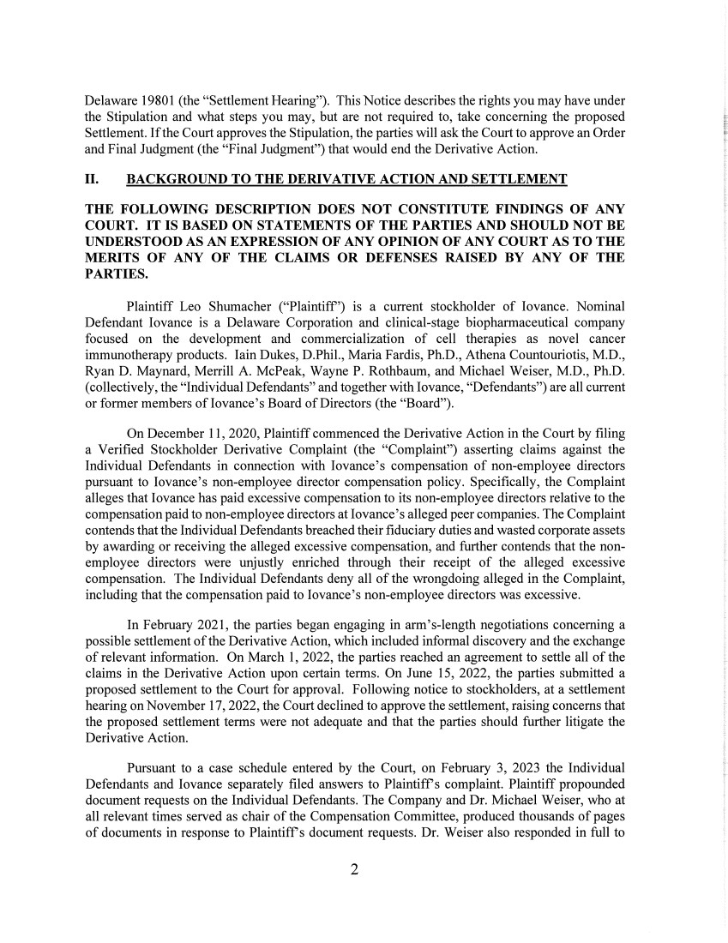 | Delaware 19801 (the "Settlement Hearing"). This Notice describes the rights you may have under the Stipulation and what steps you may, but are not required to, take concerning the proposed Settlement. If the Court approves the Stipulation, the parties will ask the Court to approve an Order and Final Judgment (the "Final Judgment") that would end the Derivative Action. II. BACKGROUND TO THE DERIVATIVE ACTION AND SETTLEMENT THE FOLLOWING DESCRIPTION DOES NOT CONSTITUTE FINDINGS OF ANY COURT. IT IS BASED ON STATEMENTS OF THE PARTIES AND SHOULD NOT BE UNDERSTOOD AS AN EXPRESSION OF ANY OPINION OF ANY COURT AS TO THE MERITS OF ANY OF THE CLAIMS OR DEFENSES RAISED BY ANY OF THE PARTIES. Plaintiff Leo Shumacher ("Plaintiff') is a current stockholder of Iovance. Nominal Defendant Iovance is a Delaware Corporation and clinical-stage biopharmaceutical company focused on the development and commercialization of cell therapies as novel cancer immunotherapy products. Iain Dukes, D.Phil., Maria Fardis, Ph.D., Athena Countouriotis, M.D., Ryan D. Maynard, Merrill A. McPeak, Wayne P. Rothbaum, and Michael Weiser, M.D., Ph.D. (collectively, the "Individual Defendants" and together with Iovance, "Defendants") are all current or former members oflovance's Board of Directors (the "Board"). On December 11, 2020, Plaintiff commenced the Derivative Action in the Court by filing a Verified Stockholder Derivative Complaint (the "Complaint") asserting claims against the Individual Defendants in connection with Iovance' s compensation of non-employee directors pursuant to Iovance's non-employee director compensation policy. Specifically, the Complaint alleges that Iovance has paid excessive compensation to its non-employee directors relative to the compensation paid to non-employee directors at Iovance's alleged peer companies. The Complaint contends that the Individual Defendants breached their fiduciary duties and wasted corporate assets by awarding or receiving the alleged excessive compensation, and further contends that the non-employee directors were unjustly emiched through their receipt of the alleged excessive compensation. The Individual Defendants deny all of the wrongdoing alleged in the Complaint, including that the compensation paid to Iovance's non-employee directors was excessive. In February 2021, the parties began engaging in arm's-length negotiations concerning a possible settlement of the Derivative Action, which included informal discovery and the exchange of relevant information. On March 1, 2022, the parties reached an agreement to settle all of the claims in the Derivative Action upon certain terms. On June 15, 2022, the parties submitted a proposed settlement to the Court for approval. Following notice to stockholders, at a settlement hearing on November 17, 2022, the Court declined to approve the settlement, raising concerns that the proposed settlement terms were not adequate and that the parties should further litigate the Derivative Action. Pursuant to a case schedule entered by the Court, on February 3, 2023 the Individual Defendants and Iovance separately filed answers to Plaintiffs complaint. Plaintiff propounded document requests on the Individual Defendants. The Company and Dr. Michael Weiser, who at all relevant times served as chair of the Compensation Committee, produced thousands of pages of documents in response to Plaintiffs document requests. Dr. Weiser also responded in full to 2
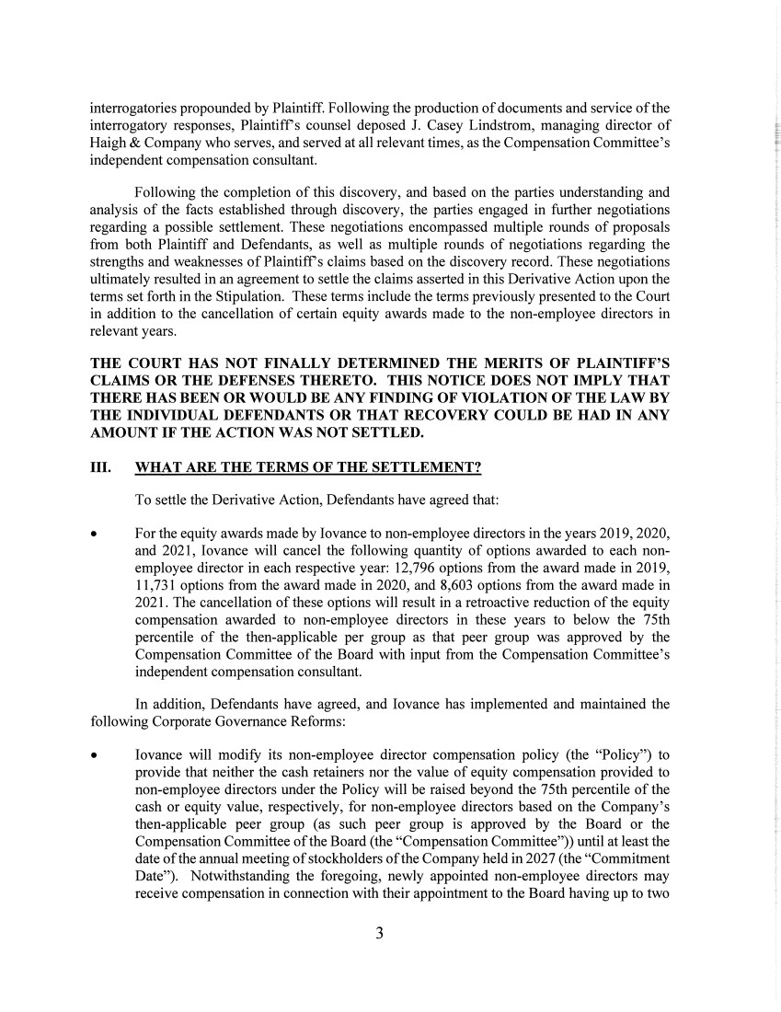 | interrogatories propounded by Plaintiff. Following the production of documents and service of the interrogatory responses, Plaintiffs counsel deposed J. Casey Lindstrom, managing director of Haigh & Company who serves, and served at all relevant times, as the Compensation Committee's independent compensation consultant. Following the completion of this discovery, and based on the parties understanding and analysis of the facts established through discovery, the parties engaged in further negotiations regarding a possible settlement. These negotiations encompassed multiple rounds of proposals from both Plaintiff and Defendants, as well as multiple rounds of negotiations regarding the strengths and weaknesses of Plaintiffs claims based on the discovery record. These negotiations ultimately resulted in an agreement to settle the claims asserted in this Derivative Action upon the terms set forth in the Stipulation. These terms include the terms previously presented to the Court in addition to the cancellation of certain equity awards made to the non-employee directors in relevant years. THE COURT HAS NOT FINALLY DETERMINED THE MERITS OF PLAINTIFF'S CLAIMS OR THE DEFENSES THERETO. THIS NOTICE DOES NOT IMPLY THAT THERE HAS BEEN OR WOULD BE ANY FINDING OF VIOLATION OF THE LAW BY THE INDIVIDUAL DEFENDANTS OR THAT RECOVERY COULD BE HAD IN ANY AMOUNT IF THE ACTION WAS NOT SETTLED. III. WHAT ARE THE TERMS OF THE SETTLEMENT? To settle the Derivative Action, Defendants have agreed that: • For the equity awards made by Iovance to non-employee directors in the years 2019, 2020, and 2021, Iovance will cancel the following quantity of options awarded to each non-employee director in each respective year: 12,796 options from the award made in 2019, 11,731 options from the award made in 2020, and 8,603 options from the award made in 2021. The cancellation of these options will result in a retroactive reduction of the equity compensation awarded to non-employee directors in these years to below the 7 5th percentile of the then-applicable per group as that peer group was approved by the Compensation Committee of the Board with input from the Compensation Committee's independent compensation consultant. In addition, Defendants have agreed, and Iovance has implemented and maintained the following Corporate Governance Reforms: • Iovance will modify its non-employee director compensation policy (the "Policy") to provide that neither the cash retainers nor the value of equity compensation provided to non-employee directors under the Policy will be raised beyond the 7 5th percentile of the cash or equity value, respectively, for non-employee directors based on the Company's then-applicable peer group ( as such peer group is approved by the Board or the Compensation Committee of the Board (the "Compensation Committee")) until at least the date of the annual meeting of stockholders of the Company held in 2027 (the "Commitment Date"). Notwithstanding the foregoing, newly appointed non-employee directors may receive compensation in connection with their appointment to the Board having up to two 3
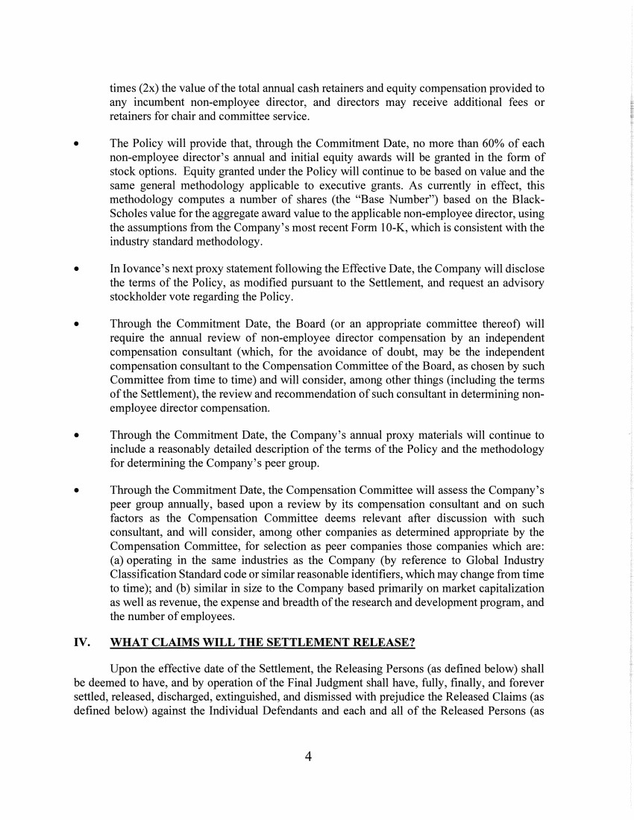 | times (2x) the value of the total annual cash retainers and equity compensation provided to any incumbent non-employee director, and directors may receive additional fees or retainers for chair and committee service. • The Policy will provide that, through the Commitment Date, no more than 60% of each non-employee director's annual and initial equity awards will be granted in the form of stock options. Equity granted under the Policy will continue to be based on value and the same general methodology applicable to executive grants. As currently in effect, this methodology computes a number of shares (the "Base Number") based on the Black-Scholes value for the aggregate award value to the applicable non-employee director, using the assumptions from the Company's most recent Form 10-K, which is consistent with the industry standard methodology. • In Iovance's next proxy statement following the Effective Date, the Company will disclose the terms of the Policy, as modified pursuant to the Settlement, and request an advisory stockholder vote regarding the Policy. • Through the Commitment Date, the Board ( or an appropriate committee thereof) will require the annual review of non-employee director compensation by an independent compensation consultant (which, for the avoidance of doubt, may be the independent compensation consultant to the Compensation Committee of the Board, as chosen by such Committee from time to time) and will consider, among other things (including the terms of the Settlement), the review and recommendation of such consultant in determining non-employee director compensation. • Through the Commitment Date, the Company's annual proxy materials will continue to include a reasonably detailed description of the terms of the Policy and the methodology for determining the Company's peer group. • Through the Commitment Date, the Compensation Committee will assess the Company's peer group annually, based upon a review by its compensation consultant and on such factors as the Compensation Committee deems relevant after discussion with such consultant, and will consider, among other companies as determined appropriate by the Compensation Committee, for selection as peer companies those companies which are: (a) operating in the same industries as the Company (by reference to Global Industry Classification Standard code or similar reasonable identifiers, which may change from time to time); and (b) similar in size to the Company based primarily on market capitalization as well as revenue, the expense and breadth of the research and development program, and the number of employees. IV. WHAT CLAIMS WILL THE SETTLEMENT RELEASE? Upon the effective date of the Settlement, the Releasing Persons (as defined below) shall be deemed to have, and by operation of the Final Judgment shall have, fully, finally, and forever settled, released, discharged, extinguished, and dismissed with prejudice the Released Claims ( as defined below) against the Individual Defendants and each and all of the Released Persons ( as 4
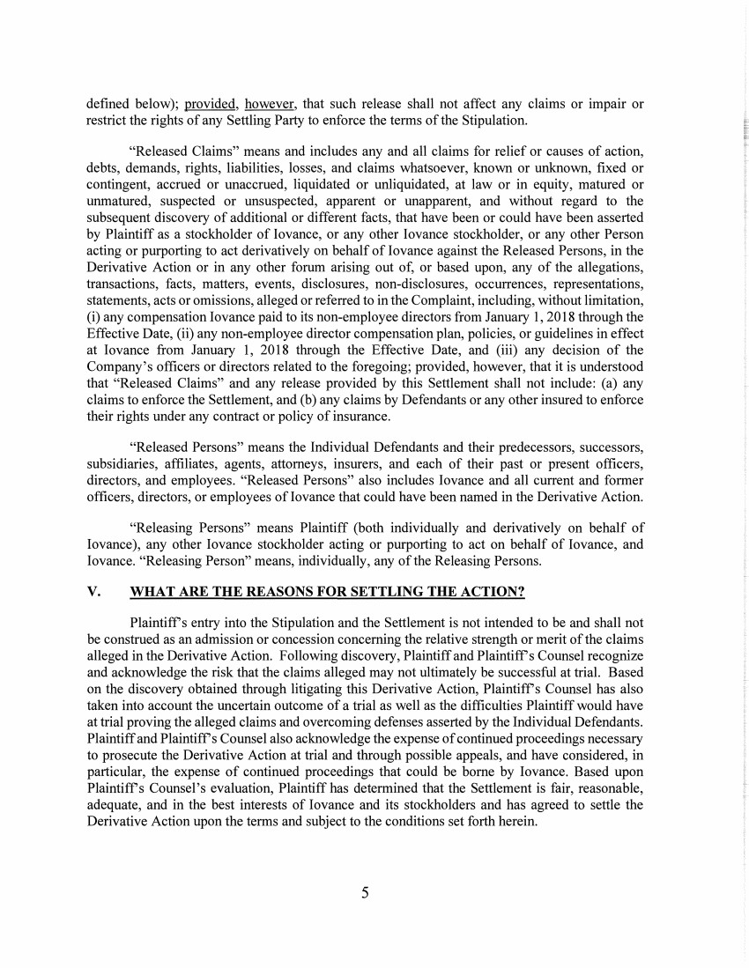 | defined below); provided, however, that such release shall not affect any claims or impair or restrict the rights of any Settling Party to enforce the terms of the Stipulation. "Released Claims" means and includes any and all claims for relief or causes of action, debts, demands, rights, liabilities, losses, and claims whatsoever, known or unknown, fixed or contingent, accrued or unaccrued, liquidated or unliquidated, at law or in equity, matured or unmatured, suspected or unsuspected, apparent or unapparent, and without regard to the subsequent discovery of additional or different facts, that have been or could have been asserted by Plaintiff as a stockholder of Iovance, or any other Iovance stockholder, or any other Person acting or purporting to act derivatively on behalf of Iovance against the Released Persons, in the Derivative Action or in any other forum arising out of, or based upon, any of the allegations, transactions, facts, matters, events, disclosures, non-disclosures, occurrences, representations, statements, acts or omissions, alleged or referred to in the Complaint, including, without limitation, (i) any compensation Iovance paid to its non-employee directors from January 1, 2018 through the Effective Date, (ii) any non-employee director compensation plan, policies, or guidelines in effect at Iovance from January 1, 2018 through the Effective Date, and (iii) any decision of the Company's officers or directors related to the foregoing; provided, however, that it is understood that "Released Claims" and any release provided by this Settlement shall not include: (a) any claims to enforce the Settlement, and (b) any claims by Defendants or any other insured to enforce their rights under any contract or policy of insurance. "Released Persons" means the Individual Defendants and their predecessors, successors, subsidiaries, affiliates, agents, attorneys, insurers, and each of their past or present officers, directors, and employees. "Released Persons" also includes Iovance and all current and former officers, directors, or employees of Iovance that could have been named in the Derivative Action. "Releasing Persons" means Plaintiff (both individually and derivatively on behalf of Iovance ), any other Iovance stockholder acting or purporting to act on behalf of Iovance, and Iovance. "Releasing Person" means, individually, any of the Releasing Persons. V. WHAT ARE THE REASONS FOR SETTLING THE ACTION? Plaintiffs entry into the Stipulation and the Settlement is not intended to be and shall not be construed as an admission or concession concerning the relative strength or merit of the claims alleged in the Derivative Action. Following discovery, Plaintiff and Plaintiffs Counsel recognize and acknowledge the risk that the claims alleged may not ultimately be successful at trial. Based on the discovery obtained through litigating this Derivative Action, Plaintiffs Counsel has also taken into account the uncertain outcome of a trial as well as the difficulties Plaintiff would have at trial proving the alleged claims and overcoming defenses asserted by the Individual Defendants. Plaintiff and Plaintiffs Counsel also acknowledge the expense of continued proceedings necessary to prosecute the Derivative Action at trial and through possible appeals, and have considered, in particular, the expense of continued proceedings that could be borne by Iovance. Based upon Plaintiffs Counsel's evaluation, Plaintiff has determined that the Settlement is fair, reasonable, adequate, and in the best interests of Iovance and its stockholders and has agreed to settle the Derivative Action upon the terms and subject to the conditions set forth herein. 5
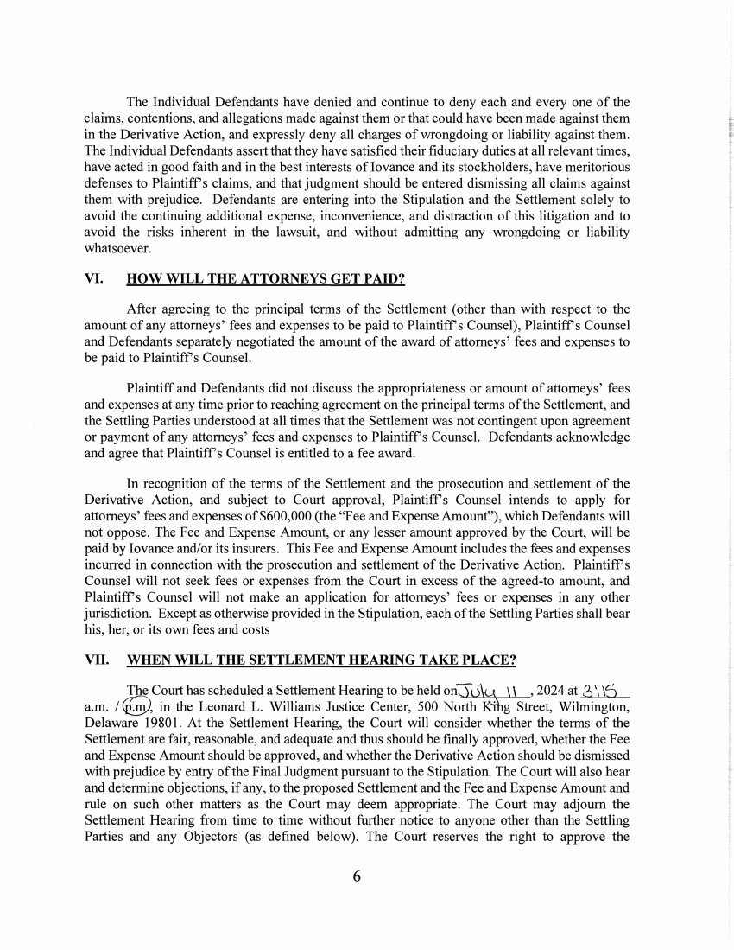 | The Individual Defendants have denied and continue to deny each and every one of the claims, contentions, and allegations made against them or that could have been made against them in the Derivative Action, and expressly deny all charges of wrongdoing or liability against them. The Individual Defendants assert that they have satisfied their fiduciary duties at all relevant times, have acted in good faith and in the best interests of Iovance and its stockholders, have meritorious defenses to Plaintiffs claims, and that judgment should be entered dismissing all claims against them with prejudice. Defendants are entering into the Stipulation and the Settlement solely to avoid the continuing additional expense, inconvenience, and distraction of this litigation and to avoid the risks inherent in the lawsuit, and without admitting any wrongdoing or liability whatsoever. VI. HOW WILL THE ATTORNEYS GET PAID? After agreeing to the principal terms of the Settlement ( other than with respect to the amount of any attorneys' fees and expenses to be paid to Plaintiffs Counsel), Plaintiffs Counsel and Defendants separately negotiated the amount of the award of attorneys' fees and expenses to be paid to Plaintiffs Counsel. Plaintiff and Defendants did not discuss the appropriateness or amount of attorneys' fees and expenses at any time prior to reaching agreement on the principal terms of the Settlement, and the Settling Parties understood at all times that the Settlement was not contingent upon agreement or payment of any attorneys' fees and expenses to Plaintiffs Counsel. Defendants acknowledge and agree that Plaintiffs Counsel is entitled to a fee award. In recognition of the terms of the Settlement and the prosecution and settlement of the Derivative Action, and subject to Court approval, Plaintiffs Counsel intends to apply for attorneys' fees and expenses of$600,000 (the "Fee and Expense Amount"), which Defendants will not oppose. The Fee and Expense Amount, or any lesser amount approved by the Court, will be paid by Iovance and/or its insurers. This Fee and Expense Amount includes the fees and expenses incurred in connection with the prosecution and settlement of the Derivative Action. Plaintiffs Counsel will not seek fees or expenses from the Court in excess of the agreed-to amount, and Plaintiffs Counsel will not make an application for attorneys' fees or expenses in any other jurisdiction. Except as otherwise provided in the Stipulation, each of the Settling Parties shall bear his, her, or its own fees and costs VII. WHEN WILL THE SETTLEMENT HEARING TAKE PLACE? The Court has scheduled a Settlement Hearing to be held on0u~ \ \ , 2024 at 2i ', J5 a.m. I~' in the Leonard L. Williams Justice Center, 500 North~ g Street, Wilmington, Delaware 19801. At the Settlement Hearing, the Court will consider whether the terms of the Settlement are fair, reasonable, and adequate and thus should be finally approved, whether the Fee and Expense Amount should be approved, and whether the Derivative Action should be dismissed with prejudice by entry of the Final Judgment pursuant to the Stipulation. The Court will also hear and determine objections, if any, to the proposed Settlement and the Fee and Expense Amount and rule on such other matters as the Court may deem appropriate. The Court may adjourn the Settlement Hearing from time to time without further notice to anyone other than the Settling Parties and any Objectors ( as defined below). The Court reserves the right to approve the 6
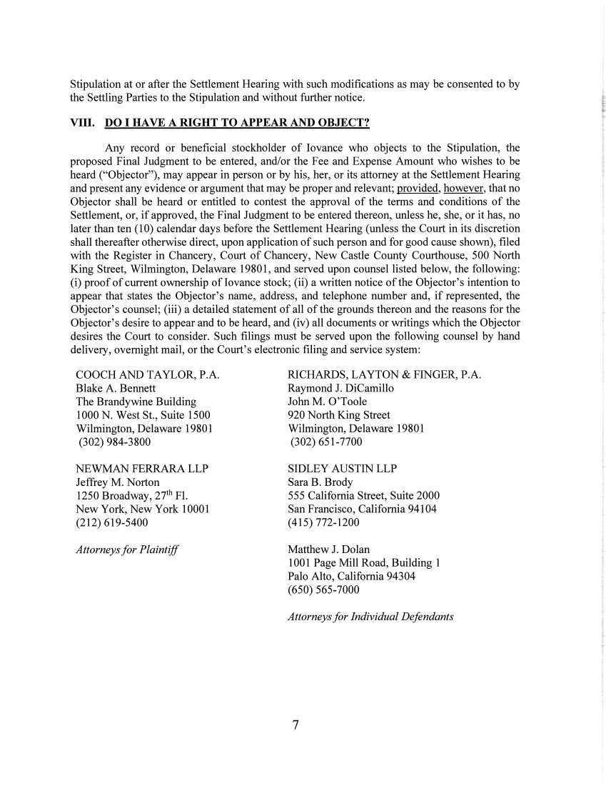 | Stipulation at or after the Settlement Hearing with such modifications as may be consented to by the Settling Parties to the Stipulation and without further notice. VIII. DO I HA VE A RIGHT TO APPEAR AND OBJECT? Any record or beneficial stockholder of Iovance who objects to the Stipulation, the proposed Final Judgment to be entered, and/or the Fee and Expense Amount who wishes to be heard ("Objector"), may appear in person or by his, her, or its attorney at the Settlement Hearing and present any evidence or argument that may be proper and relevant; provided, however, that no Objector shall be heard or entitled to contest the approval of the terms and conditions of the Settlement, or, if approved, the Final Judgment to be entered thereon, unless he, she, or it has, no later than ten (10) calendar days before the Settlement Hearing (unless the Court in its discretion shall thereafter otherwise direct, upon application of such person and for good cause shown), filed with the Register in Chancery, Court of Chancery, New Castle County Courthouse, 500 North King Street, Wilmington, Delaware 19801, and served upon counsel listed below, the following: (i) proof of current ownership oflovance stock; (ii) a written notice of the Objector's intention to appear that states the Objector's name, address, and telephone number and, if represented, the Objector's counsel; (iii) a detailed statement of all of the grounds thereon and the reasons for the Objector's desire to appear and to be heard, and (iv) all documents or writings which the Objector desires the Court to consider. Such filings must be served upon the following counsel by hand delivery, overnight mail, or the Court's electronic filing and service system: COOCH AND TAYLOR, P.A. Blake A. Bennett The Brandywine Building 1000 N. West St., Suite 1500 Wilmington, Delaware 19801 (302) 984-3800 NEWMANFERRARALLP Jeffrey M. Norton 1250 Broadway, 27th Fl. New York, New York 10001 (212) 619-5400 Attorneys for Plaintiff RICHARDS, LAYTON & FINGER, P.A. Raymond J. Dicamillo John M. O'Toole 920 North King Street Wilmington, Delaware 19801 (302) 651-7700 SIDLEY AUSTIN LLP Sara B. Brody 5 5 5 California Street, Suite 2000 San Francisco, California 94104 (415) 772-1200 Matthew J. Dolan 1001 Page Mill Road, Building 1 Palo Alto, California 94304 (650) 565-7000 Attorneys for Individual Defendants 7
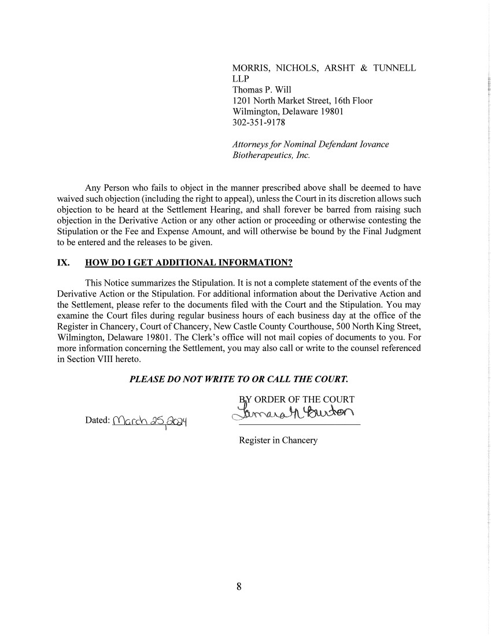 | MORRIS, NICHOLS, ARSHT & TUNNELL LLP Thomas P. Will 1201 North Market Street, 16th Floor Wilmington, Delaware 19801 302-351-9178 Attorneys for Nominal Defendant Iovance Biotherapeutics, Inc. Any Person who fails to object in the manner prescribed above shall be deemed to have waived such objection (including the right to appeal), unless the Court in its discretion allows such objection to be heard at the Settlement Hearing, and shall forever be barred from raising such objection in the Derivative Action or any other action or proceeding or otherwise contesting the Stipulation or the Fee and Expense Amount, and will otherwise be bound by the Final Judgment to be entered and the releases to be given. IX. HOW DO I GET ADDITIONAL INFORMATION? This Notice summarizes the Stipulation. It is not a complete statement of the events of the Derivative Action or the Stipulation. For additional information about the Derivative Action and the Settlement, please refer to the documents filed with the Court and the Stipulation. You may examine the Court files during regular business hours of each business day at the office of the Register in Chancery, Court of Chancery, New Castle County Courthouse, 500 North King Street, Wilmington, Delaware 19801. The Clerk's office will not mail copies of documents to you. For more information concerning the Settlement, you may also call or write to the counsel referenced in Section VIII hereto. PLEASE DO NOT WRITE TO OR CALL THE COURT. ~YORDER?:;HECOURT c:;o~~~ Register in Chancery 8

