UNITED STATES
SECURITIES AND EXCHANGE COMMISSION
Washington, D.C. 20549

FORM 8-K

Current Report

Pursuant to Section 13 or 15(d) of the Securities Exchange Act of 1934

Date of Report (date of earliest event reported): August 16, 2023

IOVANCE BIOTHERAPEUTICS, INC.
(Exact Name of Registrant as Specified in Charter)

Delaware
(State of Incorporation)
001-36860 |  | 75-3254381
Commission File Number |  | (I.R.S. Employer Identification No.)
825 Industrial Road, 4th Floor
San Carlos, California |  | 94070
(Address of Principal Executive Offices) |  | (Zip Code)
(650) 260-7120
(Registrant’s Telephone Number, Including Area Code)
Check the appropriate box below if the Form 8-K filing is intended to simultaneously satisfy the filing obligation of the registrant under any of the following provisions:

 | ☐ | Written communications pursuant to Rule 425 under the Securities Act (17 CFR 230.425).

 | ☐ | Soliciting material pursuant to Rule 14a-12 under the Exchange Act (17 CFR 240.14a-12).

 | ☐ | Pre-commencement communications pursuant to Rule 14d-2(b) under the Exchange Act (17 CFR 240.14d-2(b)).

 | ☐ | Pre-commencement communications pursuant to Rule 13e-4(c) under the Exchange Act (17 CFR 240.13e-4(c)).

Indicate by check mark whether the registrant is an emerging growth company as defined in as defined in Rule 405 of the Securities Act of 1933 (§230.405 of this chapter) or Rule 12b-2 of the Securities Exchange Act of 1934 (§240.12b-2 of this chapter). Emerging growth company ☐

If an emerging growth company, indicate by check mark if the registrant has elected not to use the extended transition period for complying with any new or revised financial accounting standards provided pursuant to Section 13(a) of the Exchange Act. ☐

Securities registered pursuant to Section 12(b) of the Act:

Title of each class | Trading  Symbol(s) | Name of each exchange on which  registered
Common stock, par value $0.000041666 per share | IOVA | The Nasdaq Stock Market, LLC

Item 7.01. | Regulation FD Disclosure.

On August 16, 2023, Iovance Biotherapeutics, Inc. (the “Company”) announced that the International Association for the Study of Lung Cancer (“IASLC”) inadvertently posted the following presentation (the “presentation”) on the IASLC’s 2023 World Conference on Lung Cancer website on the morning of August 16, 2023:

 | • | “Multicenter Phase II Trial Of LN-145 TIL Cell Therapy Plus Pembrolizumab in Patients With ICI-Naïve Metastatic NSCLC”

Such posting by IASLC, ahead of the Company’s planned disclosure in connection with the conference, was not authorized by the Company. In response to such unauthorized posting by IASLC, the Company immediately made the presentation available on its website on August 16, 2023. The presentation is attached as Exhibit 99.1 hereto and incorporated herein by reference.

The information furnished under this Item 7.01, including the accompanying Exhibit 99.1, shall not be deemed to be “filed” for the purposes of Section 18 of the Securities Exchange Act of 1934 (the “Exchange Act”), or otherwise subject to the liability of such section, nor shall such information be deemed to be incorporated by reference in any subsequent filing by the Company under the Securities Act of 1933, as amended, or the Exchange Act, regardless of the general incorporation language of such filing, except as specifically stated in such filing.

Item 8.01 | Other Events.

On August 16, 2023, the Company updated its corporate presentation that it uses for presentations at healthcare conferences and to analysts, current stockholders, and others. A copy of the Company’s presentation that it intends to use at such events is attached as Exhibit 99.2 and incorporated herein by reference.

Item 9.01. | Financial Statements and Exhibits.

(d) Exhibits.

Exhibit  No. |  | Description
99.1 |  | Presentation titled “Multicenter Phase II Trial Of LN-145 TIL Cell Therapy Plus Pembrolizumab in Patients With ICI-Naïve Metastatic NSCL”
99.2 |  | Iovance Biotherapeutics, Inc., Corporate Presentation - August 2023
104 |  | Cover Page Interactive Data File (embedded as Inline XBRL document)

SIGNATURES

Pursuant to the requirements of the Securities Exchange Act of 1934, the Registrant has duly caused this Report to be signed on its behalf by the undersigned hereunto duly authorized.

Date: August 18, 2023 | IOVANCE BIOTHERAPEUTICS, INC.
 | By: | /s/ Frederick G. Vogt
 |  | Frederick G. Vogt, Interim CEO & General Counsel

Exhibit 99.1

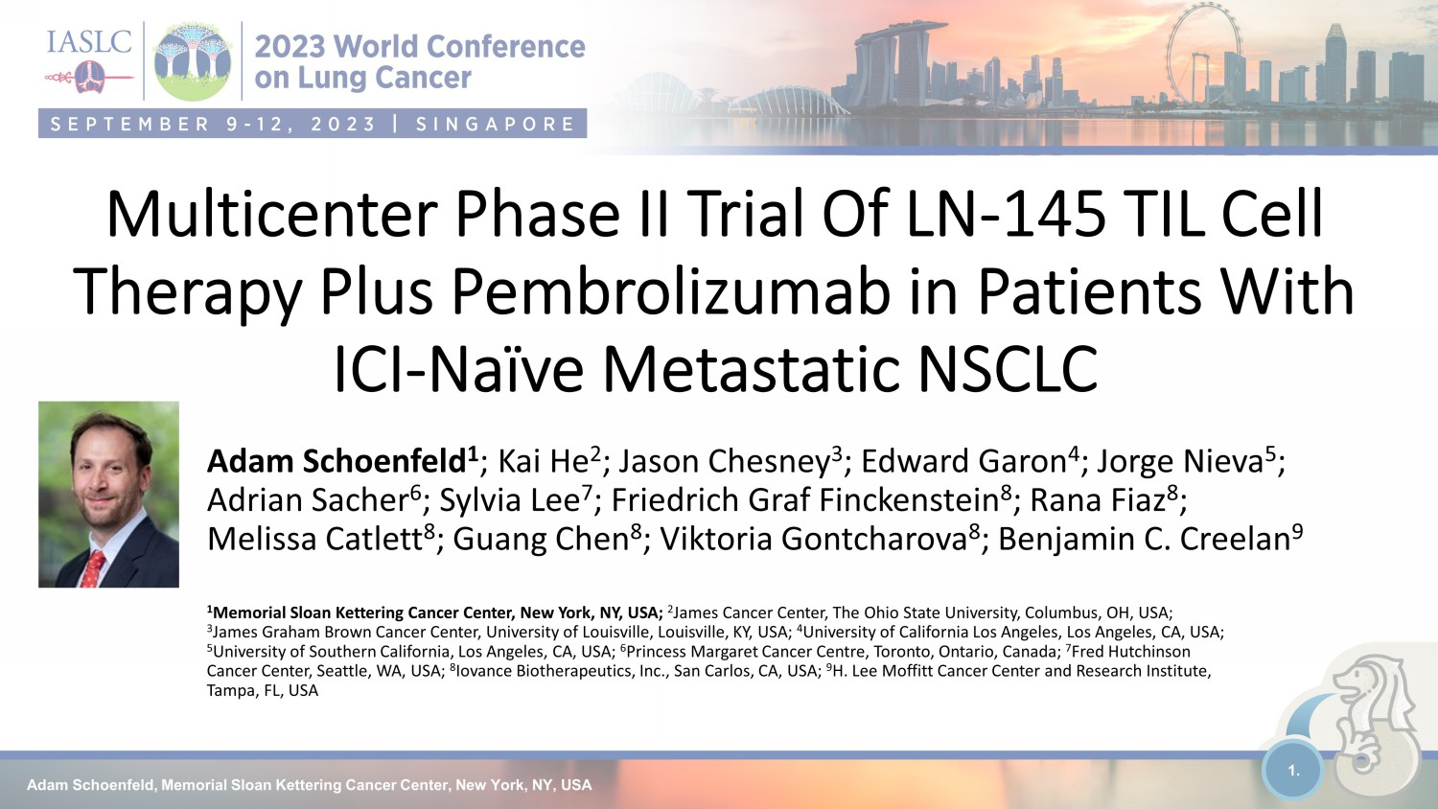
Adam Schoenfeld, Memorial Sloan Kettering Cancer Center, New York, NY, USA 1. Multicenter Phase II Trial Of LN - 145 TIL Cell Therapy Plus Pembrolizumab in Patients With ICI - Naïve Metastatic NSCLC Adam Schoenfeld 1 ; Kai He 2 ; Jason Chesney 3 ; Edward Garon 4 ; Jorge Nieva 5 ; Adrian Sacher 6 ; Sylvia Lee 7 ; Friedrich Graf Finckenstein 8 ; Rana Fiaz 8 ; Melissa Catlett 8 ; Guang Chen 8 ; Viktoria Gontcharova 8 ; Benjamin C. Creelan 9 1 Memorial Sloan Kettering Cancer Center, New York, NY, USA; 2 James Cancer Center, The Ohio State University, Columbus, OH, USA; 3 James Graham Brown Cancer Center, University of Louisville, Louisville, KY, USA; 4 University of California Los Angeles, Los Angeles, CA, USA; 5 University of Southern California, Los Angeles, CA, USA; 6 Princess Margaret Cancer Centre, Toronto, Ontario , Canada; 7 Fred Hutchinson Cancer Center, Seattle, WA , USA; 8 Iovance Biotherapeutics, Inc., San Carlos, CA, USA; 9 H. Lee Moffitt Cancer Center and Research Institute, Tampa, FL, USA

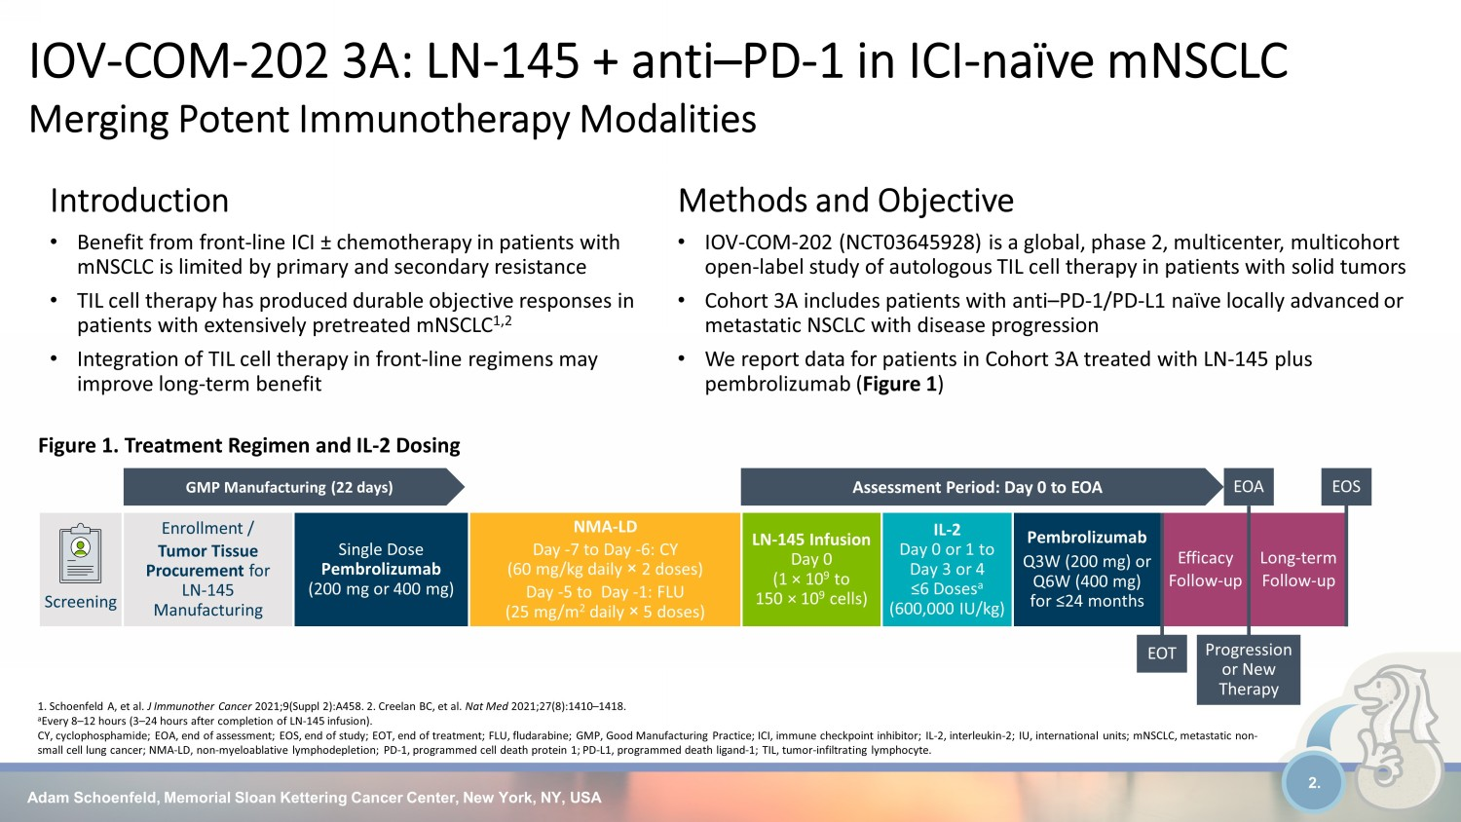
Adam Schoenfeld, Memorial Sloan Kettering Cancer Center, New York, NY, USA 2. IOV - COM - 202 3A: LN - 145 + anti – PD - 1 in ICI - naïve mNSCLC Merging Potent Immunotherapy Modalities 1. Schoenfeld A, et al. J Immunother Cancer 2021;9(Suppl 2):A458. 2. Creelan BC, et al. Nat Med 2021;27(8):1410 – 1418. a Every 8 – 12 hours (3 – 24 hours after completion of LN - 145 infusion). CY, cyclophosphamide; EOA, end of assessment; EOS, end of study; EOT, end of treatment; FLU, fludarabine; GMP, Good Manufactu rin g Practice; ICI, immune checkpoint inhibitor; IL - 2, interleukin - 2; IU, international units; mNSCLC, metastatic non - small cell lung cancer; NMA - LD, non - myeloablative lymphodepletion; PD - 1, programmed cell death protein 1; PD - L1, programmed deat h ligand - 1; TIL, tumor - infiltrating lymphocyte. Screening Enrollment / Tumor Tissue Procurement for LN-145 Manufacturing Single Dose Pembrolizumab (200 mg or 400 mg) NMA - LD Day - 7 to Day - 6: CY (60 mg/kg daily î 2 doses) Day - 5 to Day - 1: FLU (25 mg/m 2 daily î 5 doses) LN - 145 Infusion Day 0 (1 × 10 9 to 150 × 10 9 cells) IL - 2 Day 0 or 1 to Day 3 or 4 ≤6 Doses a (600,000 IU/kg) Pembrolizumab Q3W (200 mg) or Q6W (400 mg) for ≤24 months Efficacy Follow - up Long - term Follow - up Figure 1. Treatment Regimen and IL - 2 Dosing Methods and Objective • IOV - COM - 202 (NCT03645928) is a global, phase 2, multicenter, multicohort open - label study of autologous TIL cell therapy in patients with solid tumors • Cohort 3A includes patients with anti – PD - 1/PD - L1 naïve locally advanced or metastatic NSCLC with disease progression • We report data for patients in Cohort 3A treated with LN - 145 plus pembrolizumab ( Figure 1 ) GMP Manufacturing (22 days) Assessment Period: Day 0 to EOA EOA EOT EOS Progression or New Therapy Introduction • Benefit from front - line ICI ± chemotherapy in patients with mNSCLC is limited by primary and secondary resistance • TIL cell therapy has produced durable objective responses in patients with extensively pretreated mNSCLC 1,2 • Integration of TIL cell therapy in front - line regimens may improve long - term benefit

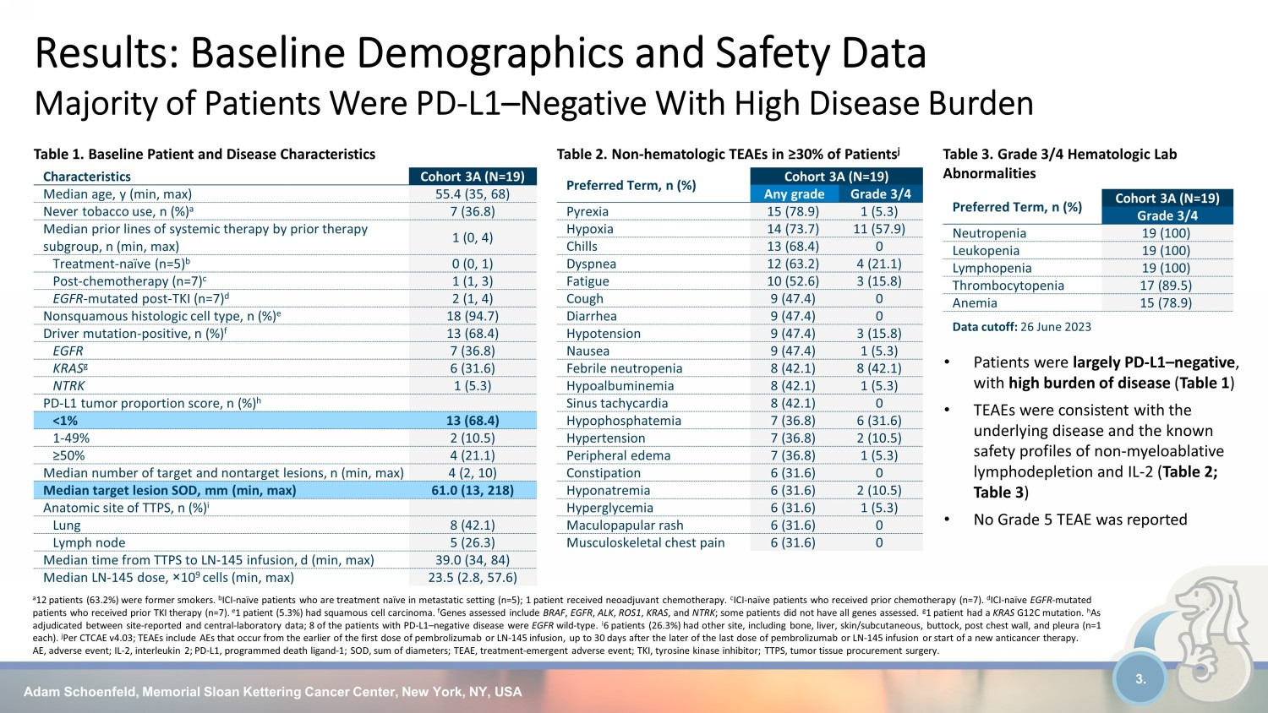
Adam Schoenfeld, Memorial Sloan Kettering Cancer Center, New York, NY, USA 3. Characteristics Cohort 3A (N=19) Median age, y (min, max) 55.4 (35, 68) Never tobacco use, n (%) a 7 (36.8) Median prior lines of systemic therapy by prior therapy subgroup, n (min, max) 1 (0, 4) Treatment - naïve (n=5) b 0 (0, 1) Post - chemotherapy (n=7) c 1 (1, 3) EGFR - mutated post - TKI (n=7) d 2 (1, 4) Nonsquamous histologic cell type, n (%) e 18 (94.7) Driver mutation - positive, n (%) f 13 (68.4) EGFR 7 (36.8) KRAS g 6 (31.6) NTRK 1 (5.3) PD - L1 tumor proportion score, n (%) h <1% 13 (68.4) 1 - 49% 2 (10.5) ≥50% 4 (21.1) Median number of target and nontarget lesions, n (min, max) 4 (2, 10) Median target lesion SOD, mm (min, max) 61.0 (13, 218) Anatomic site of TTPS, n (%) i Lung 8 (42.1) Lymph node 5 (26.3) Median time from TTPS to LN - 145 infusion, d (min, max) 39.0 (34, 84) Median LN - 145 dose, î 10 9 cells (min, max) 23.5 (2.8, 57.6) Table 2. Non - hematologic TEAEs in ≥30% of Patients j Table 3. Grade 3/4 Hematologic Lab Abnormalities Data cutoff: 26 June 2023 • Patients were largely PD - L1 – negative , with high burden of disease ( Table 1 ) • TEAEs were consistent with the underlying disease and the known safety profiles of non - myeloablative lymphodepletion and IL - 2 ( Table 2; Table 3 ) • No Grade 5 TEAE was reported Preferred Term, n (%) Cohort 3A (N=19) Any grade Grade 3/4 Pyrexia 15 (78.9) 1 (5.3) Hypoxia 14 (73.7) 11 (57.9) Chills 13 (68.4) 0 Dyspnea 12 (63.2) 4 (21.1) Fatigue 10 (52.6) 3 (15.8) Cough 9 (47.4) 0 Diarrhea 9 (47.4) 0 Hypotension 9 (47.4) 3 (15.8) Nausea 9 (47.4) 1 (5.3) Febrile neutropenia 8 (42.1) 8 (42.1) Hypoalbuminemia 8 (42.1) 1 (5.3) Sinus tachycardia 8 (42.1) 0 Hypophosphatemia 7 (36.8) 6 (31.6) Hypertension 7 (36.8) 2 (10.5) Peripheral edema 7 (36.8) 1 (5.3) Constipation 6 (31.6) 0 Hyponatremia 6 (31.6) 2 (10.5) Hyperglycemia 6 (31.6) 1 (5.3) Maculopapular rash 6 (31.6) 0 Musculoskeletal chest pain 6 (31.6) 0 Table 1. Baseline Patient and Disease Characteristics Preferred Term, n (%) Cohort 3A (N=19) Grade 3/4 Neutropenia 19 (100) Leukopenia 19 (100) Lymphopenia 19 (100) Thrombocytopenia 17 (89.5) Anemia 15 (78.9) Results: Baseline Demographics and Safety Data Majority of Patients Were PD - L1 – Negative With High Disease Burden a 12 patients (63.2%) were former smokers. b ICI - naïve patients who are treatment naïve in metastatic setting (n=5); 1 patient received neoadjuvant chemotherapy. c ICI - naïve patients who received prior chemotherapy (n=7). d ICI - naïve EGFR - mutated patients who received prior TKI therapy (n=7). e 1 patient (5.3%) had squamous cell carcinoma. f Genes assessed include BRAF , EGFR , ALK , ROS1 , KRAS , and NTRK ; some patients did not have all genes assessed. g 1 patient had a KRAS G12C mutation. h As adjudicated between site - reported and central - laboratory data; 8 of the patients with PD - L1 – negative disease were EGFR wild - type. i 6 patients (26.3%) had other site, including bone, liver, skin/subcutaneous, buttock, post chest wall, and pleura (n=1 each). j Per CTCAE v4.03; TEAEs include AEs that occur from the earlier of the first dose of pembrolizumab or LN - 145 infusion, up to 30 days after the later of the last dose of pembrolizumab or LN - 145 infusion or start of a new anticancer therapy. AE, adverse event; IL - 2, interleukin 2; PD - L1, programmed death ligand - 1; SOD, sum of diameters; TEAE, treatment - emergent advers e event; TKI, tyrosine kinase inhibitor; TTPS, tumor tissue procurement surgery.

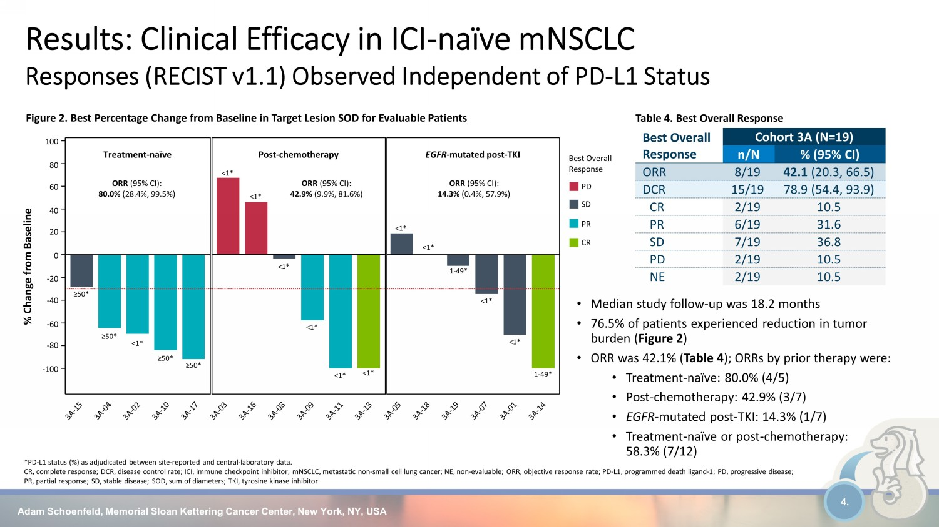
Adam Schoenfeld, Memorial Sloan Kettering Cancer Center, New York, NY, USA 4. • Median study follow - up was 18.2 months • 76.5% of patients experienced reduction in tumor burden ( Figure 2 ) • ORR was 42.1% ( Table 4 ); ORRs by prior therapy were: • Treatment - naïve: 80.0% (4/5) • Post - chemotherapy: 42.9% (3/7) • EGFR - mutated post - TKI: 14.3% (1/7) • Treatment - naïve or post - chemotherapy: 58.3% (7/12) Best Overall Response Cohort 3A (N=19) n/N % (95% CI) ORR 8/19 42.1 (20.3, 66.5) DCR 15/19 78.9 (54.4, 93.9) CR 2/19 10.5 PR 6/19 31.6 SD 7/19 36.8 PD 2/19 10.5 NE 2/19 10.5 Table 4. Best Overall Response Results: Clinical Efficacy in ICI - naïve mNSCLC Responses (RECIST v1.1) Observed Independent of PD - L1 Status *PD - L1 status (%) as adjudicated between site - reported and central - laboratory data. CR, complete response; DCR, disease control rate; ICI, immune checkpoint inhibitor; mNSCLC , metastatic non - small cell lung cancer; NE, non - evaluable; ORR, objective response rate; PD - L1, programmed death ligand - 1; PD, progressive disease; PR, partial response; SD, stable disease; SOD, sum of diameters; TKI, tyrosine kinase inhibitor. Figure 2. Best Percentage Change from Baseline in Target Lesion SOD for Evaluable Patients ORR (95% CI): 80.0% (28.4%, 99.5%) ORR (95% CI): 14.3% (0.4%, 57.9%) 100 80 60 40 20 0 - 20 - 40 - 60 - 80 - 100 Treatment - naïve Post - chemotherapy EGFR - mutated post - TKI ≥50* ≥50* <1* ≥50* ≥50* <1* <1* <1* <1* <1* <1* <1* <1* 1 - 49* <1* <1* 1 - 49* % Change from Baseline Best Overall Response PD PR SD CR ORR (95% CI): 42.9% (9.9%, 81.6%)

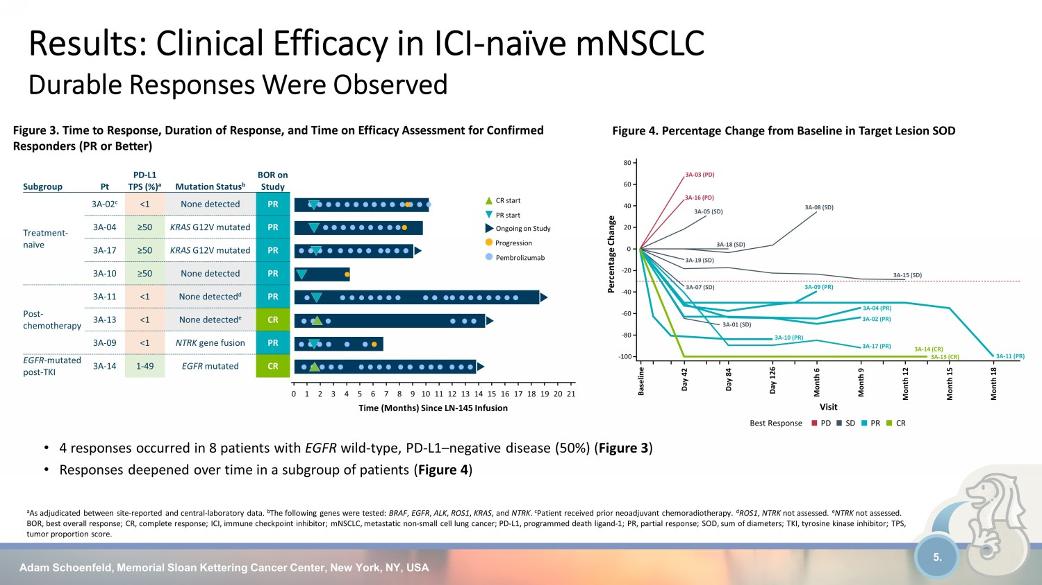
Adam Schoenfeld, Memorial Sloan Kettering Cancer Center, New York, NY, USA 5. Results: Clinical Efficacy in ICI - naïve mNSCLC Durable Responses Were Observed a As adjudicated between site - reported and central - laboratory data. b The following genes were tested: BRAF , EGFR , ALK , ROS1 , KRAS , and NTRK . c Patient received prior neoadjuvant chemoradiotherapy. d ROS1 , NTRK not assessed. e NTRK not assessed. BOR, best overall response; CR, complete response; ICI, immune checkpoint inhibitor; mNSCLC, metastatic non - small cell lung canc er; PD - L1, programmed death ligand - 1; PR, partial response; SOD, sum of diameters; TKI, tyrosine kinase inhibitor; TPS, tumor proportion score. Figure 3. Time to Response, Duration of Response, and Time on Efficacy Assessment for Confirmed Responders (PR or Better) • 4 responses occurred in 8 patients with EGFR wild - type, PD - L1 – negative disease (50%) ( Figure 3 ) • Responses deepened over time in a subgroup of patients ( Figure 4 ) Figure 4. Percentage Change from Baseline in Target Lesion SOD CR PR SD PD 3A - 16 (PD) 3A - 03 (PD) 3A - 15 (SD) 3A - 19 (SD) 3A - 18 (SD) 3A - 05 (SD) 3A - 07 (SD) 3A - 08 (SD) 3A - 01 (SD) 3A - 04 (PR) 3A - 11 (PR) 3A - 17 (PR) 3A - 02 (PR) 3A - 10 (PR) 3A - 09 (PR) 3A - 14 (CR) 3A - 13 (CR) Baseline Day 42 Day 84 Day 126 Month 6 Month 9 Month 12 Month 15 Month 18 Visit - 100 - 80 - 60 - 40 - 20 0 20 40 60 80 Percentage Change Best Response Subgroup Pt PD - L1 TPS (%) a Mutation Status b BOR on Study Treatment - naïve 3A - 02 c <1 None detected PR 3A - 04 ≥50 KRAS G12V mutated PR 3A - 17 ≥50 KRAS G12V mutated PR 3A - 10 ≥50 None detected PR Post - chemotherapy 3A - 11 <1 None detected d PR 3A - 13 <1 None detected e CR 3A - 09 <1 NTRK gene fusion PR EGFR - mutated post - TKI 3A - 14 1 - 49 EGFR mutated CR 0 Time (Months) Since LN - 145 Infusion 1 2 3 4 5 6 7 8 9 10 11 12 13 14 15 16 17 18 19 20 21 Ongoing on Study CR start PR start Progression Pembrolizumab

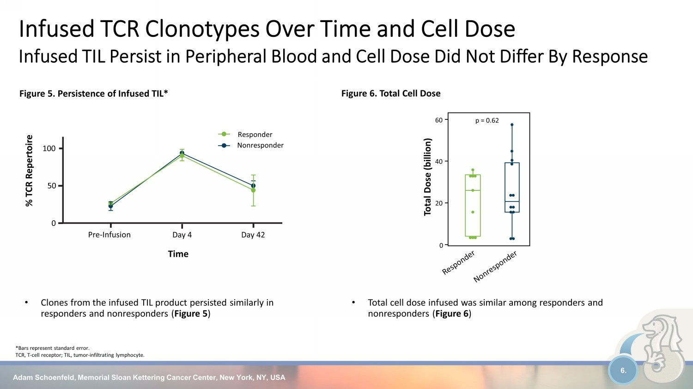
Adam Schoenfeld, Memorial Sloan Kettering Cancer Center, New York, NY, USA 6. • Clones from the infused TIL product persisted similarly in responders and nonresponders ( Figure 5 ) * Bars represent standard error. TCR, T - cell receptor; TIL, tumor - infiltrating lymphocyte. Figure 5. Persistence of Infused TIL* Infused TCR Clonotypes Over Time and Cell Dose Infused TIL Persist in Peripheral Blood and Cell Dose Did Not Differ By Response • Total cell dose infused was similar among responders and nonresponders ( Figure 6 ) Figure 6. Total Cell Dose Time % TCR Repertoire Pre - Infusion Day 4 0 50 100 Day 42 Nonresponder Responder Total Dose (billion) 0 20 40 60 p = 0.62

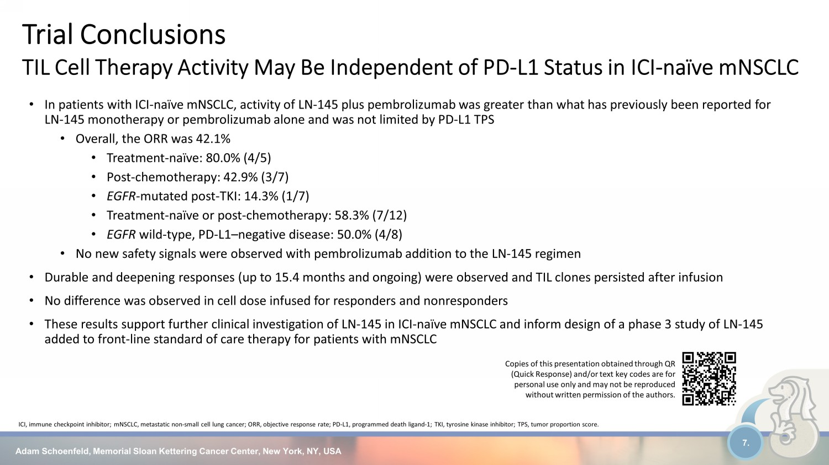
• In patients with ICI - naïve mNSCLC, activity of LN - 145 plus pembrolizumab was greater than what has previously been reported for LN-145 monotherapy or pembrolizumab alone and was not limited by PD - L1 TPS • Overall, the ORR was 42.1% • Treatment - naïve: 80.0% (4/5) • Post - chemotherapy: 42.9% (3/7) • EGFR - mutated post - TKI: 14.3% (1/7) • Treatment - naïve or post - chemotherapy: 58.3% (7/12) • EGFR wild - type, PD - L1 – negative disease: 50.0% (4/8) • No new safety signals were observed with pembrolizumab addition to the LN-145 regimen • Durable and deepening responses (up to 15.4 months and ongoing) were observed and TIL clones persisted after infusion • No difference was observed in cell dose infused for responders and nonresponders • These results support further clinical investigation of LN - 145 in ICI - naïve mNSCLC and inform design of a phase 3 study of LN - 14 5 added to front - line standard of care therapy for patients with mNSCLC Adam Schoenfeld, Memorial Sloan Kettering Cancer Center, New York, NY, USA 7. ICI, immune checkpoint inhibitor; mNSCLC, metastatic non - small cell lung cancer; ORR, objective response rate; PD - L1, programmed death ligand - 1; TKI, tyrosine kinase inhibitor; TPS, tumor proportion score. Trial Conclusions TIL Cell Therapy Activity May Be Independent of PD - L1 Status in ICI - naïve mNSCLC Copies of this presentation obtained through QR (Quick Response) and/or text key codes are for personal use only and may not be reproduced without written permission of the authors.

Exhibit 99.2


1 © 2023, Iovance Biotherapeutics, Inc. © 2023, Iovance Biotherapeutics, Inc. Corporate Overview August 16, 2023 1

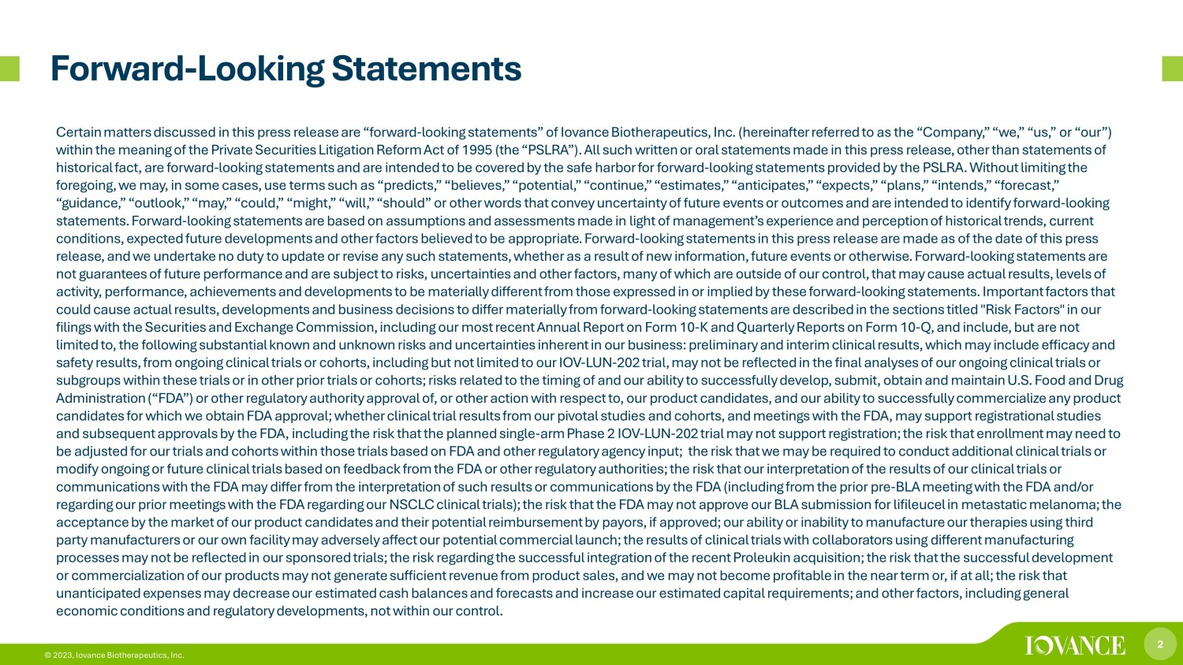
2 © 2023, Iovance Biotherapeutics, Inc. Forward - Looking Statements Certain matters discussed in this press release are “forward - looking statements” of Iovance Biotherapeutics, Inc. (hereinafter r eferred to as the “Company,” “we,” “us,” or “our”) within the meaning of the Private Securities Litigation Reform Act of 1995 (the “PSLRA”). All such written or oral statements ma de in this press release, other than statements of historical fact, are forward - looking statements and are intended to be covered by the safe harbor for forward - looking statements provided by the PSLRA. Without limiting the foregoing, we may, in some cases, use terms such as “predicts,” “believes,” “potential,” “continue,” “estimates,” “anticipate s,” “expects,” “plans,” “intends,” “forecast,” “guidance,” “outlook,” “may,” “could,” “might,” “will,” “should” or other words that convey uncertainty of future events or o utc omes and are intended to identify forward - looking statements. Forward - looking statements are based on assumptions and assessments made in light of management’s experience and perception of historical trends, current conditions, expected future developments and other factors believed to be appropriate. Forward - looking statements in this press release are made as of the date of this press release, and we undertake no duty to update or revise any such statements, whether as a result of new information, future eve nts or otherwise. Forward - looking statements are not guarantees of future performance and are subject to risks, uncertainties and other factors, many of which are outside of our control, that may cause actual results, levels of activity, performance, achievements and developments to be materially different from those expressed in or implied by these f orw ard - looking statements. Important factors that could cause actual results, developments and business decisions to differ materially from forward - looking statements are describ ed in the sections titled "Risk Factors" in our filings with the Securities and Exchange Commission, including our most recent Annual Report on Form 10 - K and Quarterly Reports on Form 10 - Q, and include, but are not limited to, the following substantial known and unknown risks and uncertainties inherent in our business: preliminary and int eri m clinical results, which may include efficacy and safety results, from ongoing clinical trials or cohorts, including but not limited to our IOV - LUN - 202 trial, may not be reflecte d in the final analyses of our ongoing clinical trials or subgroups within these trials or in other prior trials or cohorts; risks related to the timing of and our ability to successf ull y develop, submit, obtain and maintain U.S. Food and Drug Administration (“FDA”) or other regulatory authority approval of, or other action with respect to, our product candidates, an d o ur ability to successfully commercialize any product candidates for which we obtain FDA approval; whether clinical trial results from our pivotal studies and cohorts, and meeting s w ith the FDA, may support registrational studies and subsequent approvals by the FDA, including the risk that the planned single - arm Phase 2 IOV - LUN - 202 trial may not support re gistration; the risk that enrollment may need to be adjusted for our trials and cohorts within those trials based on FDA and other regulatory agency input; the risk that we may be required to conduct additional clinical trials or modify ongoing or future clinical trials based on feedback from the FDA or other regulatory authorities; the risk that our in ter pretation of the results of our clinical trials or communications with the FDA may differ from the interpretation of such results or communications by the FDA (including from t he prior pre - BLA meeting with the FDA and/or regarding our prior meetings with the FDA regarding our NSCLC clinical trials); the risk that the FDA may not approve our BLA su bmission for lifileucel in metastatic melanoma; the acceptance by the market of our product candidates and their potential reimbursement by payors, if approved; our ability or i nab ility to manufacture our therapies using third party manufacturers or our own facility may adversely affect our potential commercial launch; the results of clinical trials wit h collaborators using different manufacturing processes may not be reflected in our sponsored trials; the risk regarding the successful integration of the recent Proleukin ac quisition; the risk that the successful development or commercialization of our products may not generate sufficient revenue from product sales, and we may not become profitable in the near term or, if at all; the risk that unanticipated expenses may decrease our estimated cash balances and forecasts and increase our estimated capital requirements ; a nd other factors, including general economic conditions and regulatory developments, not within our control.

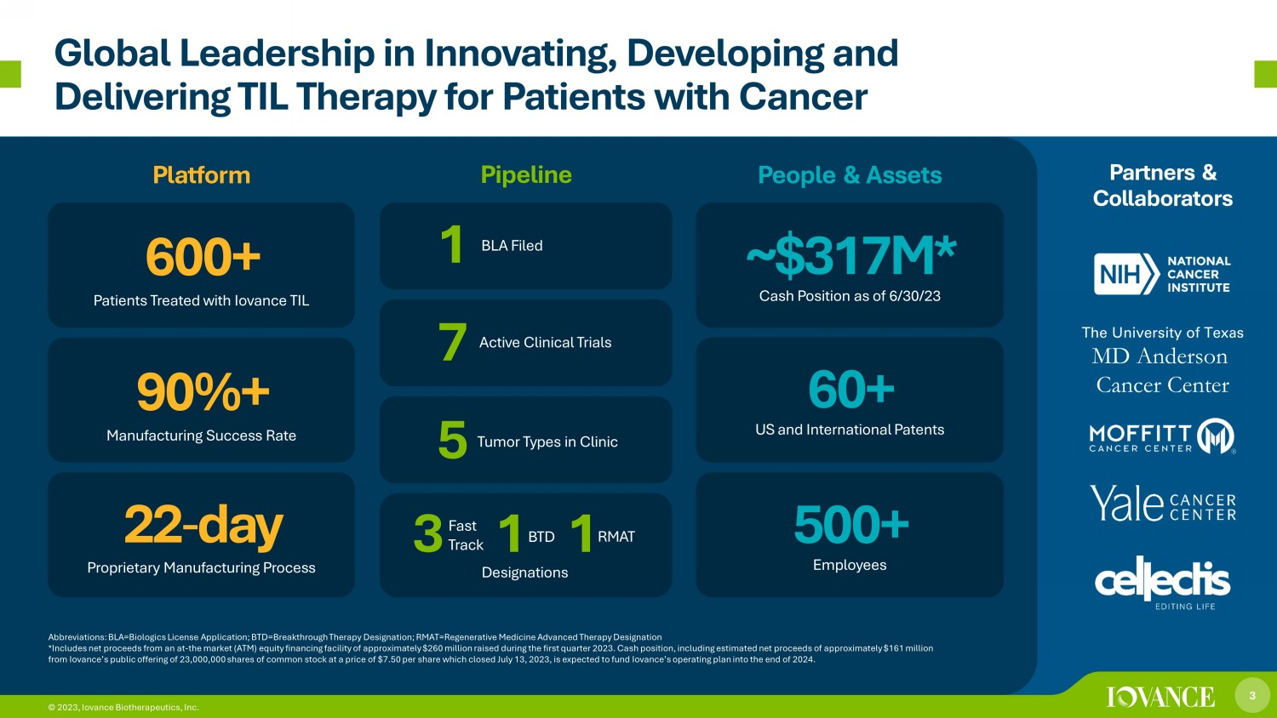
3 © 2023, Iovance Biotherapeutics, Inc. Global Leadership in Innovating, Developing and Delivering TIL Therapy for Patients with Cancer Platform Pipeline People & Assets Partners & Collaborators Abbreviations: BLA=Biologics License Application; BTD=Breakthrough Therapy Designation; RMAT=Regenerative Medicine Advanced T her apy Designation *Includes net proceeds from an at - the market (ATM) equity financing facility of approximately $260 million raised during the fir st quarter 2023. Cash position, including estimated net proceeds of approximately $161 million from Iovance’s public offering of 23,000,000 shares of common stock at a price of $7.50 per share which closed July 13, 2023, is expected to fund Iovance’s operating plan into the end of 2024. 22 - day Proprietary Manufacturing Process 90%+ Manufacturing Success Rate 600+ Patients Treated with Iovance TIL ~$317M* Cash Position as of 6/30/23 60+ US and International Patents 500+ Employees The University of Texas MD Anderson Cancer Center 3 © 2023, Iovance Biotherapeutics, Inc. 3 1 1 Designations Active Clinical Trials 7 Tumor Types in Clinic 5 BLA Filed Fast Track BTD RMAT 1

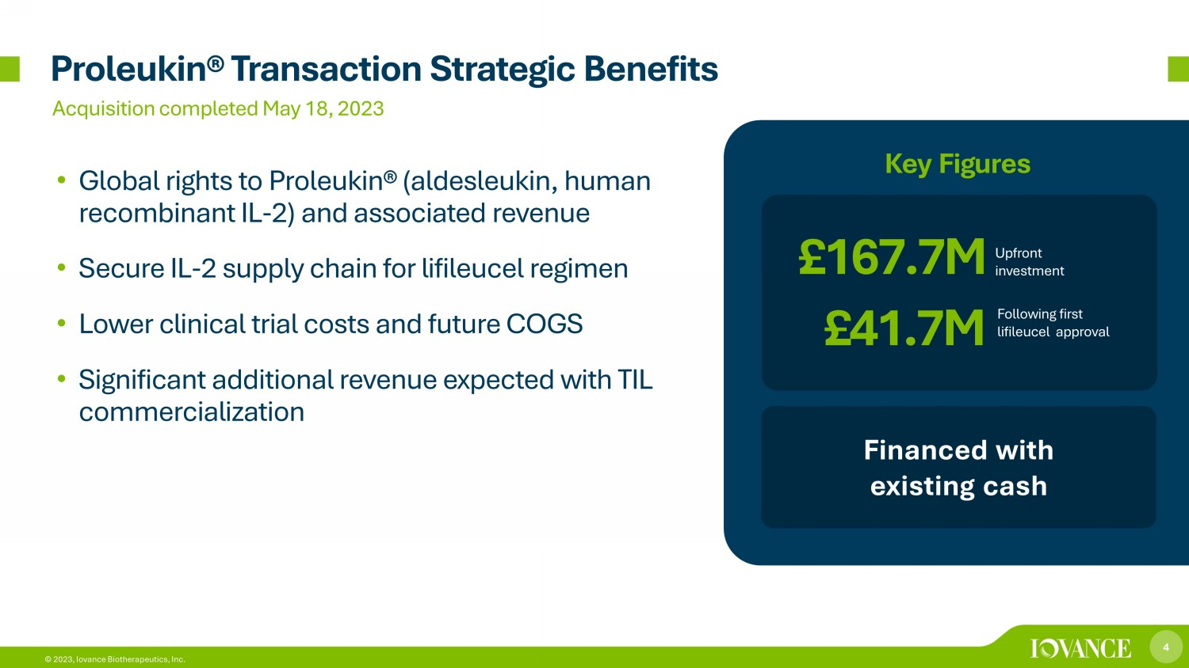
4 © 2023, Iovance Biotherapeutics, Inc. Proleukin ® Transaction Strategic Benefits • Global rights to Proleukin ® ( aldesleukin , human recombinant IL - 2) and associated revenue • Secure IL - 2 supply chain for lifileucel regimen • Lower clinical trial costs and future COGS • Significant additional revenue expected with TIL commercialization £167.7M Upfront investment Financed with existing cash Key Figures £41.7M Following first lifileucel approval Acquisition completed May 18, 2023

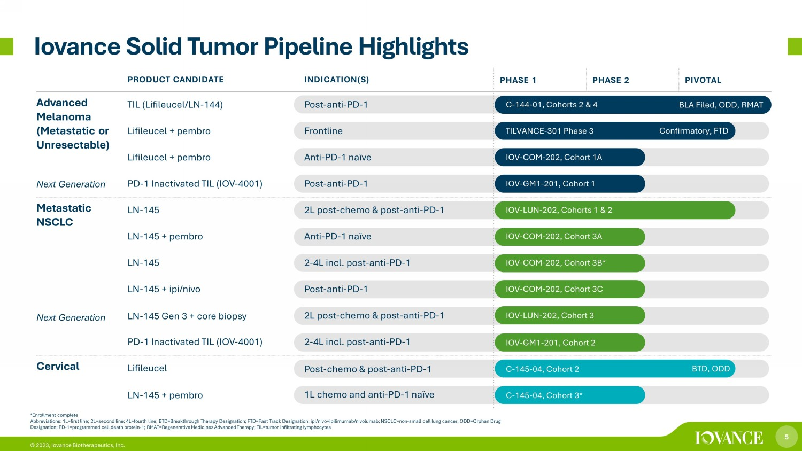
5 © 2023, Iovance Biotherapeutics, Inc. *Enrollment complete Abbreviations: 1L=first line; 2L=second line; 4L=fourth line; BTD=Breakthrough Therapy Designation; FTD=Fast Track Designatio n; ipi / nivo =ipilimumab/nivolumab; NSCLC=non - small cell lung cancer; ODD=Orphan Drug Designation; PD - 1=programmed cell death protein - 1; RMAT=Regenerative Medicines Advanced Therapy; TIL=tumor infiltrating lymphocy tes Iovance Solid Tumor Pipeline Highlights Confirmatory, FTD BLA Filed, ODD, RMAT BTD, ODD PRODUCT CANDIDATE INDICATION(S) PHASE 1 PHASE 2 PIVOTAL Advanced Melanoma (Metastatic or Unresectable) Next Generation TIL (Lifileucel/LN - 144) Post - anti - PD - 1 C - 144 - 01, Cohorts 2 & 4 Lifileucel + pembro Frontline TILVANCE - 301 Phase 3 Lifileucel + pembro Anti - PD - 1 naïve IOV - COM - 202, Cohort 1A PD - 1 Inactivated TIL (IOV - 4001) Post - anti - PD - 1 IOV - GM1 - 201, Cohort 1 Metastatic NSCLC Next Generation LN - 145 2L post - chemo & post - anti - PD - 1 IOV - LUN - 202, Cohorts 1 & 2 LN - 145 + pembro Anti - PD - 1 naïve IOV - COM - 202, Cohort 3A LN - 145 2 - 4L incl. post - anti - PD - 1 IOV - COM - 202, Cohort 3B* LN - 145 + ipi/nivo Post - anti - PD - 1 IOV - COM - 202, Cohort 3C LN - 145 Gen 3 + core biopsy 2L post - chemo & post - anti - PD - 1 IOV - LUN - 202, Cohort 3 PD - 1 Inactivated TIL (IOV - 4001) 2 - 4L incl. post - anti - PD - 1 IOV - GM1 - 201, Cohort 2 Cervical Lifileucel Post - chemo & post - anti - PD - 1 C - 145 - 04, Cohort 2 LN - 145 + pembro 1L chemo and anti - PD - 1 naïve C - 145 - 04, Cohort 3*

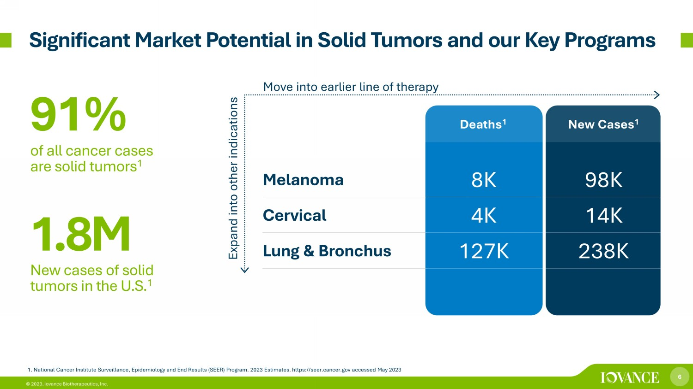
6 © 2023, Iovance Biotherapeutics, Inc. 1. National Cancer Institute Surveillance, Epidemiology and End Results (SEER) Program. 2023 Estimates. https://seer.cancer.g ov accessed May 2023 Deaths 1 New Cases 1 Melanoma 8K 98K Cervical 4K 14K Lung & Bronchus 127K 238K 91% of all cancer cases are solid tumors 1 1 .8 M New cases of solid tumors in the U.S. 1 Expand into other indications Move into earlier line of therapy Significant Market Potential in Solid Tumors and our Key Programs

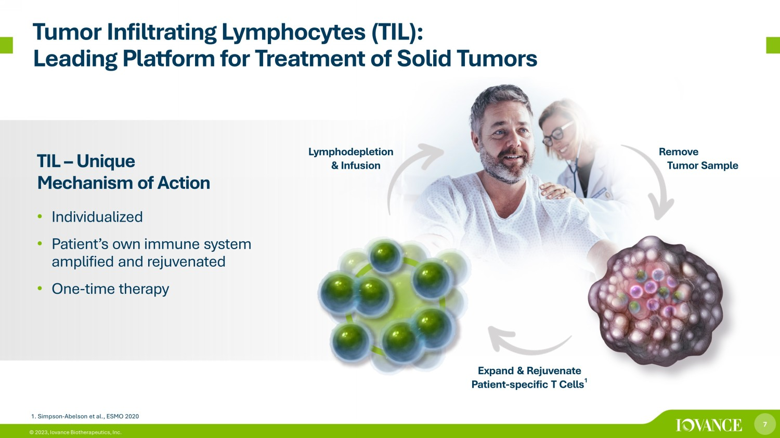
7 © 2023, Iovance Biotherapeutics, Inc. Tumor Infiltrating Lymphocytes (TIL): Leading Platform for Treatment of Solid Tumors TIL – Unique Mechanism of Action • Individualized • Patient’s own immune system amplified and rejuvenated • One - time therapy Remove Tumor Sample Expand & Rejuvenate Patient - specific T Cells 1 Lymphodepletion & Infusion 1. Simpson - Abelson et al., ESMO 2020

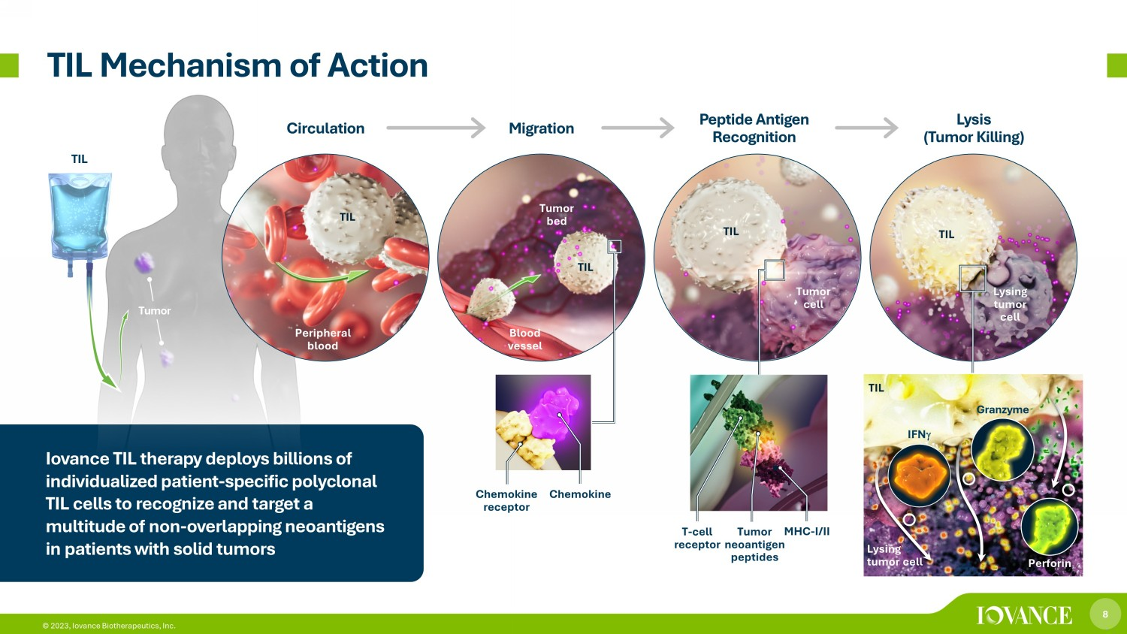
8 © 2023, Iovance Biotherapeutics, Inc. Tumor TIL Mechanism of Action TIL Peripheral blood Blood vessel Tumor cell TIL TIL Tumor bed TIL Lysing tumor cell T - cell receptor Tumor neoantigen peptides MHC - I/II Chemokine receptor Circulation Migration Peptide Antigen Recognition Lysis (Tumor Killing) Chemokine TIL IFN Granzyme Perforin TIL Iovance TIL therapy deploys billions of individualized patient - specific polyclonal TIL cells to recognize and target a multitude of non - overlapping neoantigens in patients with solid tumors Lysing tumor cell

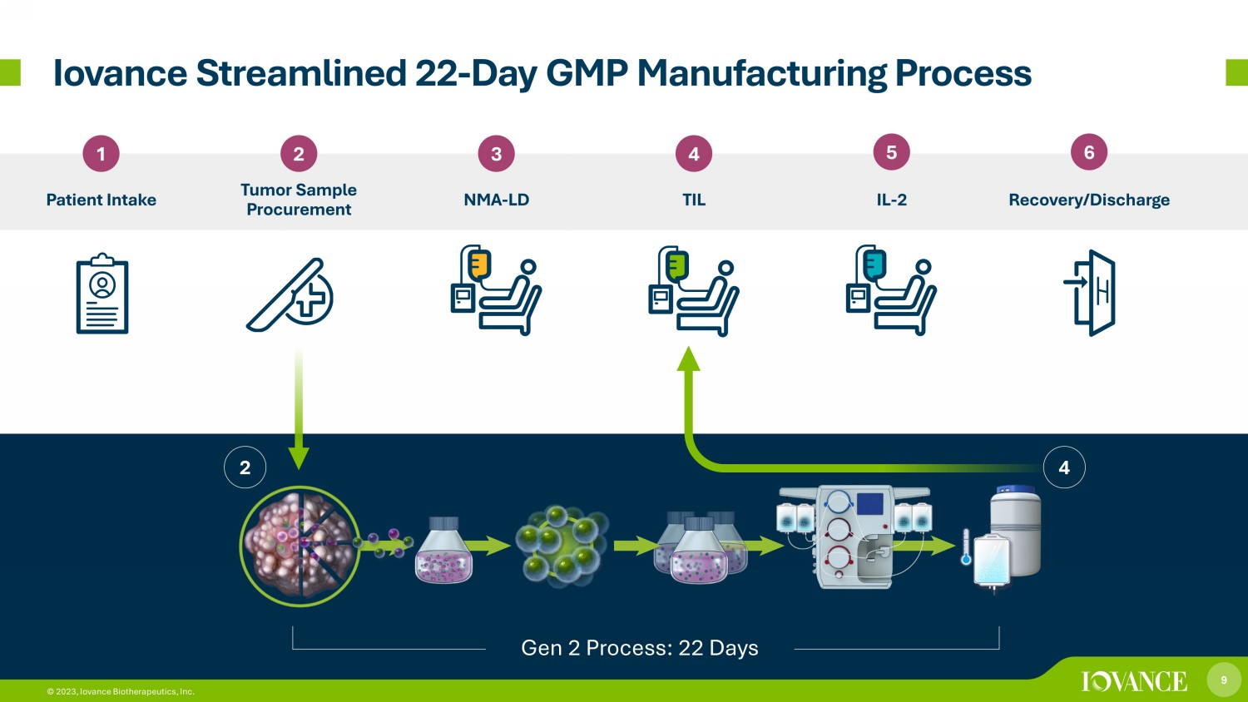
9 © 2023, Iovance Biotherapeutics, Inc. Iovance Streamlined 22 - Day GMP Manufacturing Process 1 2 Patient Intake Tumor Sample Procurement 3 4 NMA - LD TIL 5 6 IL - 2 Recovery/Discharge 4 2 Gen 2 Process: 22 Days 9 © 2023, Iovance Biotherapeutics, Inc.

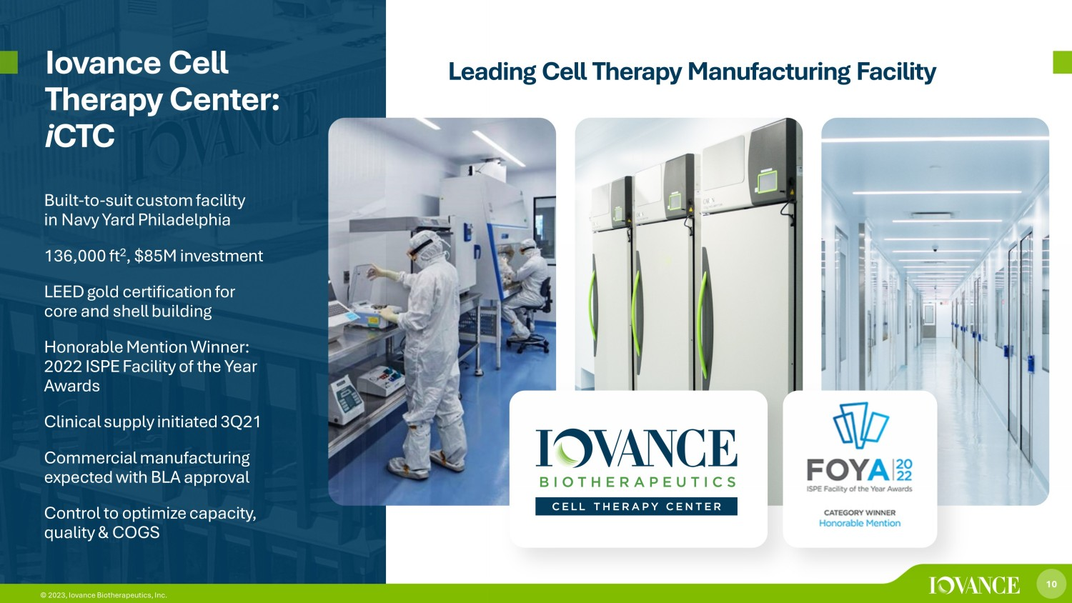
10 © 2023, Iovance Biotherapeutics, Inc. Iovance Cell Therapy Center: i CTC Built - to - suit custom facility in Navy Yard Philadelphia 136,000 ft 2 , $85M investment LEED gold certification for core and shell building Honorable Mention Winner: 2022 ISPE Facility of the Year Awards Clinical supply initiated 3Q21 Commercial manufacturing expected with BLA approval Control to optimize capacity, quality & COGS Leading Cell Therapy Manufacturing Facility

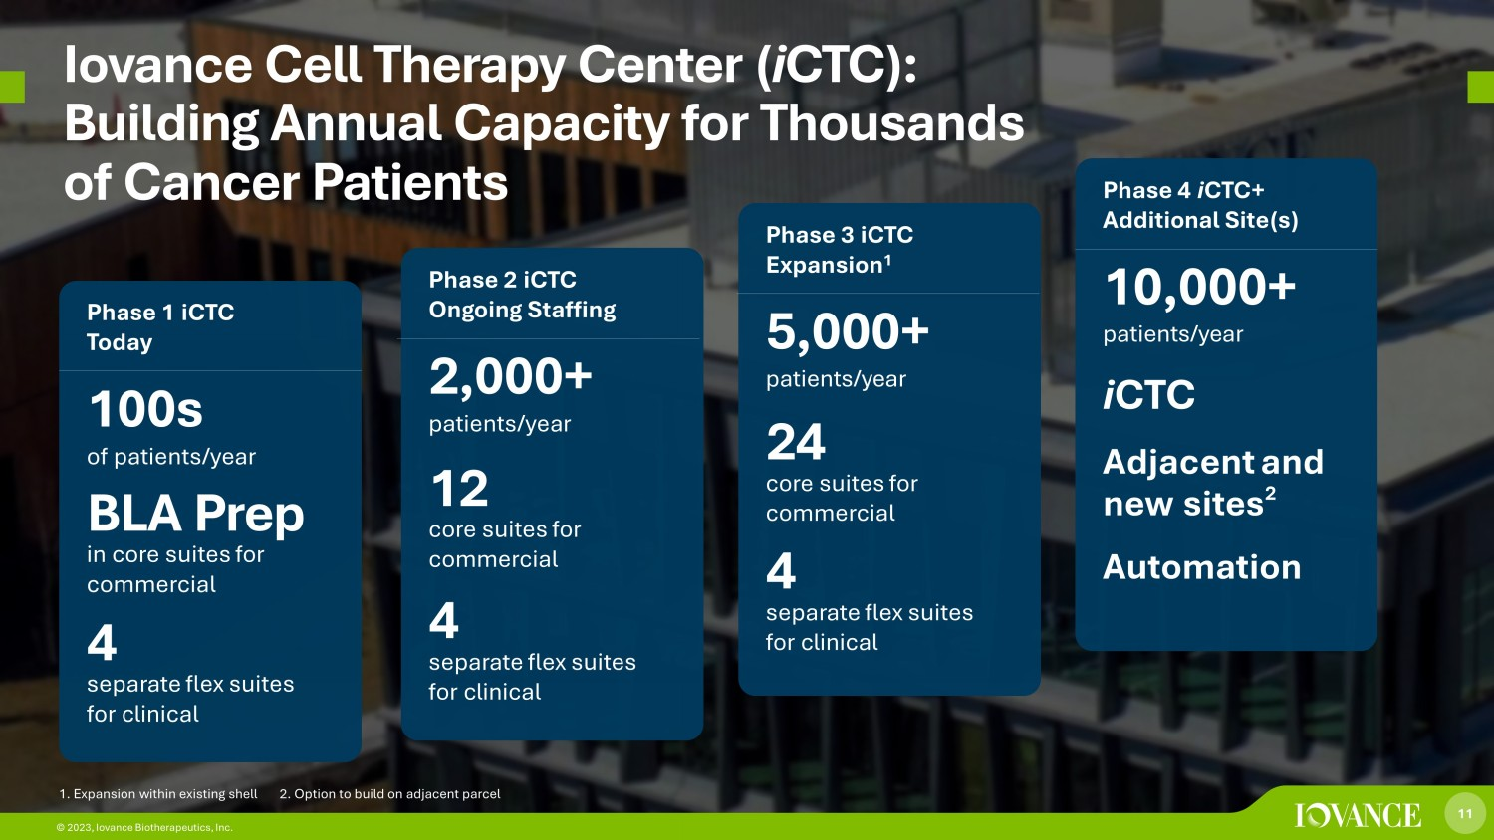
11 © 2023, Iovance Biotherapeutics, Inc. Iovance Cell Therapy Center ( i CTC ): Building Annual Capacity for Thousands of Cancer Patients Phase 1 iCTC Today 100s of patients/year BLA Prep in core suites for commercial 4 separate flex suites for clinical Phase 2 iCTC Ongoing Staffing 2,000+ patients/year 12 core suites for commercial 4 separate flex suites for clinical Phase 3 iCTC Expansion 1 5,000+ patients/year 24 core suites for commercial 4 separate flex suites for clinical Phase 4 i CTC + Additional Site(s) 10,000+ patients/year i CTC Adjacent and new sites 2 Automation 11 © 2023, Iovance Biotherapeutics, Inc. 1. Expansion within existing shell 2. Option to build on adjacent parcel

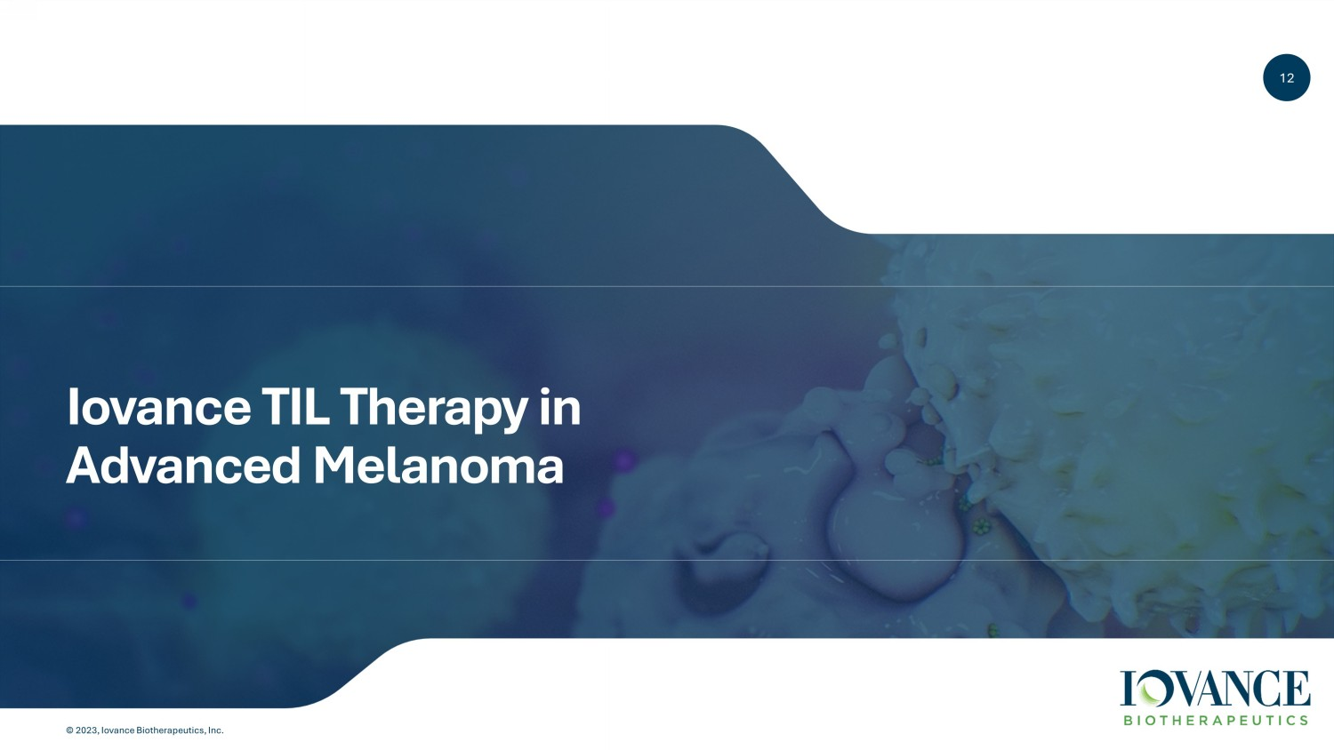
12 © 2023, Iovance Biotherapeutics, Inc. 12 Iovance TIL Therapy in Advanced Melanoma

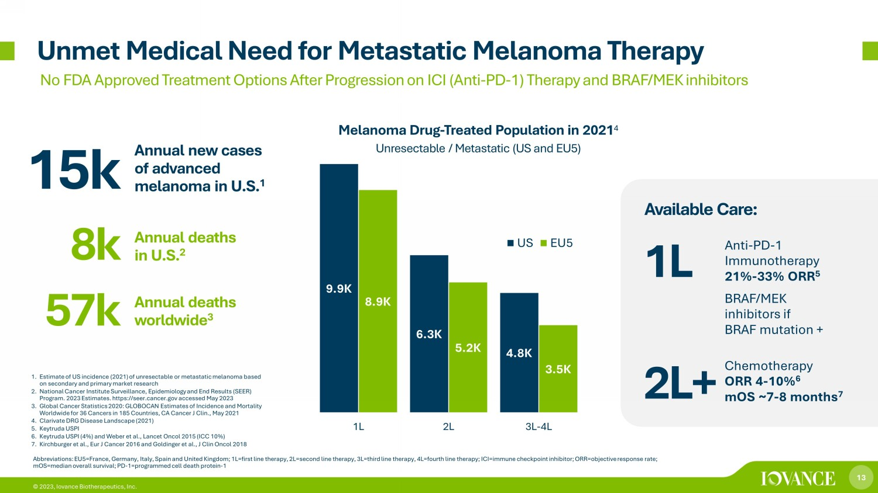
13 © 2023, Iovance Biotherapeutics, Inc. 1. Estimate of US incidence (2021) of unresectable or metastatic melanoma based on secondary and primary market research 2. National Cancer Institute Surveillance, Epidemiology and End Results (SEER) Program. 2023 Estimates. https://seer.cancer.gov accessed May 2023 3. Global Cancer Statistics 2020: GLOBOCAN Estimates of Incidence and Mortality Worldwide for 36 Cancers in 185 Countries, CA Cancer J Clin., May 2021 4. Clarivate DRG Disease Landscape (2021) 5. Keytruda USPI 6. Keytruda USPI (4%) and Weber et al., Lancet Oncol 2015 (ICC 10%) 7. Kirchburger et al., Eur J Cancer 2016 and Goldinger et al., J Clin Oncol 2018 Unmet Medical Need for Metastatic Melanoma Therapy No FDA Approved Treatment Options After Progression on ICI (Anti - PD - 1) Therapy and BRAF/MEK inhibitors BRAF/MEK inhibitors if BRAF mutation + Chemotherapy ORR 4 - 10% 6 mOS ~7 - 8 months 7 Anti - PD - 1 Immunotherapy 21% - 33% ORR 5 Available Care: 9.9K 6.3K 4.8K 8.9K 5.2K 3.5K 1L 2L 3L-4L US EU5 Melanoma Drug - Treated Population in 2021 4 Unresectable / Metastatic (US and EU5) 15k Annual new cases of advanced melanoma in U.S. 1 57k 8k Annual deaths worldwide 3 Annual deaths in U.S. 2 1L 2L+ Abbreviations: EU5=France, Germany, Italy, Spain and United Kingdom; 1L=first line therapy, 2L=second line therapy, 3L=third lin e therapy, 4L=fourth line therapy; ICI=immune checkpoint inhibitor; ORR=objective response rate; mOS=median overall survival; PD - 1=programmed cell death protein - 1

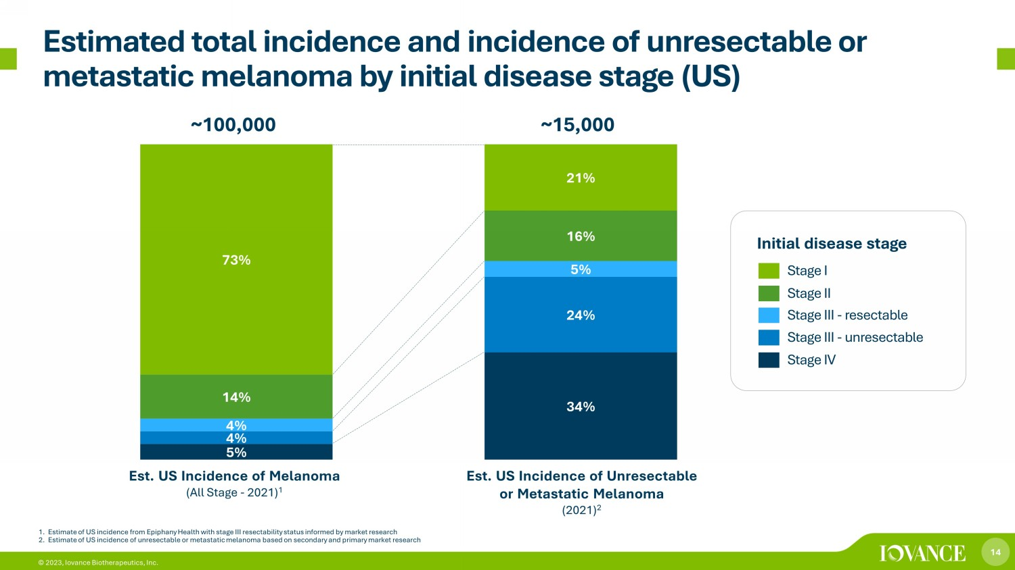
14 © 2023, Iovance Biotherapeutics, Inc. Estimated total incidence and incidence of unresectable or metastatic melanoma by initial disease stage (US) 5% 34% 4% 24% 4% 5% 14% 16% 73% 21% ~100,000 ~15,000 Stage I Stage II Stage III - unresectable Stage III - resectable Stage IV 1. Estimate of US incidence from Epiphany Health with stage III resectability status informed by market research 2. Estimate of US incidence of unresectable or metastatic melanoma based on secondary and primary market research Initial disease stage Est. US Incidence of Melanoma (All Stage - 2021) 1 Est. US Incidence of Unresectable or Metastatic Melanoma (2021) 2

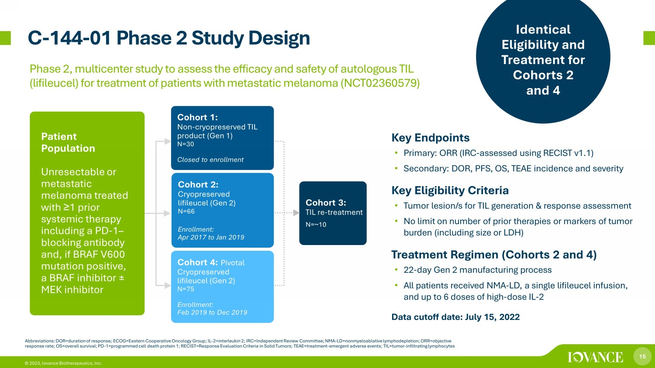
15 © 2023, Iovance Biotherapeutics, Inc. C - 144 - 01 Phase 2 Study Design Abbreviations: DOR=duration of response; ECOG=Eastern Cooperative Oncology Group; IL - 2=interleukin 2; IRC=Independent Review Committee; NMA - LD= nonmyeloablative lymphodepletion; ORR=objective response rate; OS=overall survival; PD - 1=programmed cell death protein 1; RECIST=Response Evaluation Criteria in Solid Tumors; T EAE=treatment - emergent adverse events; TIL=tumor - infiltrating lymphocytes Cohort 1: Non - cryopreserved TIL product (Gen 1) N=30 Closed to enrollment Cohort 2: Cryopreserved lifileucel (Gen 2) N=66 Enrollment: Apr 2017 to Jan 2019 Cohort 3: TIL re - treatment N=~10 Patient Population Unresectable or metastatic melanoma treated with ≥ 1 prior systemic therapy including a PD - 1 – blocking antibody and, if BRAF V600 mutation positive, a BRAF inhibitor ± MEK inhibitor Cohort 4: Pivotal Cryopreserved lifileucel (Gen 2) N=75 Enrollment: Feb 2019 to Dec 2019 Key Endpoints • Primary: ORR (IRC - assessed using RECIST v1.1) • Secondary: DOR, PFS, OS, TEAE incidence and severity Key Eligibility Criteria • Tumor lesion/s for TIL generation & response assessment • No limit on number of prior therapies or markers of tumor burden (including size or LDH) Treatment Regimen (Cohorts 2 and 4) • 22 - day Gen 2 manufacturing process • All patients received NMA - LD, a single lifileucel infusion, and up to 6 doses of high - dose IL - 2 Data cutoff date: July 15, 2022 Identical Eligibility and Treatment for Cohorts 2 and 4 Phase 2, multicenter study to assess the efficacy and safety of autologous TIL ( lifileucel ) for treatment of patients with metastatic melanoma (NCT02360579)

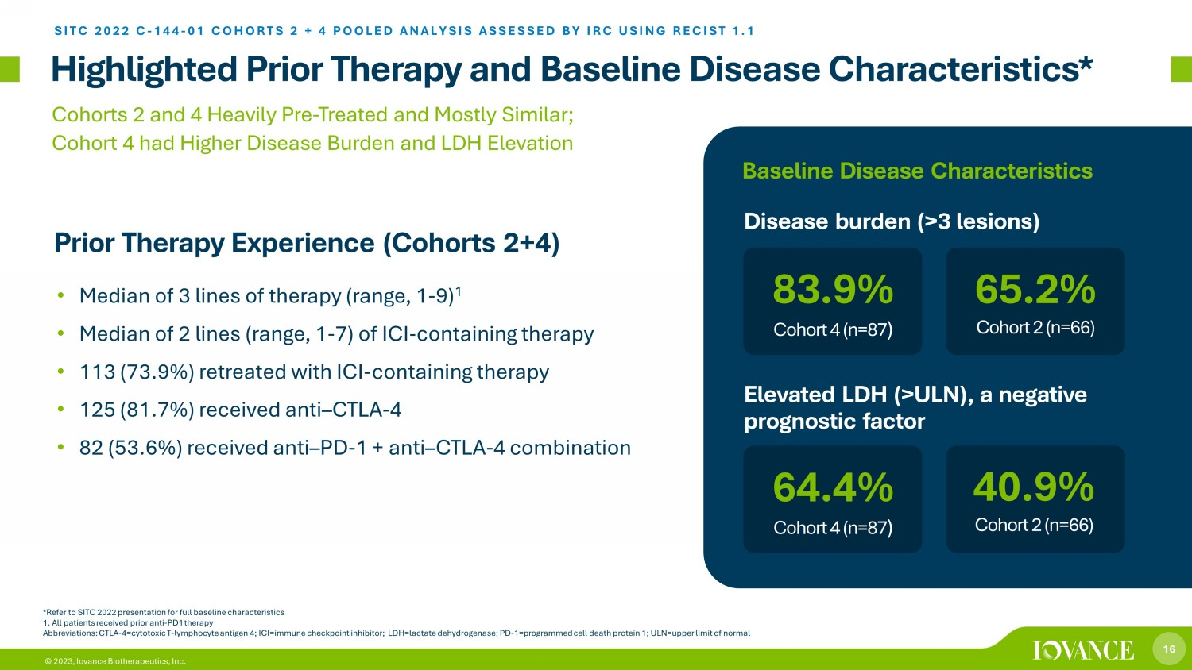
16 © 2023, Iovance Biotherapeutics, Inc. Highlighted Prior Therapy and Baseline Disease Characteristics* *Refer to SITC 2022 presentation for full baseline characteristics 1. All patients received prior anti - PD1 therapy Abbreviations: CTLA - 4=cytotoxic T - lymphocyte antigen 4; ICI=immune checkpoint inhibitor; LDH=lactate dehydrogenase; PD - 1=progra mmed cell death protein 1; ULN=upper limit of normal • Median of 3 lines of therapy (range, 1 - 9) 1 • Median of 2 lines (range, 1 - 7) of ICI - containing therapy • 113 (73.9%) retreated with ICI - containing therapy • 125 (81.7%) received anti – CTLA - 4 • 82 (53.6%) received anti – PD - 1 + anti – CTLA - 4 combination Cohorts 2 and 4 Heavily Pre - Treated and Mostly Similar; Cohort 4 had Higher Disease Burden and LDH Elevation Prior Therapy Experience (Cohorts 2+4) SITC 2022 C - 144 - 01 COHORTS 2 + 4 POOLED ANALYSIS ASSESSED BY IRC USING RECIST 1.1 64.4% Cohort 4 (n=87 ) Disease burden (>3 lesions) 40.9% Cohort 2 (n=66) 83.9% Cohort 4 (n=87 ) 65.2% Cohort 2 (n=66) Elevated LDH (>ULN), a negative prognostic factor Baseline Disease Characteristics

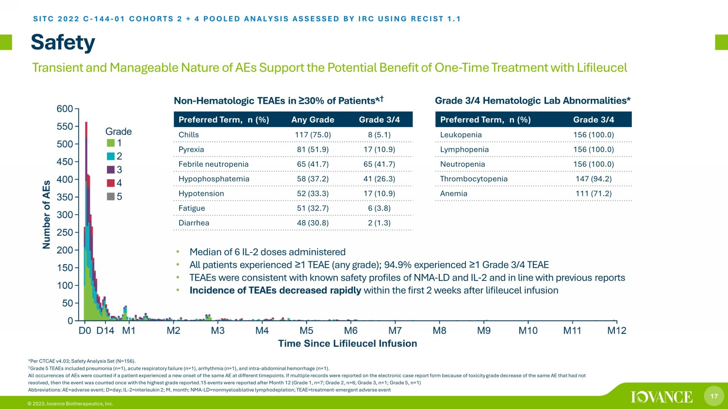
17 © 2023, Iovance Biotherapeutics, Inc. Safety Non - Hematologic TEAEs in ≥ 30% of Patients* , † *Per CTCAE v4.03; Safety Analysis Set (N=156). † Grade 5 TEAEs included pneumonia (n=1), acute respiratory failure (n=1), arrhythmia (n=1), and intra - abdominal hemorrhage (n=1). All occurrences of AEs were counted if a patient experienced a new onset of the same AE at different timepoints. If multiple rec ords were reported on the electronic case report form because of toxicity grade decrease of the same AE that had not resolved, then the event was counted once with the highest grade reported.15 events were reported after Month 12 (Grade 1, n= 7; Grade 2, n=6; Grade 3, n=1; Grade 5, n=1) Abbreviations: AE=adverse event; D=day; IL - 2=interleukin 2; M, month; NMA - LD=nonmyeloablative lymphodepletion; TEAE=treatment - em ergent adverse event • Median of 6 IL - 2 doses administered • All patients experienced ≥ 1 TEAE (any grade); 94.9% experienced ≥ 1 Grade 3/4 TEAE • TEAEs were consistent with known safety profiles of NMA - LD and IL - 2 and in line with previous reports • Incidence of TEAEs decreased rapidly within the first 2 weeks after lifileucel infusion Preferred Term, n (%) Any Grade Grade 3/4 Chills 117 (75.0) 8 (5.1) Pyrexia 81 (51.9) 17 (10.9) Febrile neutropenia 65 (41.7) 65 (41.7) Hypophosphatemia 58 (37.2) 41 (26.3) Hypotension 52 (33.3) 17 (10.9) Fatigue 51 (32.7) 6 (3.8) Diarrhea 48 (30.8) 2 (1.3) Preferred Term, n (%) Grade 3/4 Leukopenia 156 (100.0) Lymphopenia 156 (100.0) Neutropenia 156 (100.0) Thrombocytopenia 147 (94.2) Anemia 111 (71.2) Grade 3/4 Hematologic Lab Abnormalities* *UDGH SITC 2022 C - 144 - 01 COHORTS 2 + 4 POOLED ANALYSIS ASSESSED BY IRC USING RECIST 1.1 Transient and Manageable Nature of AEs Support the Potential Benefit of One - Time Treatment with Lifileucel

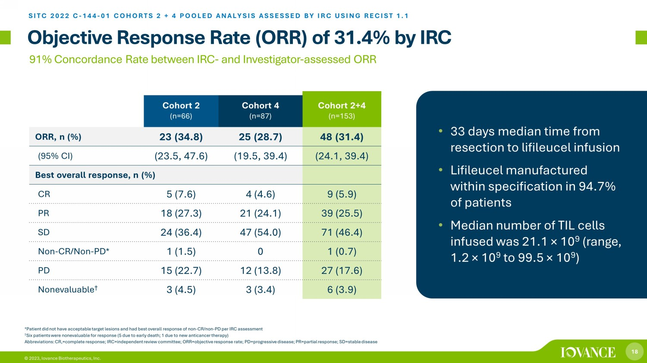
18 © 2023, Iovance Biotherapeutics, Inc. Objective Response Rate (ORR) of 31.4% by IRC SITC 2022 C - 144 - 01 COHORTS 2 + 4 POOLED ANALYSIS ASSESSED BY IRC USING RECIST 1.1 91% Concordance Rate between IRC - and Investigator - assessed ORR *Patient did not have acceptable target lesions and had best overall response of non - CR/non - PD per IRC assessment † Six patients were nonevaluable for response (5 due to early death; 1 due to new anticancer therapy) Abbreviations: CR,=complete response; IRC=independent review committee; ORR=objective response rate; PD=progressive disease; PR= partial response; SD=stable disease Cohort 2 (n=66) Cohort 4 (n=87) Cohort 2+4 (n=153) ORR, n (%) 23 (34.8) 25 (28.7) 48 (31.4) (95% CI) (23.5, 47.6) (19.5, 39.4) (24.1, 39.4) Best overall response, n (%) CR 5 (7.6) 4 (4.6) 9 (5.9) PR 18 (27.3) 21 (24.1) 39 (25.5) SD 24 (36.4) 47 (54.0) 71 (46.4) Non - CR/Non - PD* 1 (1.5) 0 1 (0.7) PD 15 (22.7) 12 (13.8) 27 (17.6) Nonevaluable † 3 (4.5) 3 (3.4) 6 (3.9) • 33 days median time from resection to lifileucel infusion • Lifileucel manufactured within specification in 94.7% of patients • Median number of TIL cells infused was 21.1 × 10 9 (range, 1.2 × 10 9 to 99.5 × 10 9 )

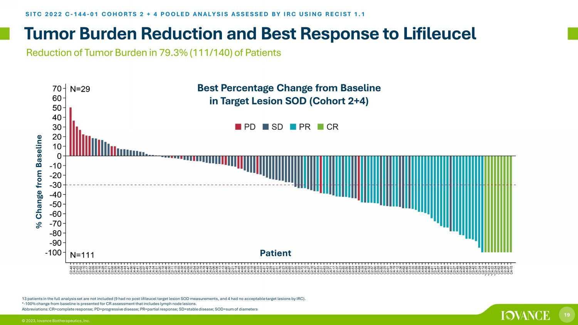
19 © 2023, Iovance Biotherapeutics, Inc. Tumor Burden Reduction and Best Response to Lifileucel SITC 2022 C - 144 - 01 COHORTS 2 + 4 POOLED ANALYSIS ASSESSED BY IRC USING RECIST 1.1 13 patients in the full analysis set are not included (9 had no post lifileucel target lesion SOD measurements, and 4 had no acc ep table target lesions by IRC). * - 100% change from baseline is presented for CR assessment that includes lymph node lesions. Best Percentage Change from Baseline in Target Lesion SOD (Cohort 2+4) Reduction of Tumor Burden in 79.3% (111/140) of Patients Abbreviations: CR=complete response; PD=progressive disease; PR=partial response; SD=stable disease; SOD=sum of diameters % Change from Baseline Patient

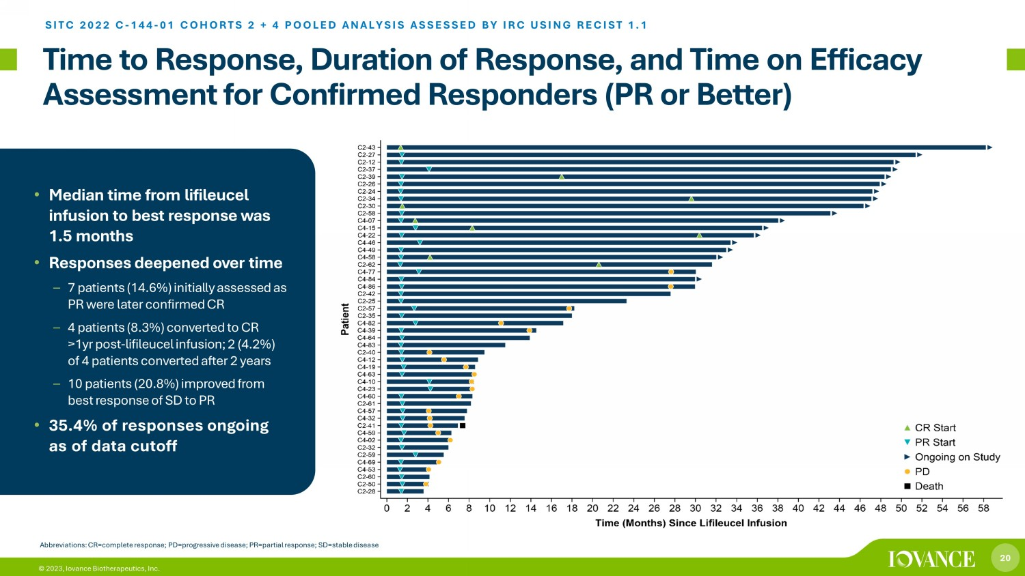
20 © 2023, Iovance Biotherapeutics, Inc. Time to Response, Duration of Response, and Time on Efficacy Assessment for Confirmed Responders (PR or Better) SITC 2022 C - 144 - 01 COHORTS 2 + 4 POOLED ANALYSIS ASSESSED BY IRC USING RECIST 1.1 • Median time from lifileucel infusion to best response was 1.5 months • Responses deepened over time – 7 patients (14.6%) initially assessed as PR were later confirmed CR – 4 patients (8.3%) converted to CR >1yr post - lifileucel infusion; 2 (4.2%) of 4 patients converted after 2 years – 10 patients (20.8%) improved from best response of SD to PR • 35.4% of responses ongoing as of data cutoff Abbreviations: CR=complete response; PD=progressive disease; PR=partial response; SD=stable disease

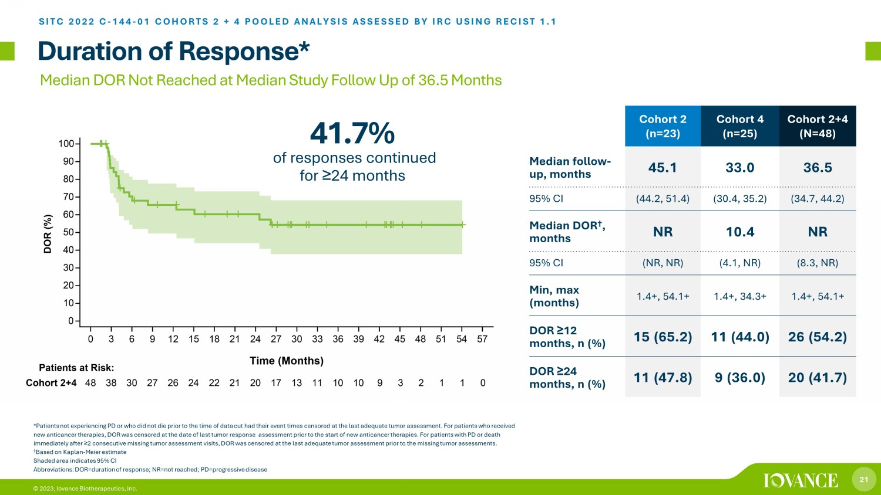
21 © 2023, Iovance Biotherapeutics, Inc. Cohort 2 (n=23) Cohort 4 (n=25) Cohort 2+4 (N=48) Median follow - up, months 45.1 33.0 36.5 95% CI (44.2, 51.4) (30.4, 35.2) (34.7, 44.2) Median DOR † , months NR 10.4 NR 95% CI (NR, NR) (4.1, NR) (8.3, NR) Min, max (months) 1.4+, 54.1+ 1.4+, 34.3+ 1.4+, 54.1+ DOR ≥ 12 months, n (%) 15 (65.2) 11 (44.0) 26 (54.2) DOR ≥ 24 months, n (%) 11 (47.8) 9 (36.0) 20 (41.7) Duration of Response* SITC 2022 C - 144 - 01 COHORTS 2 + 4 POOLED ANALYSIS ASSESSED BY IRC USING RECIST 1.1 *Patients not experiencing PD or who did not die prior to the time of data cut had their event times censored at the last ade qua te tumor assessment. For patients who received new anticancer therapies, DOR was censored at the date of last tumor response assessment prior to the start of new anticance r t herapies. For patients with PD or death immediately after ≥ 2 consecutive missing tumor assessment visits, DOR was censored at the last adequate tumor assessment prior to the missing tu mor assessments. † Based on Kaplan - Meier estimate Shaded area indicates 95% CI Abbreviations: DOR=duration of response; NR=not reached; PD=progressive disease Median DOR Not Reached at Median Study Follow Up of 36.5 Months 41.7% of responses continued for ≥ 24 months ​

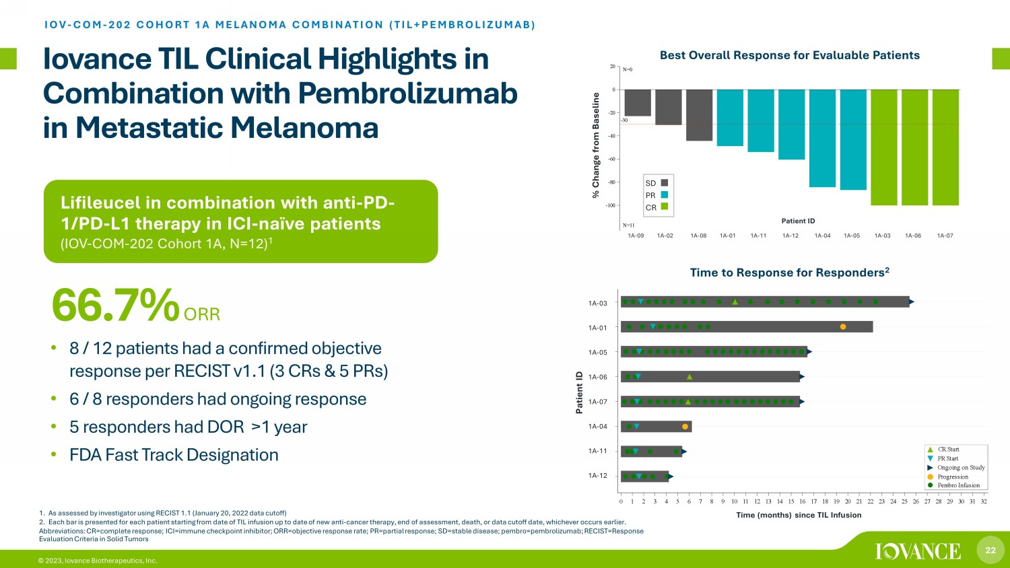
22 © 2023, Iovance Biotherapeutics, Inc. Lifileucel in combination with anti - PD - 1/PD - L1 therapy in ICI - naïve patients (IOV - COM - 202 Cohort 1A, N=12 ) 1 Iovance TIL Clinical Highlights in Combination with Pembrolizumab in Metastatic Melanoma IOV - COM - 202 COHORT 1A MELANOMA COMBINATION (TIL+PEMBROLIZUMAB) • 8 / 12 patients had a confirmed objective response per RECIST v1.1 (3 CRs & 5 PRs) • 6 / 8 responders had ongoing response • 5 responders had DOR >1 year • FDA Fast Track Designation 66.7% ORR 1. As assessed by investigator using RECIST 1.1 (January 20, 2022 data cutoff) 2. Each bar is presented for each patient starting from date of TIL infusion up to date of new anti - cancer therapy, end of assessme nt, death, or data cutoff date, whichever occurs earlier. Abbreviations: CR=complete response; ICI=immune checkpoint inhibitor; ORR=objective response rate; PR=partial response; SD=st abl e disease; pembro =pembrolizumab; RECIST=Response Evaluation Criteria in Solid Tumors Time (months) since TIL Infusion 1A-12 1A-11 1A-04 1A-07 1A-06 1A-05 1A-01 1A-03 S u b j e c t s 0 1 2 3 4 5 6 7 8 9 10 11 12 13 14 15 16 17 18 19 20 21 22 23 24 25 26 27 28 29 30 31 32 Time (months) since TIL Infusion Pembro Infusion Progression Ongoing on Study PR Start CR Start Time (months) since TIL Infusion 1A - 03 1A - 01 1A - 05 1A - 06 1A - 07 1A - 04 1A - 11 1A - 12 Patient ID Time to Response for Responders 2 Patient ID CRPRSD Best Overall Response -30 1A-09 1A-02 1A-08 1A-01 1A-11 1A-12 1A-04 1A-05 1A-03 1A-06 1A-07 -100 -80 -60 -40 -20 0 20 % C h a n g e f r o m B a s e l i n e N=0 N=11 Cohort 1A % Change from Baseline SD PR CR 1A - 09 1A - 02 1A - 08 1A - 01 1A - 11 1A - 12 1A - 04 1A - 05 1A - 03 1A - 06 1A - 07 Patient ID Best Overall Response for Evaluable Patients

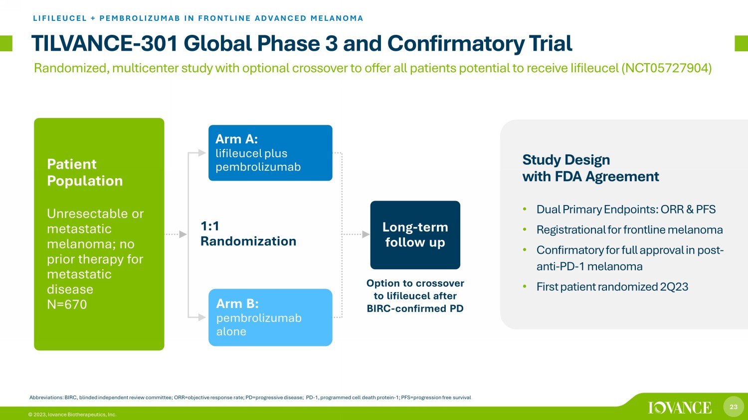
23 © 2023, Iovance Biotherapeutics, Inc. 1:1 Randomization TILVANCE - 301 Global Phase 3 and Confirmatory Trial LIFILEUCEL + PEMBROLIZUMAB IN FRONTLINE ADVANCED MELANOMA Abbreviations: BIRC, blinded independent review committee; ORR=objective response rate; PD=progressive disease; PD - 1, programme d cell death protein - 1; PFS=progression free survival Arm A: lifileucel plus pembrolizumab Long - term follow up Patient Population Unresectable or metastatic melanoma; no prior therapy for metastatic disease N=670 Arm B: pembrolizumab alone Study Design with FDA Agreement • Dual Primary Endpoints: ORR & PFS • Registrational for frontline melanoma • Confirmatory for full approval in post - anti - PD - 1 melanoma • First patient randomized 2Q23 Option to crossover to lifileucel after BIRC - confirmed PD Randomized, multicenter study with optional crossover to offer all patients potential to receive Iifileucel (NCT05727904)

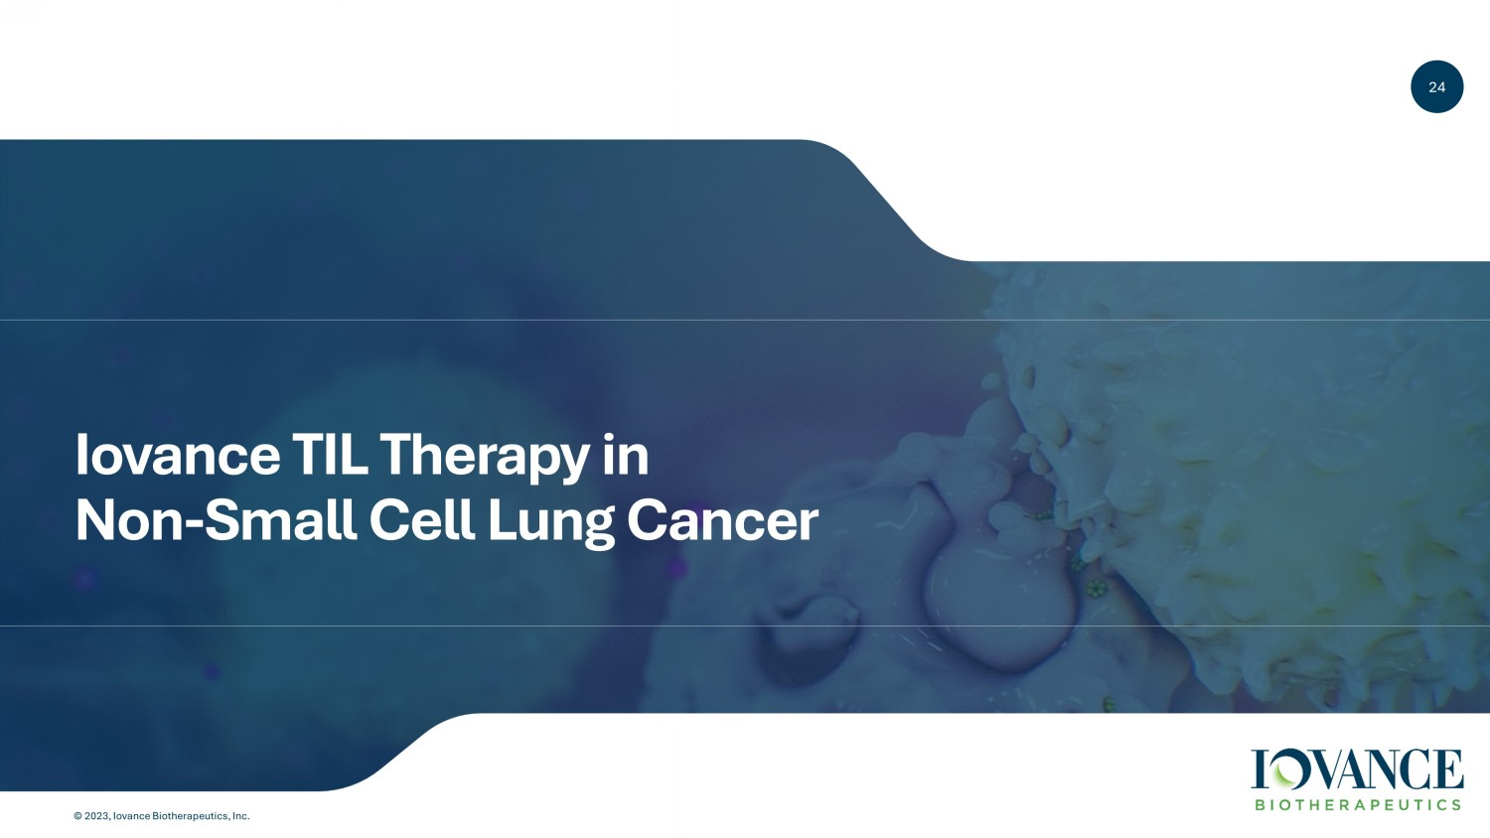
24 © 2023, Iovance Biotherapeutics, Inc. 24 Iovance TIL Therapy in Non - Small Cell Lung Cancer

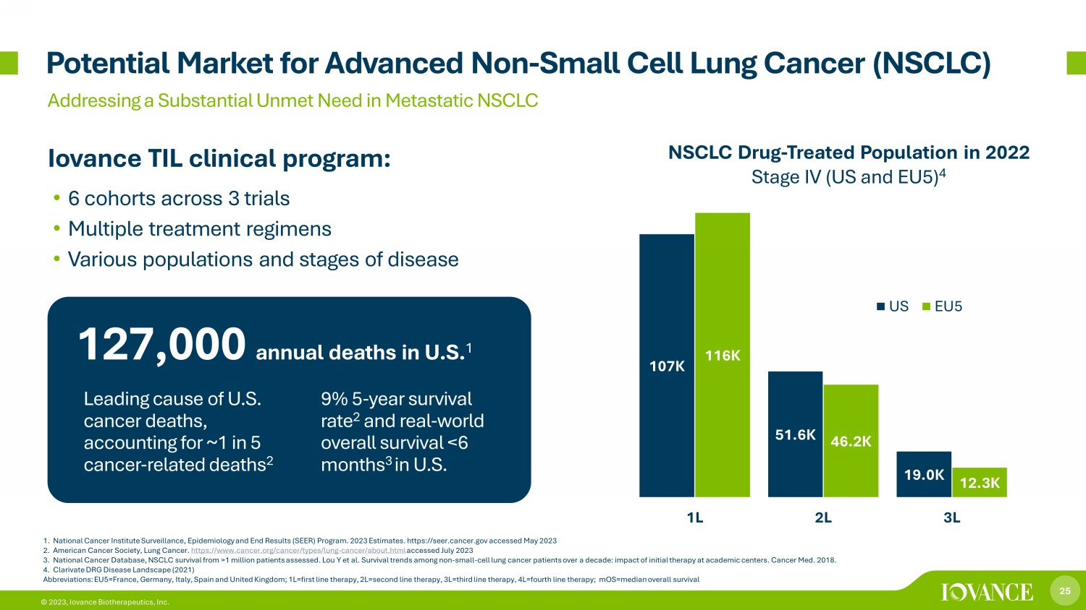
25 © 2023, Iovance Biotherapeutics, Inc. 1. National Cancer Institute Surveillance, Epidemiology and End Results (SEER) Program. 2023 Estimates. https://seer.cancer.gov acc essed May 2023 2. American Cancer Society, Lung Cancer. https://www.cancer.org/cancer/types/lung - cancer/about.html accessed July 2023 3. National Cancer Database, NSCLC survival from >1 million patients assessed. Lou Y et al. Survival trends among non - small - cell lu ng cancer patients over a decade: impact of initial therapy at academic centers. Cancer Med. 2018. 4. Clarivate DRG Disease Landscape (2021) Abbreviations: EU5=France, Germany, Italy, Spain and United Kingdom; 1L=first line therapy, 2L=second line therapy, 3L=third lin e therapy, 4L=fourth line therapy; mOS =median overall survival Potential Market for Advanced Non - Small Cell Lung Cancer (NSCLC) Addressing a Substantial Unmet Need in Metastatic NSCLC Iovance TIL clinical program: • 6 cohorts across 3 trials • Multiple treatment regimens • Various populations and stages of disease Annual Deaths in U.S. 2 127,000 annual deaths in U.S. 1 107K 51.6K 19.0K 116K 46.2K 12.3K 1L 2L 3L US EU5 NSCLC Drug - Treated Population in 2022 Stage IV (US and EU5) 4 Leading cause of U.S. cancer deaths, accounting for ~1 in 5 cancer - related deaths 2 9% 5 - year survival rate 2 and real - world overall survival <6 months 3 in U.S.

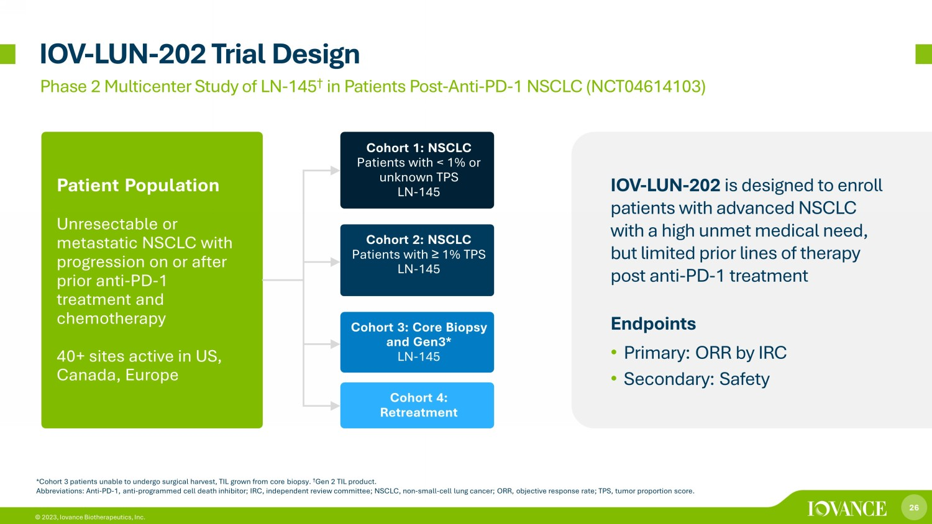
26 © 2023, Iovance Biotherapeutics, Inc. IOV - LUN - 202 Trial Design Phase 2 Multicenter Study of LN - 145 † in Patients Post - Anti - PD - 1 NSCLC (NCT04614103) Endpoints • Primary: ORR by IRC • Secondary: Safety * Cohort 3 patients unable to undergo surgical harvest, TIL grown from core biopsy. † Gen 2 TIL product. Abbreviations: Anti - PD - 1, anti - programmed cell death inhibitor; IRC, independent review committee; NSCLC, non - small - cell lung ca ncer; ORR, objective response rate; TPS, tumor proportion score. Iovance TIL Therapy LN - 145 in NSCLC IOV - LUN - 202 is designed to enroll patients with advanced NSCLC with a high unmet medical need, but limited prior lines of therapy post anti - PD - 1 treatment Patient Population Unresectable or metastatic NSCLC with progression on or after prior anti - PD - 1 treatment and chemotherapy 40+ sites active in US, Canada, Europe Cohort 1: NSCLC Patients with < 1% or unknown TPS LN - 145 Cohort 2: NSCLC Patients with ≥ 1% TPS LN - 145 Cohort 3: Core Biopsy and Gen3* LN - 145 Cohort 4: Retreatment

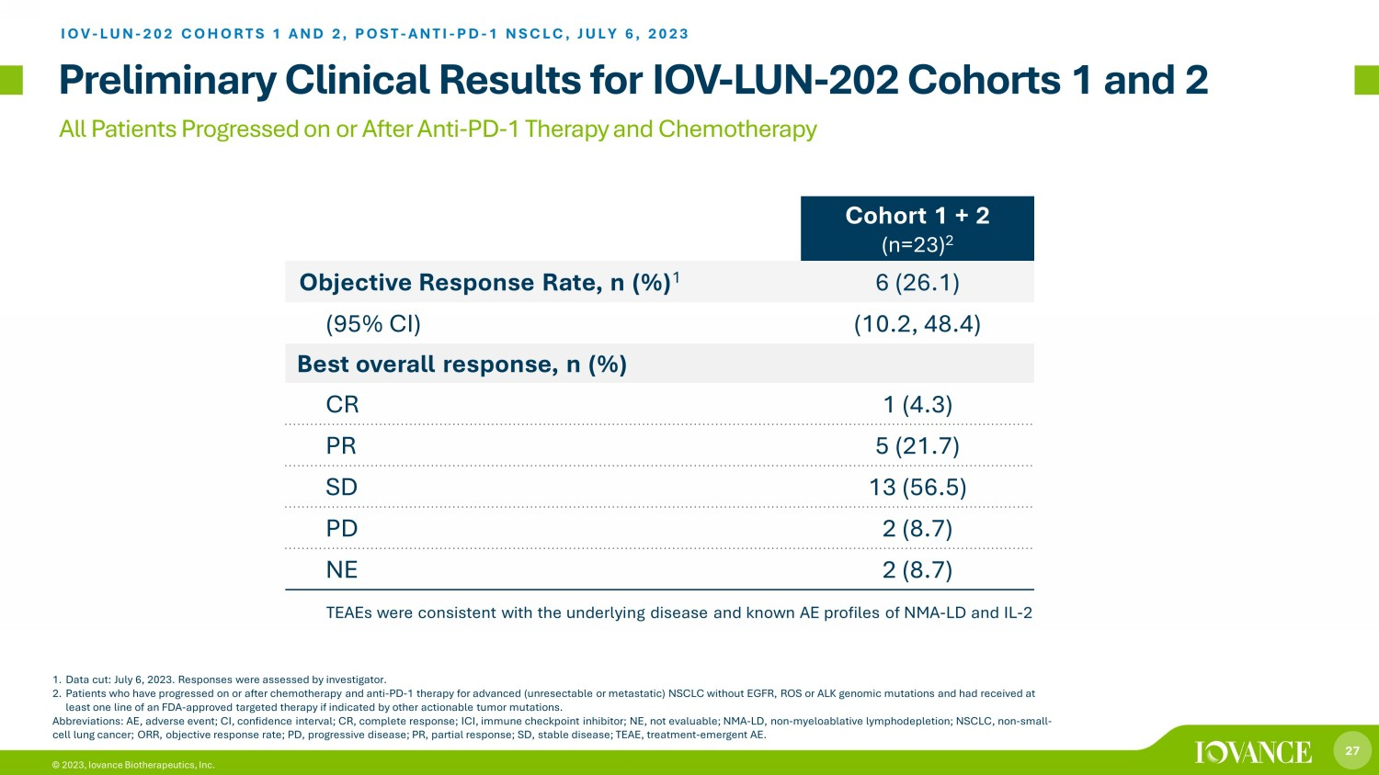
27 © 2023, Iovance Biotherapeutics, Inc. All Patients Progressed on or After Anti - PD - 1 Therapy and Chemotherapy Preliminary Clinical Results for IOV - LUN - 202 Cohorts 1 and 2 1. Data cut: July 6, 2023. Responses were assessed by investigator. 2. Patients who have progressed on or after chemotherapy and anti - PD - 1 therapy for advanced (unresectable or metastatic) NSCLC with out EGFR, ROS or ALK genomic mutations and had received at least one line of an FDA - approved targeted therapy if indicated by other actionable tumor mutations. Abbreviations: AE, adverse event; CI, confidence interval; CR, complete response; ICI, immune checkpoint inhibitor; NE, not e val uable; NMA - LD, non - myeloablative lymphodepletion; NSCLC, non - small - cell lung cancer; ORR, objective response rate; PD, progressive disease; PR, partial response; SD, stable disease; TEAE, trea tme nt - emergent AE. Iovance TIL Therapy LN - 145 in NSCLC Cohort 1 + 2 (n=23) 2 Objective Response Rate, n (%) 1 6 (26.1) (95% CI) (10.2, 48.4) Best overall response, n (%) CR 1 (4.3) PR 5 (21.7) SD 13 (56.5) PD 2 (8.7) NE 2 (8.7) IOV - LUN - 202 COHORTS 1 AND 2, POST - ANTI - PD - 1 NSCLC, JULY 6, 2023 TEAEs were consistent with the underlying disease and known AE profiles of NMA - LD and IL - 2

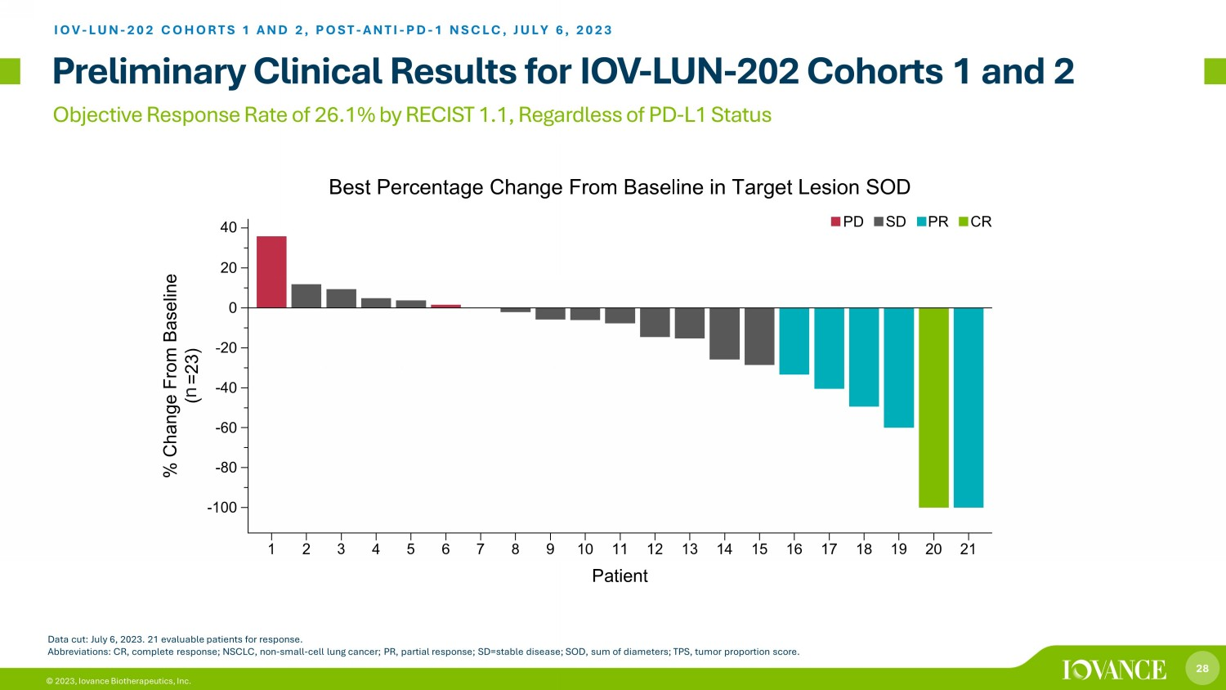
28 © 2023, Iovance Biotherapeutics, Inc. Objective Response Rate of 26.1% by RECIST 1.1, Regardless of PD - L1 Status Preliminary Clinical Results for IOV - LUN - 202 Cohorts 1 and 2 IOV - LUN - 202 COHORTS 1 AND 2, POST - ANTI - PD - 1 NSCLC, JULY 6, 2023 Data cut: July 6, 2023. 21 evaluable patients for response. Abbreviations: CR, complete response; NSCLC, non - small - cell lung cancer; PR, partial response; SD=stable disease; SOD, sum of di ameters; TPS, tumor proportion score. n

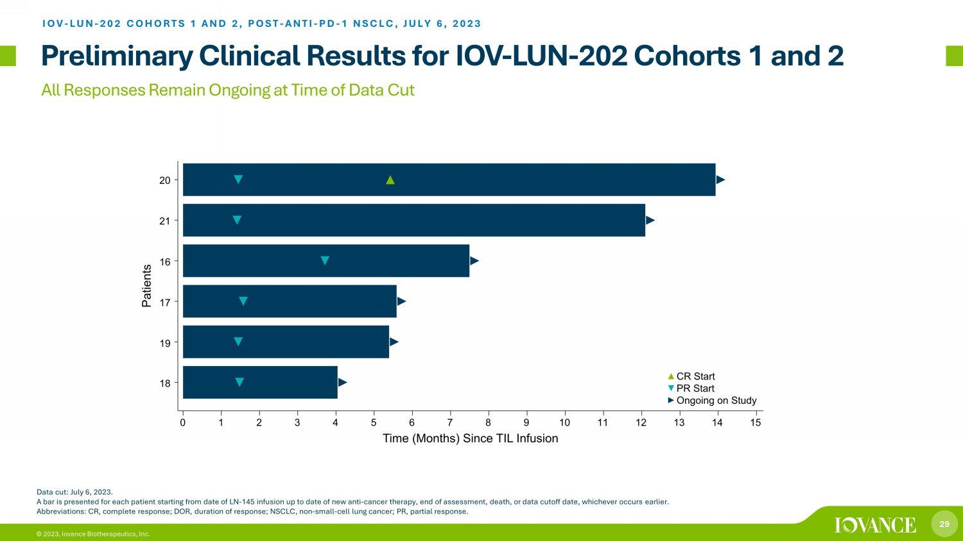
29 © 2023, Iovance Biotherapeutics, Inc. All Responses Remain Ongoing at Time of Data Cut Data cut: July 6, 2023. A bar is presented for each patient starting from date of LN - 145 infusion up to date of new anti - cancer therapy, end of assessme nt, death, or data cutoff date, whichever occurs earlier. Abbreviations: CR, complete response; DOR, duration of response; NSCLC, non - small - cell lung cancer; PR, partial response. IOV - LUN - 202 COHORTS 1 AND 2, POST - ANTI - PD - 1 NSCLC, JULY 6, 2023 Preliminary Clinical Results for IOV - LUN - 202 Cohorts 1 and 2

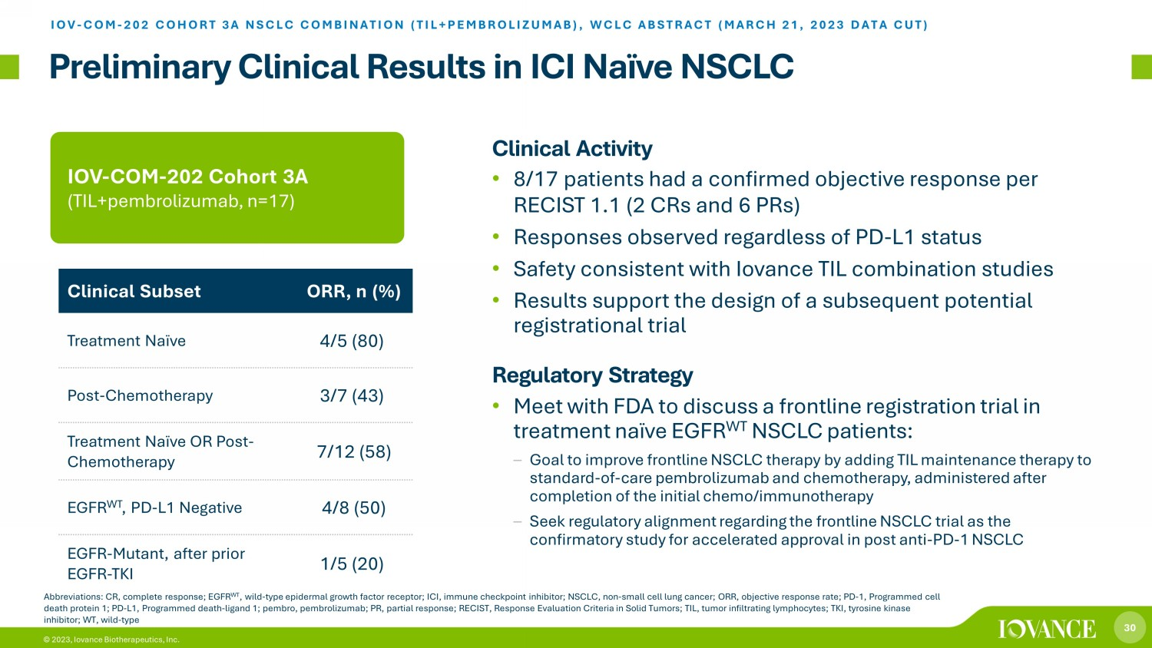
30 © 2023, Iovance Biotherapeutics, Inc. Preliminary Clinical Results in ICI Naïve NSCLC Clinical Activity • 8/17 patients had a confirmed objective response per RECIST 1.1 (2 CRs and 6 PRs) • Responses observed regardless of PD - L1 status • Safety consistent with Iovance TIL combination studies • Results support the design of a subsequent potential registrational trial Regulatory Strategy • Meet with FDA to discuss a frontline registration trial in treatment naïve EGFR WT NSCLC patients: – Goal to improve frontline NSCLC therapy by adding TIL maintenance therapy to standard - of - care pembrolizumab and chemotherapy, administered after completion of the initial chemo/immunotherapy – Seek regulatory alignment regarding the frontline NSCLC trial as the confirmatory study for accelerated approval in post anti - PD - 1 NSCLC IOV - COM - 202 Cohort 3A (TIL+pembrolizumab, n= 17 ) Clinical Subset ORR, n (%) Treatment Naïve 4/5 (80) Post - Chemotherapy 3/7 (43) Treatment Naïve OR Post - Chemotherapy 7/12 (58) EGFR WT , PD - L1 Negative 4/8 (50) EGFR - Mutant, after prior EGFR - TKI 1/5 (20) Abbreviations: CR, complete response; EGFR WT , wild - type epidermal growth factor receptor; ICI, immune checkpoint inhibitor; NSCLC, non - small cell lung cancer; ORR, objective response rate; PD - 1, Programmed cell death protein 1; PD - L1, Programmed death - ligand 1; pembro , pembrolizumab; PR, partial response; RECIST, Response Evaluation Criteria in Solid Tumors; TIL, tumor infiltrating lymphocyte s; TKI, tyrosine kinase inhibitor; WT, wild - type IOV - COM - 202 COHORT 3A NSCLC COMBINATION (TIL+PEMBROLIZUMAB), WCL C ABSTRACT (MARCH 21, 2023 DATA CUT)

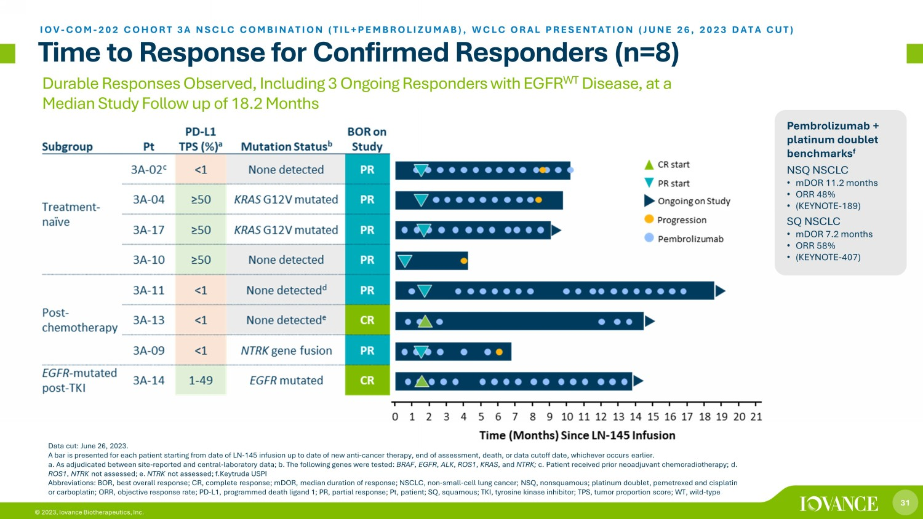
31 © 2023, Iovance Biotherapeutics, Inc. Durable Responses Observed, Including 3 Ongoing Responders with EGFR WT Disease, at a Median Study Follow up of 18.2 Months Time to Response for Confirmed Responders (n=8) IOV - COM - 202 COHORT 3A NSCLC COMBINATION (TIL+PEMBROLIZUMAB ), WCLC ORAL PRESENTATION (JUNE 26, 2023 DATA CUT) Pembrolizumab + platinum doublet benchmarks f NSQ NSCLC • mDOR 11.2 months • ORR 48% • (KEYNOTE - 189) SQ NSCLC • mDOR 7.2 months • ORR 58% • (KEYNOTE - 407) Data cut: June 26, 2023. A bar is presented for each patient starting from date of LN - 145 infusion up to date of new anti - cancer therapy, end of assessme nt, death, or data cutoff date, whichever occurs earlier. a. As adjudicated between site - reported and central - laboratory data; b. The following genes were tested: BRAF , EGFR , ALK , ROS1 , KRAS , and NTRK; c. Patient received prior neoadjuvant chemoradiotherapy; d. ROS1 , NTRK not assessed; e. NTRK not assessed; f.Keytruda USPI Abbreviations: BOR, best overall response; CR, complete response; mDOR, median duration of response; NSCLC, non - small - cell lung cancer; NSQ, nonsquamous; platinum doublet, pemetrexed and cisplatin or carboplatin; ORR, objective response rate; PD - L1, programmed death ligand 1; PR, partial response; Pt, patient; SQ, squamous; TKI, tyrosine kinase inhibitor; TPS, tumor proportion score; WT, wild - type

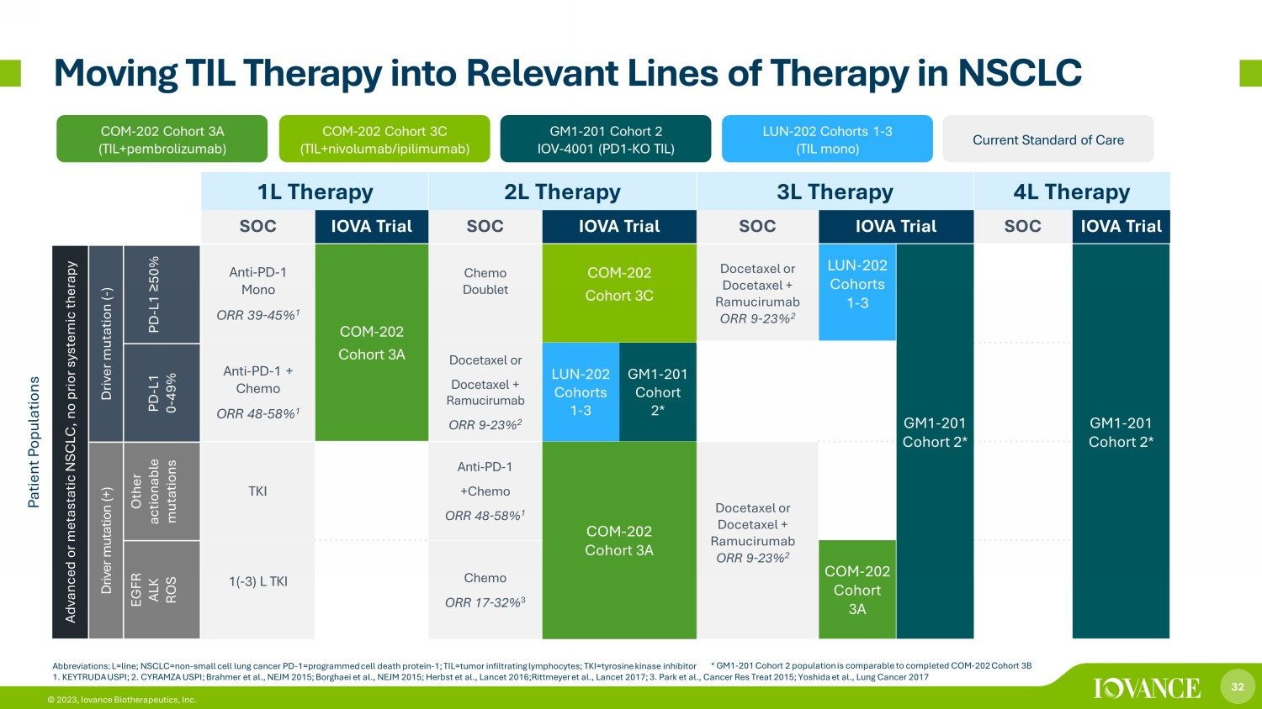
32 © 2023, Iovance Biotherapeutics, Inc. 1L Therapy 2L Therapy 3L Therapy 4L Therapy SOC IOVA Trial SOC IOVA Trial SOC IOVA Trial SOC IOVA Trial Anti - PD - 1 Mono ORR 39 - 45% 1 COM - 202 Cohort 3A Chemo Doublet COM - 202 Cohort 3C Docetaxel or Docetaxel + Ramucirumab ORR 9 - 23% 2 LUN - 202 Cohorts 1 - 3 GM1 - 201 Cohort 2* GM1 - 201 Cohort 2* Anti - PD - 1 + Chemo ORR 48 - 58% 1 Docetaxel or Docetaxel + Ramucirumab ORR 9 - 23% 2 LUN - 202 Cohorts 1 - 3 GM1 - 201 Cohort 2* TKI Anti - PD - 1 +Chemo ORR 48 - 58% 1 COM - 202 Cohort 3A Docetaxel or Docetaxel + Ramucirumab ORR 9 - 23% 2 1( - 3) L TKI Chemo ORR 17 - 32% 3 COM - 202 Cohort 3A * GM1 - 201 Cohort 2 population is comparable to completed COM - 202 Cohort 3B Moving TIL Therapy into Relevant Lines of Therapy in NSCLC COM - 202 Cohort 3A (TIL+pembrolizumab) LUN - 202 Cohorts 1 - 3 (TIL mono) COM - 202 Cohort 3C (TIL+ nivolumab / i pilimumab) GM1 - 201 Cohort 2 IOV - 4001 (PD1 - KO TIL) Current Standard of Care Patient Populations Advanced or metastatic NSCLC, no prior systemic therapy Driver mutation ( - ) PD - L1 ≥ 50% PD - L1 0 - 49% Driver mutation (+) Other actionable mutations EGFR ALK ROS Abbreviations: L=line; NSCLC=non - small cell lung cancer PD - 1=programmed cell death protein - 1; TIL=tumor infiltrating lymphocytes ; TKI=tyrosine kinase inhibitor 1. KEYTRUDA USPI; 2. CYRAMZA U S PI; Brahmer et al., NEJM 2015; Borghaei et al., NEJM 2015; Herbst et al., Lancet 2016;Rittmeyer et al., Lancet 2017; 3. Park et al., Cancer Res Treat 2015; Yoshida et al., Lung Cancer 2017

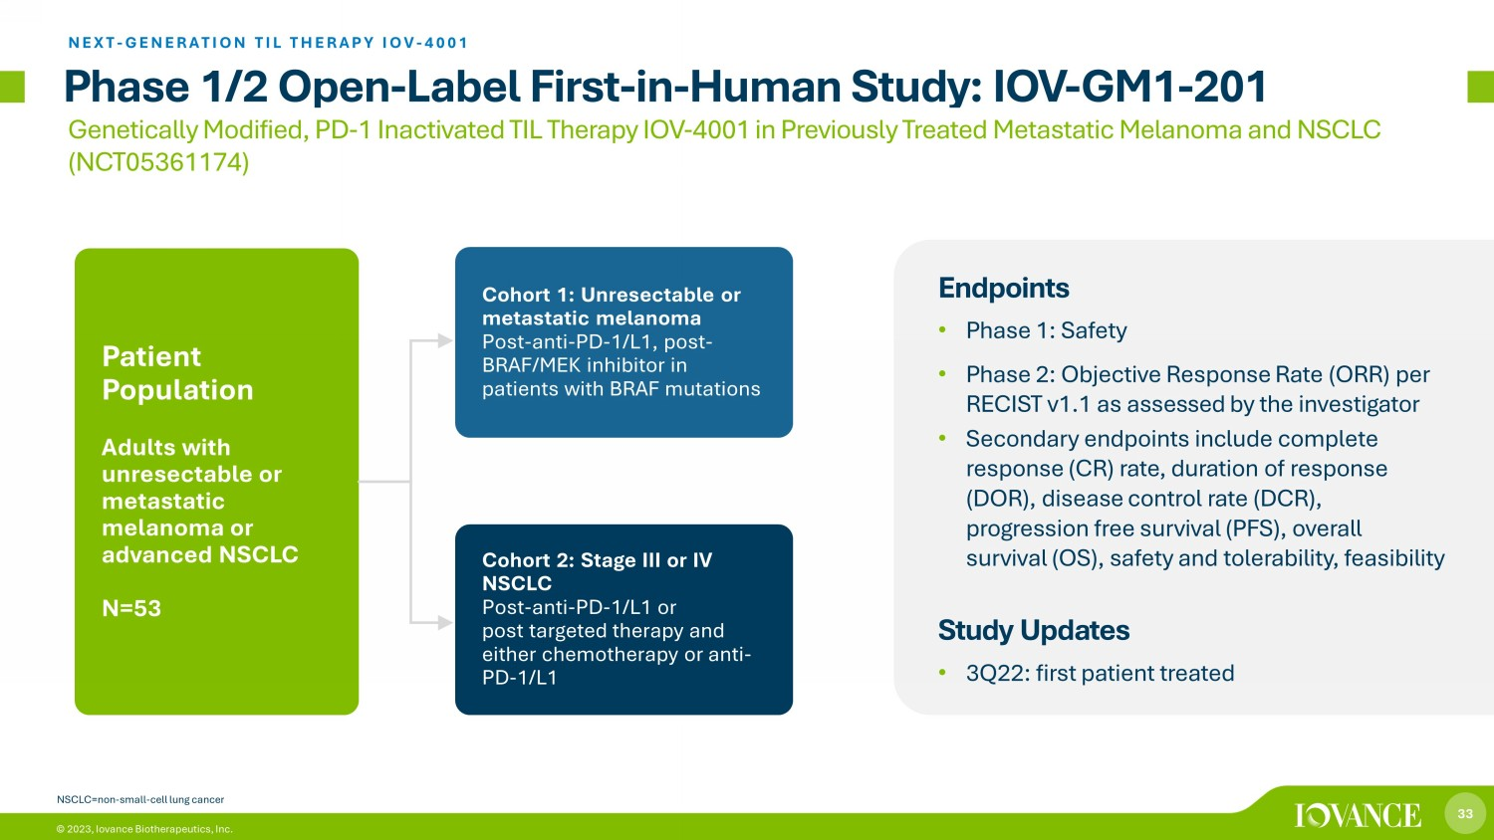
33 © 2023, Iovance Biotherapeutics, Inc. Phase 1/2 Open - Label First - in - Human Study: IOV - GM1 - 201 Endpoints • Phase 1: Safety • Phase 2: Objective Response Rate (ORR) per RECIST v1.1 as assessed by the investigator • Secondary endpoints include complete response (CR) rate, duration of response (DOR), disease control rate (DCR), progression free survival (PFS), overall survival (OS), safety and tolerability, feasibility Study Updates • 3Q22: first patient treated Cohort 1: Unresectable or metastatic melanoma Post - anti - PD - 1/L1, post - BRAF/MEK inhibitor in patients with BRAF mutations Cohort 2: Stage III or IV NSCLC Post - anti - PD - 1/L1 or post targeted therapy and either chemotherapy or anti - PD - 1/L1 Patient Population Adults with unresectable or metastatic melanoma or advanced NSCLC N=53 Genetically Modified, PD - 1 Inactivated TIL Therapy IOV - 4001 in Previously Treated Metastatic Melanoma and NSCLC (NCT05361174) NEXT - GENERATION TIL THERAPY IOV - 4001 NSCLC=non - small - cell lung cancer


34 © 2023, Iovance Biotherapeutics, Inc. 34 Launch Preparation

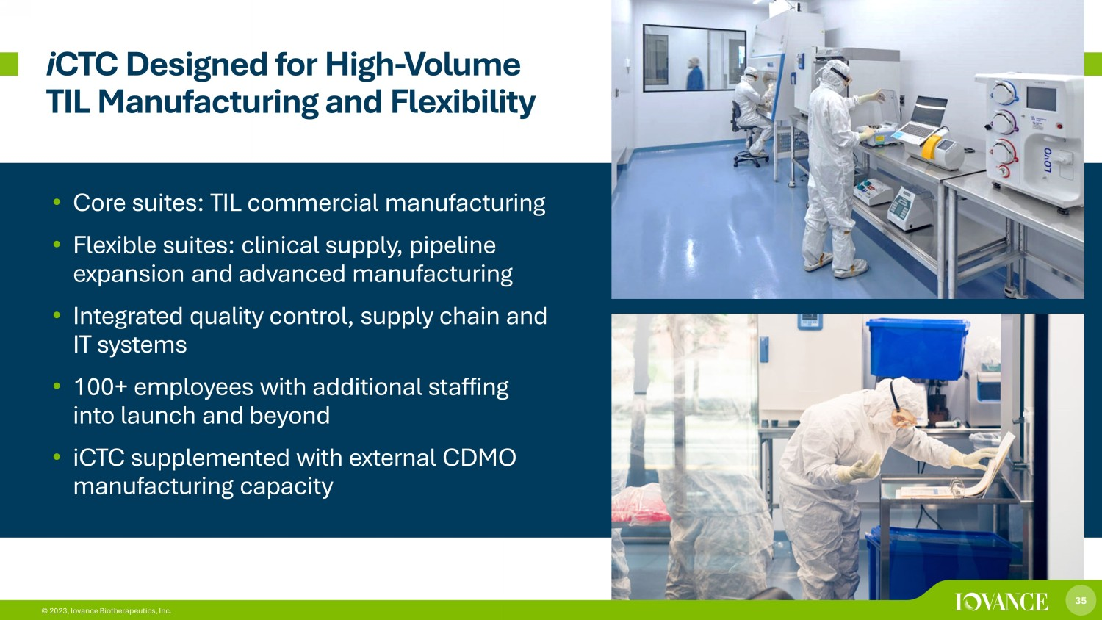
35 © 2023, Iovance Biotherapeutics, Inc. i CTC Designed for High - Volume TIL Manufacturing and Flexibility • Core suites: TIL commercial manufacturing • Flexible suites: clinical supply, pipeline expansion and advanced manufacturing • Integrated quality control, supply chain and IT systems • 100+ employees with additional staffing into launch and beyond • iCTC supplemented with external CDMO manufacturing capacity 35 © 2023, Iovance Biotherapeutics, Inc.

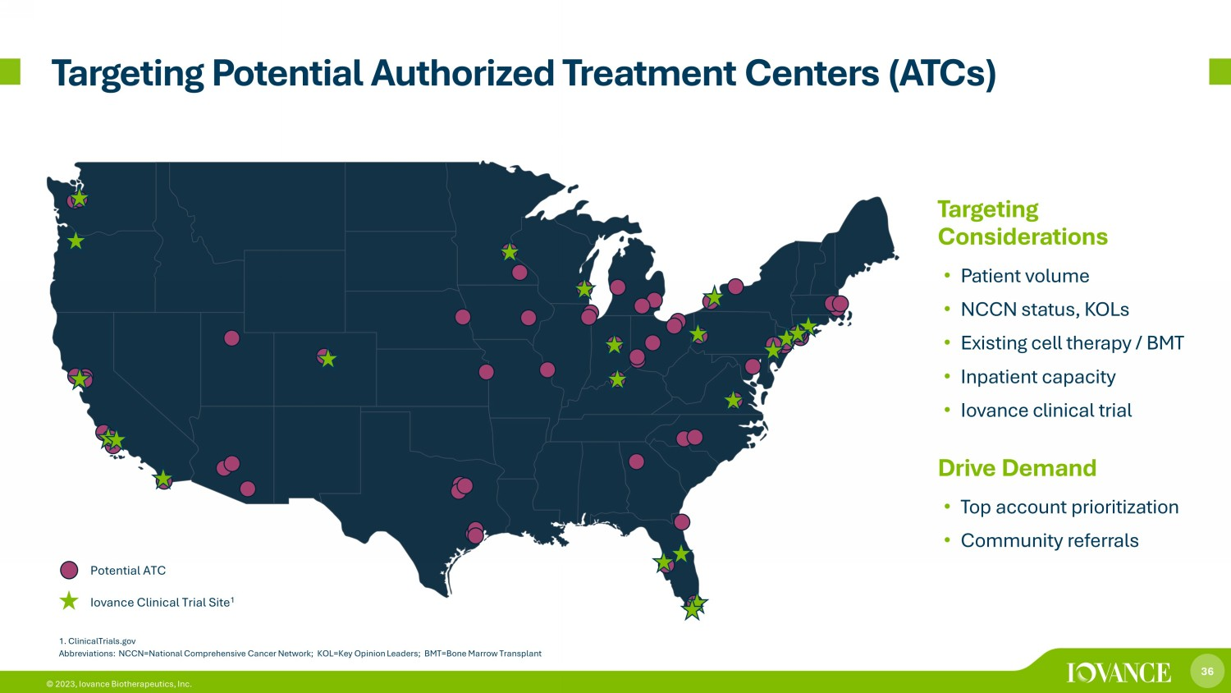
36 © 2023, Iovance Biotherapeutics, Inc. Targeting Potential Authorized Treatment Centers (ATCs) Potential ATC Iovance Clinical Trial Site 1 1. ClinicalTrials.gov Abbreviations: NCCN=National Comprehensive Cancer Network; KOL=Key Opinion Leaders; BMT=Bone Marrow Transplant Targeting Considerations • Patient volume • NCCN status, KOLs • Existing cell therapy / BMT • Inpatient capacity • Iovance clinical trial (s) Drive Demand • Top account prioritization • Community referrals

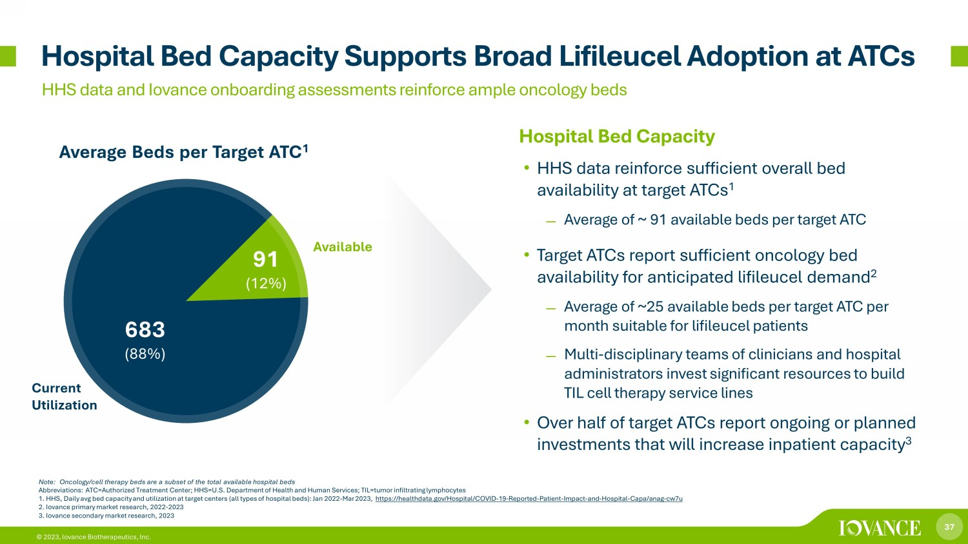
37 © 2023, Iovance Biotherapeutics, Inc. Hospital Bed Capacity • HHS data reinforce sufficient overall bed availability at target ATCs 1 ̶ Average of ~ 91 available beds per target ATC • Target ATCs report sufficient oncology bed availability for anticipated lifileucel demand 2 ̶ Average of ~25 available beds per target ATC per month suitable for lifileucel patients ̶ Multi - disciplinary teams of clinicians and hospital administrators invest significant resources to build TIL cell therapy service lines • Over half of target ATCs report ongoing or planned investments that will increase inpatient capacity 3 Average Beds per Target ATC 1 Hospital Bed Capacity Supports Broad Lifileucel Adoption at ATCs HHS data and Iovance onboarding assessments reinforce ample oncology beds Note: Oncology/cell therapy beds are a subset of the total available hospital beds Abbreviations: ATC=Authorized Treatment Center; HHS=U.S. Department of Health and Human Services; TIL=tumor infiltrating lympho cytes 1. HHS, Daily avg bed capacity and utilization at target centers (all types of hospital beds): Jan 2022 - Mar 2023, https://healthdata.gov/Hospital/COVID - 19 - Reported - Patient - Impact - and - Hospital - Capa/anag - cw7u 2. Iovance primary market research, 2022 - 2023 3. Iovance secondary market research, 2023 683 (88%) 91 (12%) Current Utilization Available

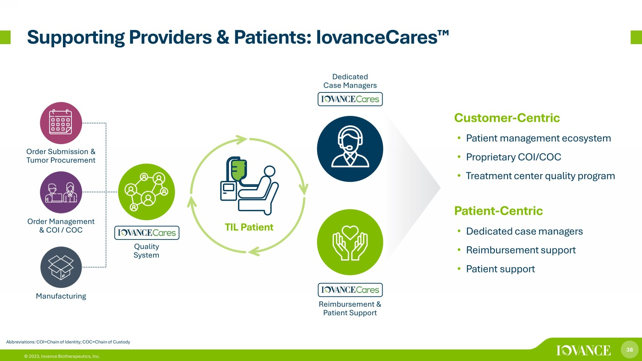
38 © 2023, Iovance Biotherapeutics, Inc. Supporting Providers & Patients: IovanceCares ¯ Abbreviations: COI=Chain of Identity; COC=Chain of Custody Customer - Centric • Patient management ecosystem • Proprietary COI/COC • Treatment center quality program Patient - Centric • Dedicated case managers • Reimbursement support • Patient support Quality System Dedicated Case Managers Reimbursement & Patient Support Order Submission & Tumor Procurement Order Management & COI / COC Manufacturing TIL Patient

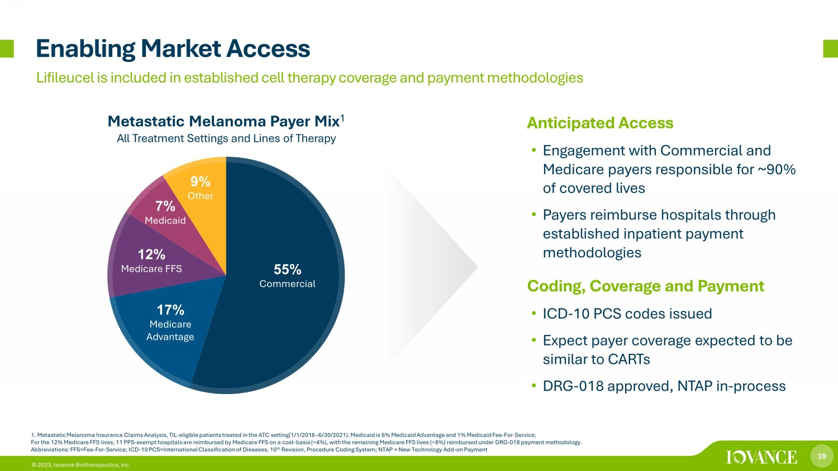
39 © 2023, Iovance Biotherapeutics, Inc. 55% Commercial 17% Medicare Advantage 12% Medicare FFS 7% Medicaid 9% Other Enabling Market Access Metastatic Melanoma Payer Mix 1 All Treatment Settings and Lines of Therapy 1. Metastatic Melanoma Insurance Claims Analysis, TIL - eligible patients treated in the ATC setting(1/1/2018 – 6/30/2021). Medicai d is 6% Medicaid Advantage and 1% Medicaid Fee - For - Service; For the 12% Medicare FFS lives, 11 PPS - exempt hospitals are reimbursed by Medicare FFS on a cost - basis (~4%), with the remaining Medicare FFS lives (~8%) reimbursed under DRG - 018 payment methodology. Abbreviations: FFS=Fee - For - Service; ICD - 10 PCS=International Classification of Diseases, 10 th Revision, Procedure Coding System; NTAP = New Technology Add - on Payment Lifileucel is included in established cell therapy coverage and payment methodologies Anticipated Access • Engagement with Commercial and Medicare payers responsible for ~90% of covered lives • Payers reimburse hospitals through established inpatient payment methodologies Coding, Coverage and Payment • ICD - 10 PCS codes issued • Expect payer coverage expected to be similar to CARTs • DRG - 018 approved, NTAP in - process


40 © 2023, Iovance Biotherapeutics, Inc. 40 Other TIL Therapy Clinical Program Highlights

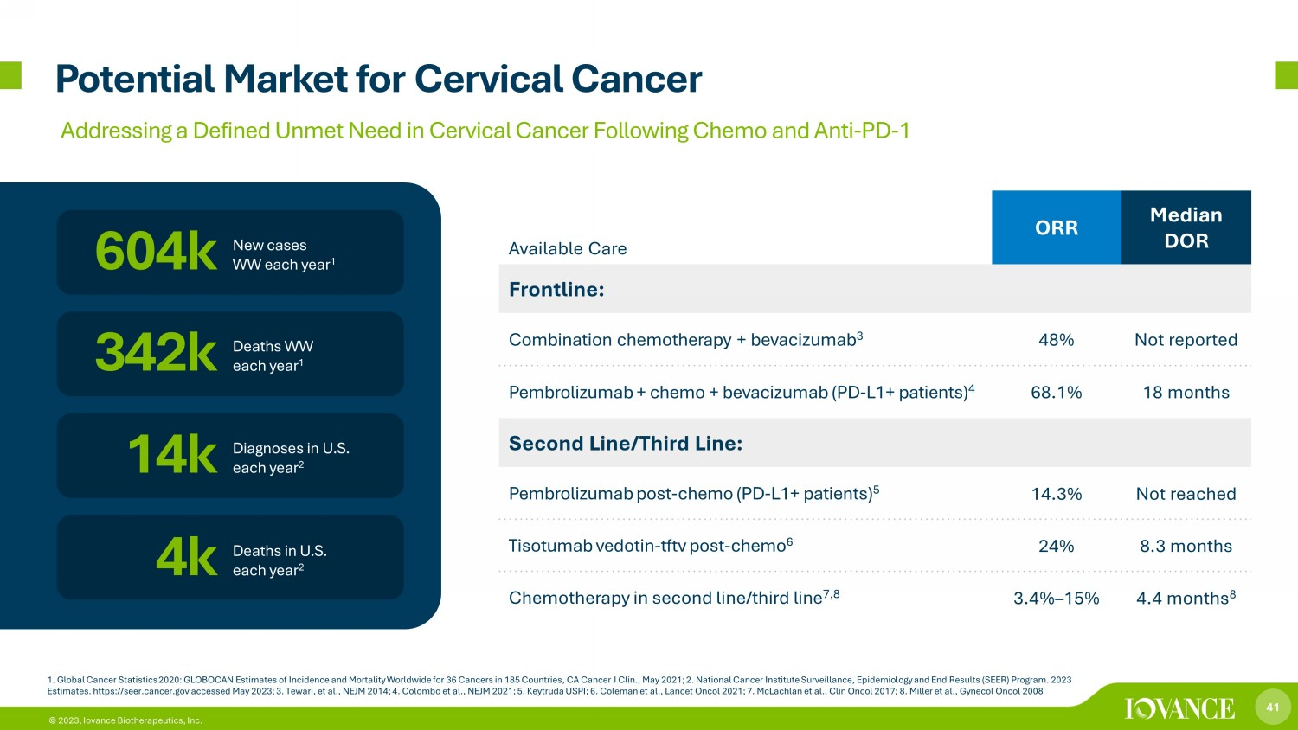
41 © 2023, Iovance Biotherapeutics, Inc. Potential Market for Cervical Cancer 1. Global Cancer Statistics 2020: GLOBOCAN Estimates of Incidence and Mortality Worldwide for 36 Cancers in 185 Countries, CA Ca ncer J Clin., May 2021; 2. National Cancer Institute Surveillance, Epidemiology and End Results (SEER) Program. 2023 Estimates. https://seer.cancer.gov accessed May 2023; 3. Tewari, et al., NEJM 2014; 4. Colombo et al., NEJM 2021; 5. Keytruda US PI; 6. Coleman et al., Lancet Oncol 2021; 7. McLachlan et al., Clin Oncol 2017; 8. Miller et al., Gynecol Oncol 2008 New cases WW each year 1 604k 14k Diagnoses in U.S. each year 2 342k 4k Deaths WW each year 1 Deaths in U.S. each year 2 Available Care ORR Median DOR Frontline: Combination chemotherapy + bevacizumab 3 48% Not reported Pembrolizumab + chemo + bevacizumab (PD - L1+ patients) 4 68.1% 18 months Second Line/Third Line: Pembrolizumab post - chemo (PD - L1+ patients) 5 14.3% Not reached Tisotumab vedotin - tftv post - chemo 6 24% 8.3 months Chemotherapy in second line/third line 7,8 3.4% – 15% 4.4 months 8 Addressing a Defined Unmet Need in Cervical Cancer Following Chemo and Anti - PD - 1

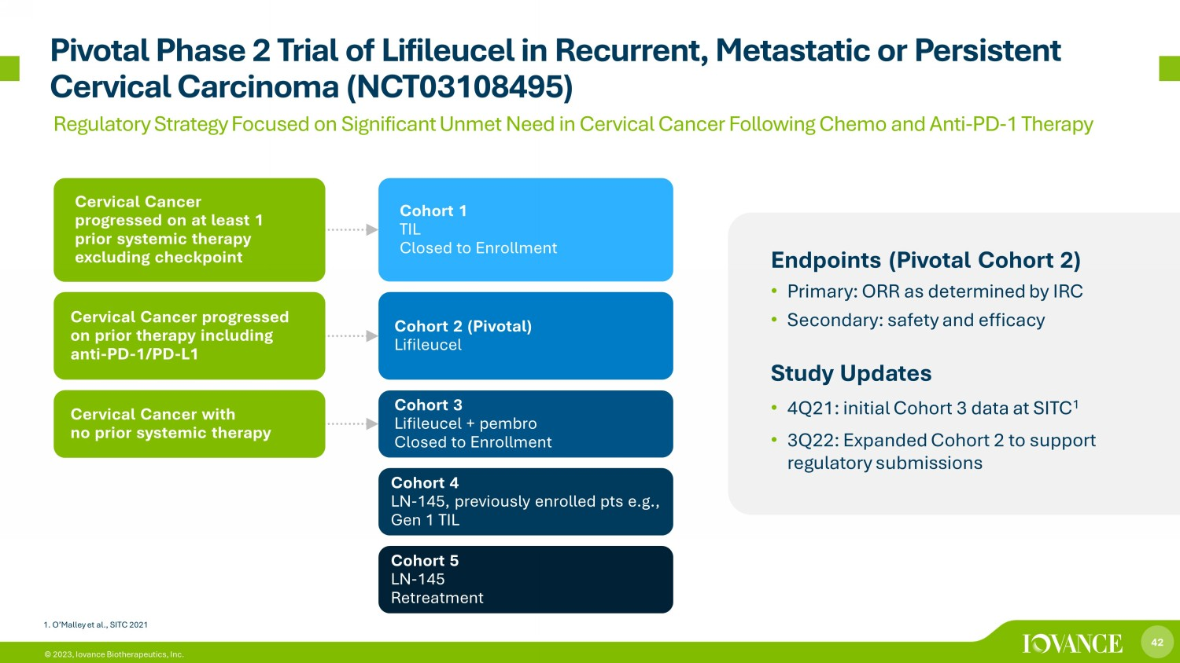
42 © 2023, Iovance Biotherapeutics, Inc. Pivotal Phase 2 Trial of Lifileucel in Recurrent, Metastatic or Persistent Cervical Carcinoma (NCT03108495) Endpoints (Pivotal Cohort 2) • Primary: ORR as determined by IRC • Secondary: safety and efficacy Study Updates • 4Q21: initial Cohort 3 data at SITC 1 • 3Q22: Expanded Cohort 2 to support regulatory submissions Cohort 1 TIL Closed to Enrollment Cohort 2 (Pivotal) Lifileucel Cohort 3 Lifileucel + pembro Closed to Enrollment Cohort 4 LN - 145, previously enrolled pts e.g., Gen 1 TIL Cohort 5 LN - 145 Retreatment Cervical Cancer progressed on at least 1 prior systemic therapy excluding checkpoint Cervical Cancer progressed on prior therapy including anti - PD - 1/PD - L1 Cervical Cancer with no prior systemic therapy 1. O’Malley et al., SITC 2021 Regulatory Strategy Focused on Significant Unmet Need in Cervical Cancer Following Chemo and Anti - PD - 1 Therapy


43 © 2023, Iovance Biotherapeutics, Inc. 43 Next - Generation Research Programs

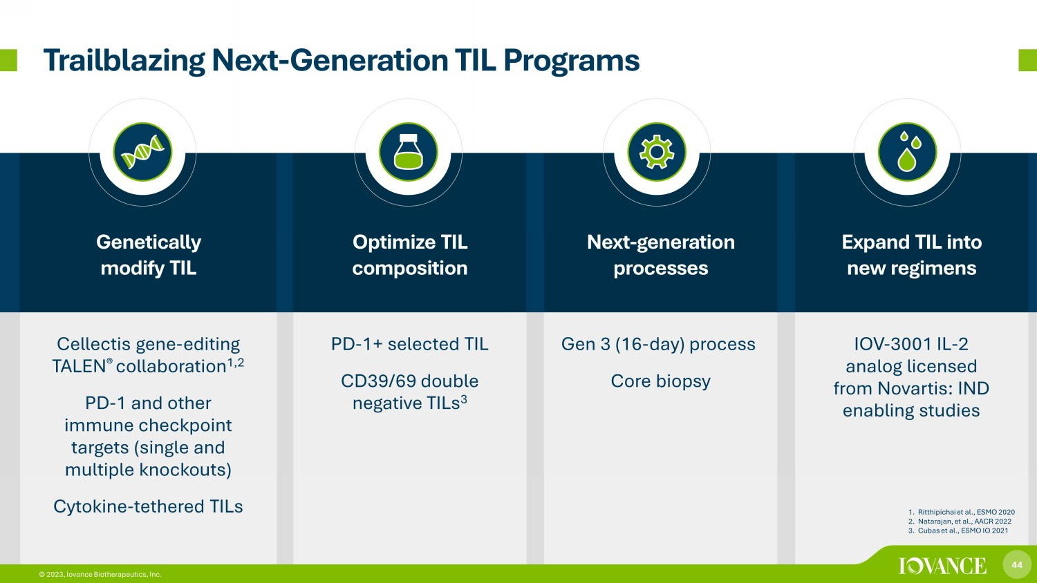
44 © 2023, Iovance Biotherapeutics, Inc. Genetically modify TIL Optimize TIL composition Next - generation processes Expand TIL into new regimens Cellectis gene - editing TALEN ® collaboration 1,2 PD - 1 and other immune checkpoint targets (single and multiple knockouts) Cytokine - tethered TILs PD - 1+ selected TIL CD39/69 double n egative TILs 3 Gen 3 (16 - day) process Core biopsy IOV - 3001 IL - 2 analog licensed from Novartis: IND enabling studies Trailblazing Next - Generation TIL Programs 1. Ritthipichai et al., ESMO 2020 2. Natarajan, et al., AACR 2022 3. Cubas et al., ESMO IO 2021 44 © 2023, Iovance Biotherapeutics, Inc.


45 © 2023, Iovance Biotherapeutics, Inc. 45 Corporate Summary & Milestones

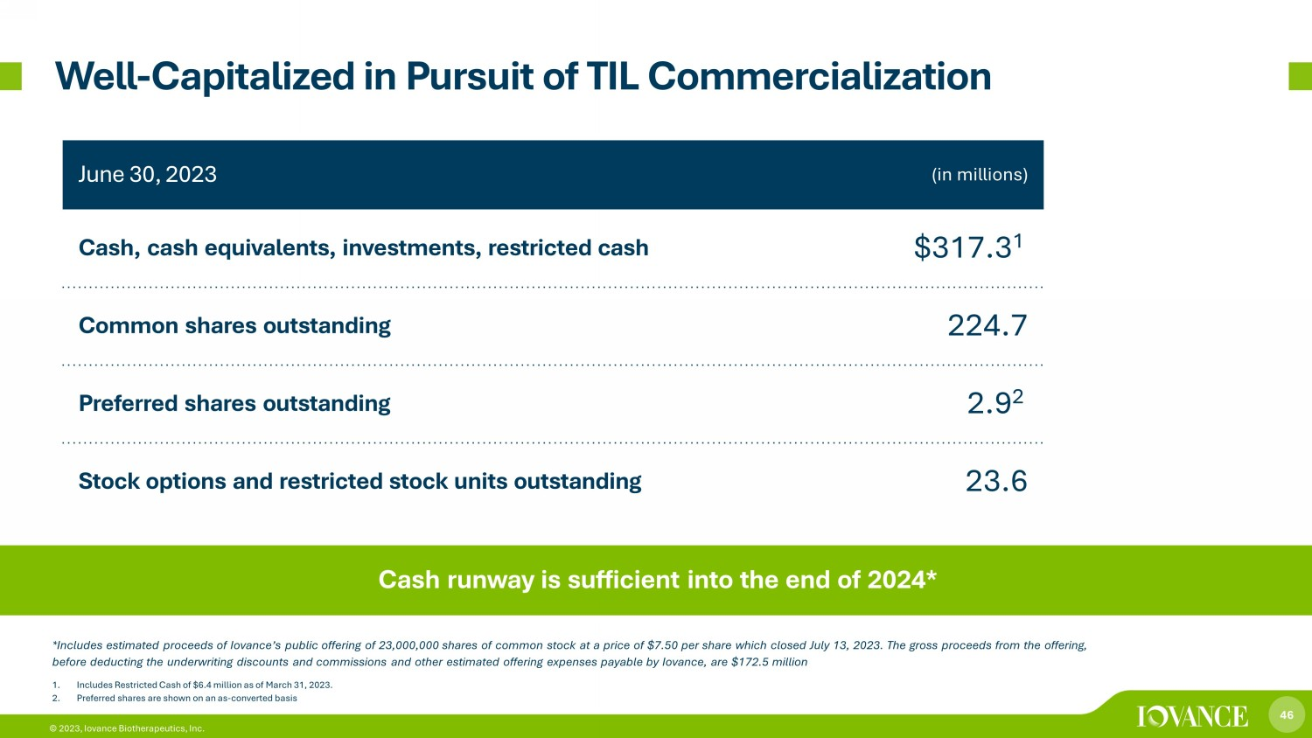
46 © 2023, Iovance Biotherapeutics, Inc. June 30, 2023 (in millions) Cash, cash equivalents, investments, restricted cash $317.3 1 Common shares outstanding 224.7 Preferred shares outstanding 2.9 2 Stock options and restricted stock units outstanding 23.6 1. Includes Restricted Cash of $6.4 million as of March 31, 2023. 2. Preferred shares are shown on an as - converted basis Well - Capitalized in Pursuit of TIL Commercialization Cash runway is sufficient into the end of 2024* *Includes estimated proceeds of Iovance’s public offering of 23,000,000 shares of common stock at a price of $7.50 per share whi ch closed July 13, 2023. The gross proceeds from the offering, before deducting the underwriting discounts and commissions and other estimated offering expenses payable by Iovance, are $17 2.5 million

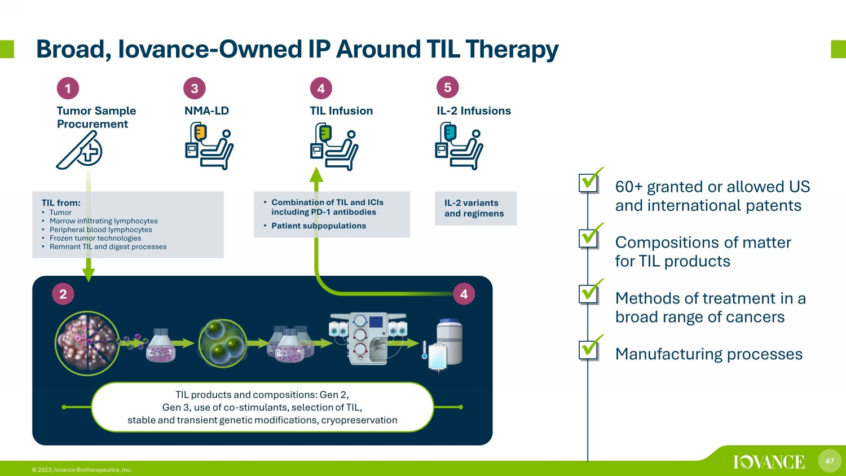
47 © 2023, Iovance Biotherapeutics, Inc. Broad, Iovance - Owned IP Around TIL Therapy TIL products and compositions: Gen 2, Gen 3, use of co - stimulants, selection of TIL, stable and transient genetic modifications, cryopreservation 1 Tumor Sample Procurement 3 4 NMA - LD TIL Infusion 5 IL - 2 Infusions 4 2 TIL from: • Tumor • Marrow infiltrating lymphocytes • Peripheral blood lymphocytes • Frozen tumor technologies • Remnant TIL and digest processes • Combination of TIL and ICIs including PD - 1 antibodies • Patient subpopulations IL - 2 variants and regimens x 60+ granted or allowed US and international patents x Compositions of matter for TIL products x Methods of treatment in a broad range of cancers x Manufacturing processes

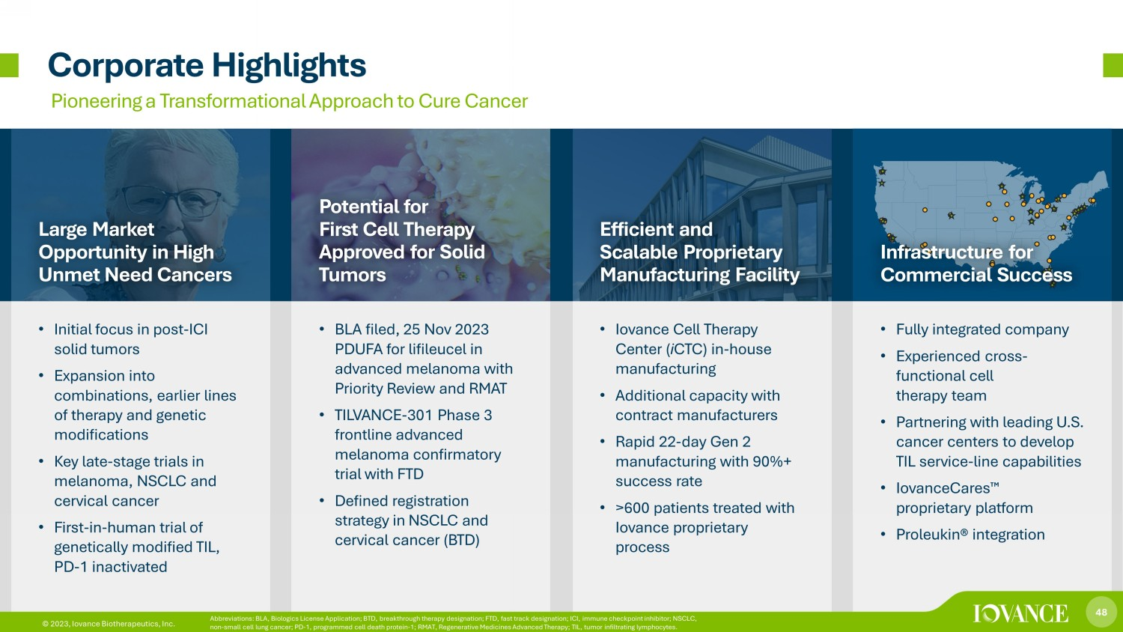
48 © 2023, Iovance Biotherapeutics, Inc. Corporate Highlights Pioneering a Transformational Approach to Cure Cancer Large Market Opportunity in High Unmet Need Cancers Potential for First Cell Therapy Approved for Solid Tumors Efficient and Scalable Proprietary Manufacturing Facility Infrastructure for Commercial Success • Initial focus in post - ICI solid tumors • Expansion into combinations, earlier lines of therapy and genetic modifications • Key late - stage trials in melanoma, NSCLC and cervical cancer • First - in - human trial of genetically modified TIL, PD - 1 inactivated • BLA filed, 25 Nov 2023 PDUFA for lifileucel in advanced melanoma with Priority Review and RMAT • TILVANCE - 301 Phase 3 frontline advanced melanoma confirmatory trial with FTD • Defined registration strategy in NSCLC and cervical cancer (BTD) • Iovance Cell Therapy Center ( i CTC) in - house manufacturing • Additional capacity with contract manufacturers • Rapid 22 - day Gen 2 manufacturing with 90%+ success rate • >600 patients treated with Iovance proprietary process • Fully integrated company • Experienced cross - functional cell therapy team • Partnering with leading U.S. cancer centers to develop TIL service - line capabilities • IovanceCares ¯ proprietary platform • Proleukin® integration 48 © 2023, Iovance Biotherapeutics, Inc. Abbreviations: BLA, Biologics License Application; BTD, breakthrough therapy designation; FTD, fast track designation; ICI, i mmu ne checkpoint inhibitor; NSCLC, non - small cell lung cancer; PD - 1, programmed cell death protein - 1; RMAT, Regenerative Medicines Advanced Therapy; TIL, tumor inf iltrating lymphocytes.

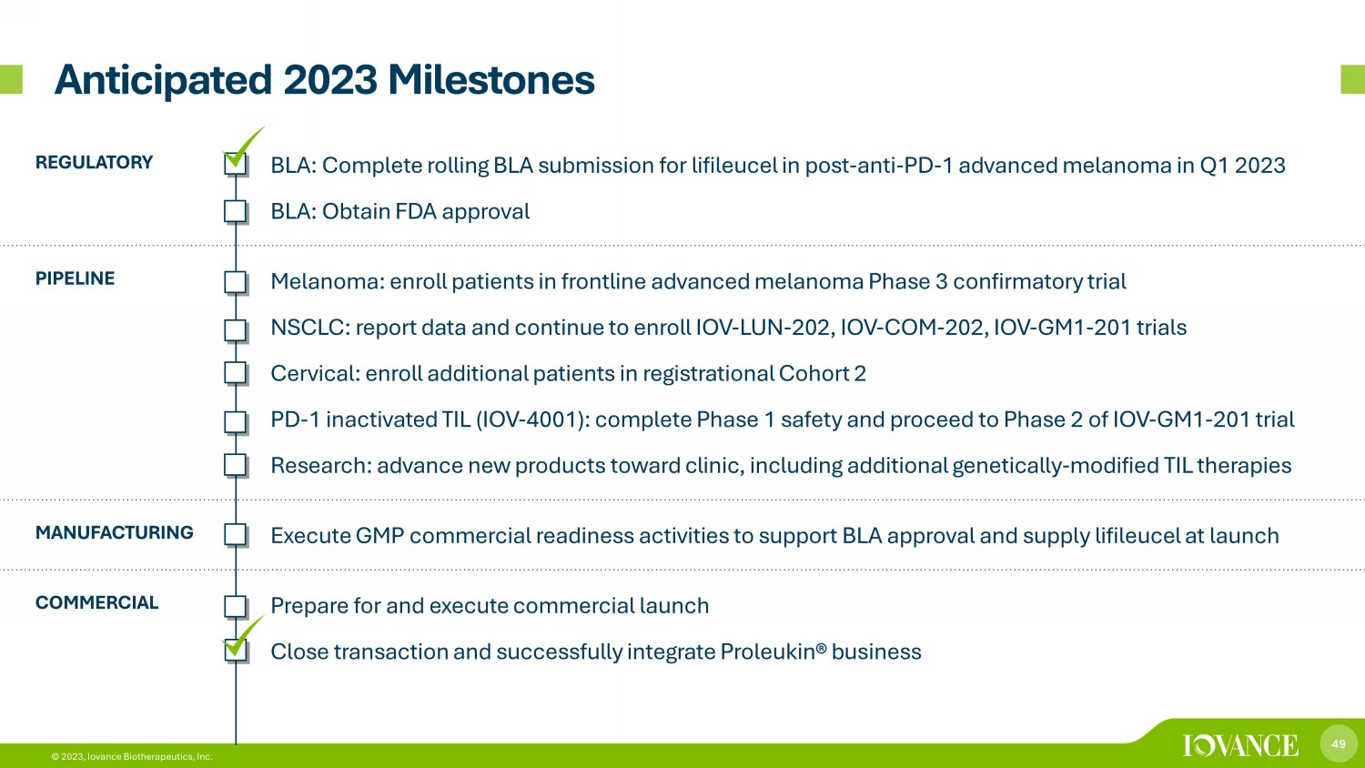
49 © 2023, Iovance Biotherapeutics, Inc. Anticipated 2023 Milestones REGULATORY • BLA: Complete rolling BLA submission for lifileucel in post - anti - PD - 1 advanced melanoma in Q1 2023 • BLA: Obtain FDA approval PIPELINE • Melanoma: enroll patients in frontline advanced melanoma Phase 3 confirmatory trial • NSCLC: report data and continue to enroll IOV - LUN - 202, IOV - COM - 202, IOV - GM1 - 201 trials • Cervical: enroll additional patients in registrational Cohort 2 • PD - 1 inactivated TIL (IOV - 4001): complete Phase 1 safety and proceed to Phase 2 of IOV - GM1 - 201 trial • Research: advance new products toward clinic, including additional genetically - modified TIL therapies MANUFACTURING • Execute GMP commercial readiness activities to support BLA approval and supply lifileucel at launch COMMERCIAL • Prepare for and execute commercial launch • Close transaction and successfully integrate Proleukin® business


50 © 2023, Iovance Biotherapeutics, Inc. © 2023, Iovance Biotherapeutics, Inc. Thank You

